PREPARATORY

PROBLEMS

Solutions

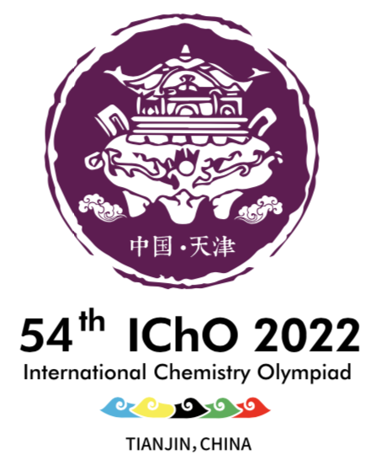

**Table of contents**

Problem 1. The Past and Present of Bronze Ware 3

Problem 2. The Chemical Element in Mysterious Elixir 3

Problem 3. Cyanotype, Prussian blue and related compounds 5

Problem 4. Tianjin Painted Clay Figure Zhang 5

Problem 5 Chinese Cloisonné 6

Problem 6. "Titanium" is awesome 6

Problem 7. Kaolinite and Sodalite 7

Problem 8. Mars Chemistry 7

Problem 9. Greenhouse gas and carbon neutrality 8

Problem 10. Packing of binary crystals 9

Problem 11. Determination of Calcium Ions by Titration with Ethylene Bis(oxyethylenenitrilo) Tetraacetic Acid (EGTA) 10

Problem 12. Fast Determination of Vitamin C by Gold Colloids 11

Problem 13. Allenes 12

Problem 14. Cyclopropanes 14

Problem 15. Lewis base catalysis 15

Problem 16. Isosorbitol 15

Problem 17. Total Synthesis of Hopeanol 16

Problem 18. Total Synthesis of Lithospermic acid 18

Problem 19. Reaction of peptides 19

Problem 20. Total Synthesis of Hapalindole-Type Natural Products 20

Problem 21. Total Synthesis of Schindilactone A 21

Problem 22. Recyclable Plastic—Turning Waste into Treasure 22

Problem 23. The combustion of water gas 23

Problem 24. The thermodynamics of decomposition reactions 24

Problem 25. The condensation of 1-butanol vapor 25

Problem 26. Chemical kinetics 26

Problem 27: Electrochemistry 27

Problem 28. π-conjugated systems 28

Practical Tasks 29

P1. Extraction of Berberine and Its Structural Characterization 30

P2. Synthesis of (2,4-Dichlorophenoxy)acetic Acid and Evaluation of Product Purity 31

P3. Enzymatic Protein Digestion 32

P4. Synthesis of the Thermochromic Spin-crossover Materials 33

P5. The Extraction of Indigo from Radix Isatidis and its Synthesis for Application in Tie-dyeing 34

P6. Synthesis of Carbon Dots Made from Kitchen Waste 35

P7. Synthesis and Purity Analysis of N-acetylphenylalanine in Aqueous Phase 35

P8. Reaction Types and Chemical Logic (Virtual Experiment) 36

P9. Properties and Identification of Heavy Metal Ions (Virtual Experiment) 37

### Problem 1. The Past and Present of Bronze Ware

**1-1** (d)

**1-2** 2CuFeS2 + 2SiO2 + 5 O2 → 2Cu + 2 FeSiO3 +4SO2

**1-3** reaction 1: 4CuCl+ 4H2O + O2 = 2Cu2(OH)3Cl + 2HCl

reaction 2: 4Cu + 4HCl + O2= 4CuCl + 2H2O

**1-4** reaction 3: 2CuCl + Na2CO3 → Cu + CuCO3 + 2 NaCl

reaction 4: Ag2O + 2CuCl → 2AgCl + Cu2O

**1-5-1 A:** NO2  **C:** SnO2 **E:** PbSO4 **F:** CuSO4⋅5H2O

**1-5-2** **B:** Cu2+,(H+) **D:** Cu2+**,**  (, H+)

**1-6-1** reaction 5: 2Cu2++ 4 I → 2CuI + I2

reaction 6: I2 + 2 → + 2 I

**1-6-2** 2CuSO4⋅5H2O~ 2Cu2+~ I2~ 2

*M*w (CuSO4⋅5H2O) =249.69 g mol−1



**1-7** 249.69 × 15.09% = 37.68

249.69×13.58%=33.91

249.69×7.08%=17.68

H2O,2:2:1

### Problem 2. The Chemical Element in Mysterious Elixir

**2-1**

realgar

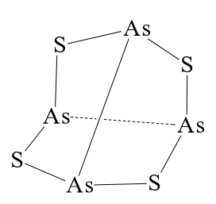

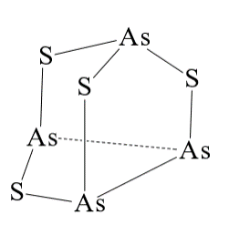

**2-2** Realgar is difficult to dissolve in ammonium carbonate solution, and orpiment is easy to dissolve:

As4S4 + NH4HCO3 →×

As2S3 + 6NH4HCO3 → (NH4)3AsS3 + (NH4)3AsO3 + 6CO2↑+ 3H2O

**2-3-1** Al2O3 + 6Zn + 12HCl → 2AsH3↑ + 6ZnCl2 + 3H2O

2AsH3  2As + 3H2

2As + 5NaClO + 3H2O → 2H3AsO4 + 5NaCl

**2-3-2** 2AsH3↑ + 12AgNO3 + 3H2O → 12Ag↓ + As2O3 + 12HNO3

**2-3-3** 75As +  → 76As +γ

**2-3-4** (CH3)3As, or other reasonable volatile liquids.

**2-3-5**

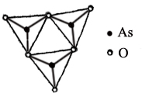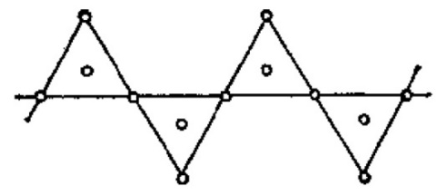

$\text{As}{\text{Ο}}_{\text{}}^{\text{−}}$ $\text{As}{\text{Ο}}_{\text{3}}^{\text{−}}$

**2-3-6** CuS

**2-3-7** three / tri-

**2-3-8** Na3AsSO3·7H2O

As2O3 is an amphoteric oxide and has strong reducibility in alkaline medium. It can react with sulfur to form , , AsS3O3, . In 5.00 g As2O3, *n*(As) = 2×5/197.84 = 0.0505 mol. Since 1.44g sulfur, *n*(S) = 0.0449 mol, react completely, the amount of As2O3 is excess slightly. It can be deduced that the As:S ratio in product is 1:1. So the product is 0.0449 × (1 − 13.3%) = 0.0389 mol Na3AsSO3 (sodium mono-thioarsenate, *M*r = 223.95). According to the weight of product, we known the crystal contains 7 water:

[13.66 − (0.0389 × 223.95)] / 18.02 × 0.0389 ≈ 7

4H2O + 6NaOH + As2O3  + 2S → 2Na3AsSO3·7H2O

*M*r 32.06 350.09

*n*  0.0389 0.0389

### Problem 3. Cyanotype, Prussian blue and related compounds

**3-1 A** Fe4[Fe(CN)6]3; **B** Fe3[Fe(CN)6]2; **C** Fe[Fe(CN)6]; **D** K2Fe[Fe(CN)6]

**3.2**

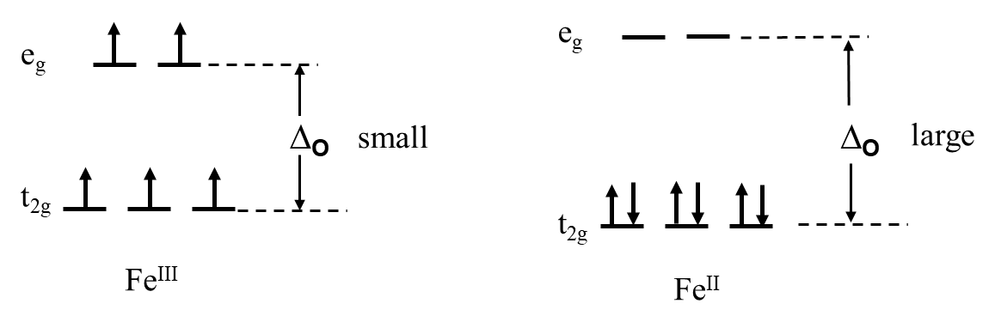

**3.3** In each unit cell, there are 4 FeIII; 3 FeII and 1 [FeII] vacancy; 18 CN− groups and 6 [CN−] vacancies.

**3.4** Formation of Prussian Blue:

2 Fe3+ + 2 K+ + 2 [Fe(CN)6]3− + → 2 KFe[Fe(CN)6] + CO2 + + H+

Formation of William White:

2 KFe[Fe(CN)6] + 2K+ + → 2 K2Fe[Fe(CN)6] + CO2 + C5H4O52−+ H+

**3-5-1** (**G**) KCo[Fe(CN)6]

**3-5-2**  (b) (c) (f)

**3-6-1**  Na2FeCo(CN)6

**3-6-2**

Charge: Na2FeCo(CN)6 → 2Na + FeCo(CN)6

Discharge: 2Na + FeCo(CN)6 → Na2FeCo(CN)6

### Problem 4. Tianjin Painted Clay Figure Zhang

**4-1-1** MgO + NH4H2PO4 + 5H2O → NH4MgPO4·6H2O

**4-1-2** 

**4-2**  SiO2· *x*H2O

**4-3 B:** Li3N; **D:** Li2O; **E:** LiOH; **F:** NH3

**4-4** ∆*H* = −393.5 − 601.6 + 1095.8 = 100.7 kJ mol−1

∆*S* = 213.8 + 27 − 65.7 = 175.1 J mol−1 K−1

∆*G* = ∆*H* − *T*∆*S* = 100.7 − *T* × 175.1×10−3 < 0

*T* > 575.1 K

### Problem 5 Chinese Cloisonné

**5-1** (1) Co2+ + 2OH− → Co(OH)2↓

(2) 4Co(OH)2 + O2 + 2H2O → 4Co(OH)3

(3) 2Co(OH)3 + 6HCl → 2CoCl2 + Cl2↑ + 6H2O

**5-2 A**. [Co(NH3)6]Cl3  **B**. [CoCl (NH3)5]Cl2  **C**. [CoCl2 (NH3)4]Cl **D**. [Co(NH3)3 Cl3]

**5-3-1** (b)II

**5-3-2**

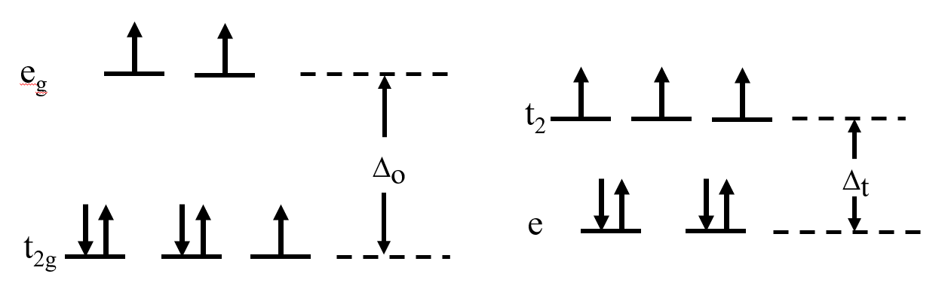

$\text{Co(}{\text{H}}_{\text{2}}\text{O}{\text{)}}_{\text{6}}^{\text{2+}}$ $\text{Co}{\text{Cl}}_{\text{4}}^{\text{2}\text{−}}$

**5-3-3** *μ*=[*n*(*n*+2)]1/2 =[3(3+2)]1/2=3.87*μ*B

**5-4** (a), (d)

### Problem 6. "Titanium" is awesome

**6-1-1**   Fe2+ H+

**6-1-2** FeSO4·7H2O

**6-1-3** TiOSO4 + 2H2O → H2TiO3↓ + H2SO4

**6-2**  2FeTiO3 + 3Cl2 + C→2TiO2 + 2FeCl3 + CO2

**6-3-1**

TiO2 + 2C + 2Cl2 → TiCl4 + 2CO

TiCl4 + O2 → TiO2 + 2Cl2

**6-3-2** Without adding carbon: TiO2 + Cl2→TiCl4 + O2

= −804.2 − (−944.0) = 139.8 kJ mol−1

= 205.2 + 252.3 – 50.6-223.1×2 = –39.3 J K−1 mol−1

 It is always positive. The reaction cannot proceed. The direct chlorination reaction of TiO2 is thermodynamically impossible.

With carbon: TiO2(s) + 2Cl2 (g) + 2C → TiCl4(l) + 2CO(g)

 = −81.2 kJ mol−1,  = 139.5 J K−1 mol−1

 is negative. Any temperature can be spontaneous. Adding carbon powder and using coupling reaction make the reaction possible.

**6-4-1** 3TiO2 + Al + 6H → 3Ti3 + Al3 + 3H2O；

**6-4-2 **

**6-5-1** BaCl2 + TiCl4 + 2H2C2O4 + 5H2O → BaTiO(C2O4)2•4H2O↓+ 6HCl

BaTiO(C2O4)2•4H2O  BaTiO3 + 2CO2↑+ 2CO↑+ 4H2O

**6-5-2** (b), (c)

### Problem 7. Kaolinite and Sodalite

**7-1**  K2Al2Si6O16 + 2 H2O + CO2 → Al2Si2O5(OH)4·+ 4 SiO2 + K2CO3

**7-2** Mg3Si2O5(OH)4

**7-3-1** Si3Al4O12

Tips for solving the problem: According to the information, the detective chemical formula can be written as [Si0.750.25]T[Al1.330.67]OO4 here  represents empty, T for tetrahedral, and O for Octahedral positions, then the corresponding stoichiometric presentation is Si3Al4O12.

**7-3-2**

stage 1: Al2Si2O5(OH)4 →·Al2Si2O7 + 2 H2O

stage 2: 2 Al2Si2O7 → Si3Al4O12 + SiO2

stage 3: 3 Si3Al4O12 → 2 Si2Al6O13 + 5SiO2

**7-4-1**  [Si24O60]24−

Tips for solving the problem: There are 14 faces, 24 corners and 36 edges (14 + 24 −2 = 36) in the β-cage, so there are 24 silicon atoms (at the corners). Since the SiO4 tetrahedra are linked by vertex-sharing, the number of the oxygen atoms is 36 + 24 = 60.

**7-4-2**  Na6Al6Si6O24

Tips for solving the problem: let see the content of the unit cell: it can be seen that there is a cage inside the cell and six squares are just on the six plane faces, and each is shared by two cells. Therefore, there are 24/2=12 T (Si, Al) atoms each cell. Since the chemical formula is NaAlSiO4, there should be 6 Al and 6 Si in the framework with the composition ${\text{Al}}_{\text{6}}{\text{Si}}_{\text{6}}{\text{O}}_{\text{24}}^{\text{6}\text{−}}$, and 6 Na+ are needed to compensate the negative charge. Then the composition of the unit cell should be Na6Al6Si6O24.

### Problem 8. Mars Chemistry

**8-1** 6Fe2SiO4 + 2H2O + CO2 → 4Fe3O4 + 6SiO2 + CH4

**8-2**  2.51×1013 g





6Fe2SiO4 + 2H2O + CO2 → 4Fe3O4 + 6SiO2 + CH4





**8-3-1** KMnO4; Fe2+; magnetite; hematite.

**8-3-2** 2CO (g) + 2H2 (g); +247 kJ mol−1

**8-3-3** H2+2e→H2O+CO2

CO+2e→2CO2

### Problem 9. Greenhouse gas and carbon neutrality

**9-1-1** 2NaHCO3  Na2CO3 + CO2↑ + H2O

**9-1-2** (b)

**9-1-3** (a) (b)

**9-2-1** 4Na++ 3CO2 +4e− → 2Na2CO3 + C

**9-2-2** (c)

**9-2-3** 2.35

**9-3-1** cathode reaction: 2CO2 + 12e− + 12H+ → C2H4 + 4H2O

anode reaction: 4OH− → O2 + 2H2O + 4e−

**9-3-2** Total moles of ethylene = (90.0 mL ÷ 1000) × 5.19% ÷ 22.4 mol/L = 0.0000209 mol

The charge required to generate ethylene = 0.0000209 mol × 12 × 96485 C/mol = 24.2 C

Total charge = 3600 s × 0.0100 A =36.0 C

Faraday efficiency = 24.2 ÷ 36.0 × 100% = 67.2%

Total mass of generated ethylene = 0.0000209 mol × 28.06 g/mol × 1000 = 0.586 mg

Ethylene production rate = 0. 586 mg ÷ 1 h = 0.586 mg h−1.

**9-4-1** Known *W* = 5.230 kJ,

Since Δ*T* = 0, we have

Δ*U* = 0, *Q*r = *W* = 5.230 kJ

Δ*S* = *Q*r/*T* = 19.14 J·K1

Δ*H* = Δ*U* + Δ(*pV*) = Δ*U* + Δ*nRT* = 0

Δ*G* = Δ*H* − TΔ*S* = −5.230 kJ

**9-4-2** (b)

**9-4-3**

(1) From Langmuir isotherm equation



With values of *V*1 = 0.0692 m3 kg1, *P*1 = 5.2 kPa, and *V*2 = 0.0826 m3 kg1, *P*2 = 13.5 kPa

we can solve *α* = 54.34, *V*m = 0.0940 m3 kg1

(2) Specific surface area

*S* = (0.0940dm3 g) ÷ (22.4 dm3 mol) × (6.02 × 1023 mol1) × (0.32 × 1018 m2)

= 808 m2 g1

### Problem 10. Packing of binary crystals

**10-1**







**10-2**

NaCl type:

; 

CsCl type:

; 

**10-3**

Assuming I− anions are in contact with each other

 (*bcc*)

I− anions form trigonal holes, and AB = *a*; BC = AC = , Assume AO = BO =CO = *x*,

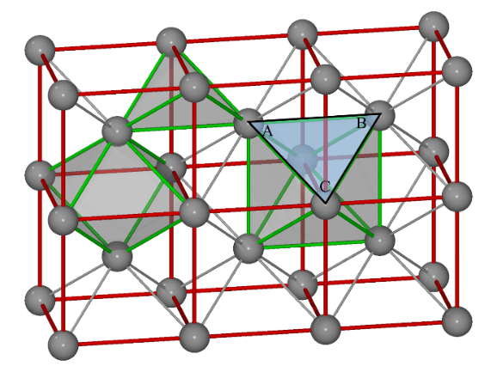 



*r*max(Ag+) = 267 − 218 = 49 pm

### Problem 11. Determination of Calcium Ions by Titration with Ethylene Bis(oxyethylenenitrilo) Tetraacetic Acid (EGTA)

**11-1**. EGTA is a hexabasic acid, insoluble in water. If using distilled water to dissolve the EGTA, 0.020 mol L1 solution can not be obtained. EGTA can be dissolved in the dilute basic solution as a weak acid.

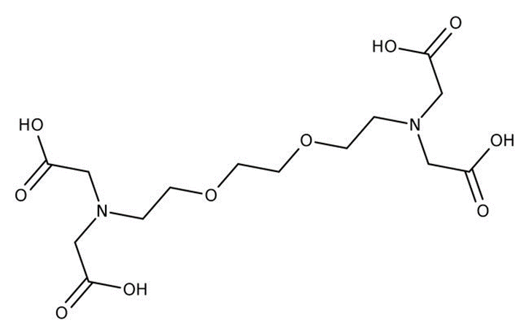

**11-2**. At pH=10，

*α*E(H) = 1 + [H+] / *K*a6 + [H+]2 / *K*a6∙*K*a5 + [H+]3 / *K*a6∙*K*a5∙*K*a4 + [H+]4 / *K*a6∙*K*a5∙*K*a4∙*K*a3

= 1 + 1010 / 109.53 + 1010×2 / 10(9.53+8.93) + 1010×3 / 10(9.53+8.93+2.73) + 1010×4 / 10 (9.53+8.93+2.73+2.08)

= 100.14

**11-3**. In the presence of Mg2+ ions,

*α*E(Mg) = 1 + *K*MgE∙*c*Mgsp = 1 + 105.21 × 0.010 / 2 = 102.91

*α*E = 100.14 + 102.91  1 = 102.91

lg*K′*CaE = 10.97  2.91 = 8.06

pCasp = (8.06  lg 0.010 / 2) / 2 = 5.18, pCat = 3.8

ΔpCa′ = 3.8  5.18 = 1.38

*E*t = × 100% = 3.2%

**11-4**. At pH12,

[OH] = 102，[Mg2+]sp = *K*sp / [OH]2 = 1010.74 / 102×2 = 106.74

αE(Mg) = 1 + *K*MgE∙[Mg2+]sp = 1 + 105.21 × 106.74 = 1

lg*K′*CaE = 10.97, pCasp = (10.97  lg0.010 / 2) / 2 = 6.64，pCat = 5.6

ΔpCa′ = 5.6  6.64 = 1.04

*E*t = × 100% = 0.05%。

**11-5**.

*c*(Ca2+) = (2.4907 × 1 / 10) / 100.09 = 2.488 × 103 ( mol L1)

*c*(H4E) = 2.488×103 × 25.00 / 25.85 = 2.406 × 103 ( mol L1)

content of calcium =2.406 × 103 × (0.83  0.20 / 10) × 1000 / 0.80 = 2.4 (mmol L1)

### Problem 12. Fast Determination of Vitamin C by Gold Colloids

**12-1**. (b)

**12-2**.

The volume of AuNP (*V*AuNP) is calculated by Eq.(12-1), where *D* is the diameter of gold colloid:

 (12-1)

The volume of one gold atom (*V*Au) is calculated by Eq.(12-2), where *m* is the mass of each gold atom, and *N*A is the Avogadro’s constant:

 (12-2)

Accordingly, the number of gold atoms (*N*) is calculated by Eq. (12-3):

 (12-3)



The molar concentration of the gold colloidal solution is calculated by dividing the total number of gold atoms (*N*total, equivalent to the initial amount of gold salt added to the reaction solution) over the average number of gold atoms per nanosphere (*N*) according to Eq.(12-3), where *V* is the volume of the reaction solution in liter:

 (12-4)

The extinction coefficient of the colloid gold is determined according to Lambert-Beer law, Eq.(12-5):

 (12-5)





**12-3**. According to Lambert-Beer law:



Since the amount of chloroauric acid is excess, the concentration of gold colloid is proportional to that of vitamin C.

 





*Cx* = 2.14 μg mL1

### Problem 13. Allenes

**13-1-1** *S*a

**13-1-2** (a) MeMgBr is a nucleophile; (b) MeMgBr is a base.

**13-2** 

**13-3-1 **

**13-3-2 **

**13-3-3 **

**13-3-4 **

**13-3-5 **

**13-3-6 **

**13-4-1** 

**13-4-2** (a) i) ethynylmagnesium bromide, THF; ii) NH4Cl(aq.)

**13-4-3** (c) i) NaH, THF; ii) MeI; iii) 3 M HCl

**13-4-4** (d) Nucleophilic addition

**13-4-5** 

### Problem 14. Cyclopropanes

**14-1**  (a).

**14-2-1** 

**14-2-2**

7.23 (2H, d, *J* = 8.0 Hz): a

7.19 (2H, d, *J* = 8.0 Hz): b

3.77 (3H, s), 3.39 (3H, s): f, g

3.14 (1H, dd, *J*= 9.0 and 8.1 Hz): c

2.12 (1H, dd, *J* = 8.1, 5.1 Hz), 1.74 (1H, dd, *J* = 9.0, 5.1 Hz): d, e

**14-3**.

**14-4** 

**14-5** 

### Problem 15. Lewis base catalysis

**15-1** (b), (c), (d)

**15-2** (c)

**15-3**



**15-4** 

**15-5** 

**15-6** (b), (e)

**15-7** 

**15-8** 

### Problem 16. Isosorbitol

**16-1**



**2**

**16-2** (b) Pd-C, H2

**16-3**

  

**3**  **4**  **5**

**16-4** Steric effect

**16-5** (b) −2H2O

**16-6** 

**6** **7**

### Problem 17. Total Synthesis of Hopeanol

**17-1**  

**17-2** 

**17-3** 

**17-4**  

**17-5** (b) Dess-Martin periodinane (1,1,1-Triacetoxy-1,1-dihydro-1,2-benziodoxol-3(1H)-one)

**17-6** (a) **11a**

**17-7** (c) Me2S=CH2

**17-8** 

**17-9** 

**17-10** (a) BBr3, CH2Cl2

**17-11** 

**17-12** (a) oxidant

### Problem 18. Total Synthesis of Lithospermic acid

**18-1** 

**18-2** (c) H2CrO4

**18-3** 

**18-4** 

**18-5** 

**18-6**  (b) (COCl)2, Me2SO

**18-7** 

**18-8** 

**18-9** 

**18-10** 

**18-11** 

### Problem 19. Reaction of peptides

**19-1** 

**19-2** 

**19-3** 

**19-4** 

**19-5** 

**19-6** 

### Problem 20. Total Synthesis of Hapalindole-Type Natural Products

**20-1** (e)

**20-2** (b)

**20-3**



**20-4**

**20-5** 

**20-6** 

### Problem 21. Total Synthesis of Schindilactone A

**21-1-1** 

**21-1-2** 

**21-1-3** 

**21-2** The excellent diastereoselectivity observed in the Grignard reaction presumably could be attributed to the steric bulk of the OTES group in substrate **8**, which might direct the attack of the Grignard reagent on the ketone from the less hindered face.

 

**21-3-1** 

**21-3-2** 

**21-3-3** (b) SN1 reaction

**21-3-4** 

### Problem 22. Recyclable Plastic—Turning Waste into Treasure

**22-1**

 

**1 2**

**22-2** 69

Since it is ‘at most’, considering that m1 > m2 >> n1 > n2 and the values are quite different, if there are 3 different kinds of dehydrogenation product **A**, the alkene metathesis may produce at most 6 different kinds of fragments:



Similarly **B** may produce at most 8 different kinds of fragments, and the cross alkene metathesis product contains at most 6×8 = 48 possibilities. However, dehydrogenation product **A** can also form self-recombinant products, at most *C*62 + 6 = 21 possibilities. Therefore the polymer alkene mixture **C** contains at most 48 + 21 = 69 possibilities.

*Notice that mixture **C** is alkene, which allows C=C double bond position isomerism.

**22-3** 24

When the light alkane added is n-hexane, it can only break into 5 different types of fragments (C1 ~ C5 residues), and since hydrogenation erases all the C=C double bond isomers, there are 11 different kinds ofcrossproduct (the length of alkane product varies from C78 ~ C88), then about self-recombinant of **A**, another 13 possibilities should be considered (the length of alkane product varies from C156 ~ C168). Therefore there are 11 + 13 = 24 kinds of **D** in the ultimate alkane mixture

*Notice that **D** is different from **C**, **D** is the alkane product after hydrogenation, it is not necessary to consider the location of C=C double bonds.

**22-4** (a)

Only PP contains no heteroatom in the polymer main chain, while Phenolic Resin has oxygen, polyamide has nitrogen, and polyurethane has both oxygen and nitrogen in the main chain.

**22-5** (d)

PMMA thermolysis generates stable tertiary carbon free radicals, the decomposed chain mostly undergoes internal disproportionation and MMA monomers are mainly obtained; but PE thermolysis forms carbon radicals with hydrogen on it, which is not that stable and lead to chain transfer easily, therefore preventing further depolymerization.

**22-6** (c)

**22-7**



**M1 M2**

**22-8** The left graph (red) belongs to **P1**, the right graph (blue) belongs to **P2**.

The main difference is the absorption peaks of C-O stretching vibration at 1250cm−1, and apparently the density of C-O structure is higher in **P2**.

**22-9** From above to below: **R2**, **R3**, **R1**.

### Problem 23. The combustion of water gas

**23-1**



Design the following processes:



Assume the initial amounts of substances of H2(g), CO(g), O2(g) and N2(g) 1 mol，1mol, 2 mol, and *n* mol, respectively.



Under constant pressure and adiabatic conditions:







**23-2** Only consider the combustion of CO:





### Problem 24. The thermodynamics of decomposition reactions

**24-1** Design the following processes for the decomposition of Ag2CO3(s):



Then:



**24-2** Further:



The minimum partial pressure of CO2 needed is 1.58 kPa.

**24-3** Assume the initial amount of substance of PCl5 is 1mol.



The molar mass of PCl5, *M*, is 208.5×103 kg mol1. Assume PCl5 is an ideal gas.





**24-4**



### Problem 25. The condensation of 1-butanol vapor

**25-1** According to the Kelvin equation:



**25-2** The volume of the droplet: 

The mass of the droplet is ρV，then the total number of the molecules, N, is:



### Problem 26. Chemical kinetics

**26-1** For a second order reaction:





*k′* is the consumption rate of A2B.



**26-2** At time t:



**26-3** The half-life is not related to the initial concentration, then it is a first-order reaction:











By comparing the three activation energies in mechanism b, the first step is fast, but the second step is slow, then:



According to equilibrium approximation: 

Then , where 

So ,

and 

### Problem 27: Electrochemistry

**27-1** The half-reactions and the overall cell reaction:



**27-2** 

which means the temperature coefficient 





**27-3**



Given:



Design a battery: ┊┊



### Problem 28. π-conjugated systems

**28-1** *λ*a,max < *λ*b,max < *λ*c,max

(a) 1, 3-butadiene, (b) 1, 3, 5-hexatriene, and (c) 1, 3, 5, 7-octatetraene have 2*k* values of 4, 6, and 8, respectively.

; ;



The order of the absorption spectrum:*λ*a,max < *λ*b,max < *λ*c,max

**28-2**



*d* = 135 pm

**28-3** An anthracene molecule has 14 π electrons.



|  |  |  |  |  |  |  |  |  |  |
| --- | --- | --- | --- | --- | --- | --- | --- | --- | --- |
| *n*x | 1 | 2 | 3 | 4 | 5 | 1 | 2 | 3 | 6 |
| *n*y | 1 | 1 | 1 | 1 | 1 | 2 | 2 | 2 | 1 |
|  | 10 | 13 | 18 | 25 | 34 | 37 | 40 | 45 | 45 |
|  |  |  |  |  |  |  | HOMO | LUMO | LUMO |

 *b* = 245nm

**28-4** 1, 3, 5-hexatriene molecule has 6 π electrons that occupy three molecular orbitals. Their energy levels are:

*E*1=α+1.802β

*E*2=α+1.247β

*E*3(HOMO)=α+0.445β

*E*4(LUMO)= α−0.445β

**28-5**  

### Practical Tasks

### P1. Extraction of Berberine and Its Structural Characterization

**Questions**

1. *Y* = *m*1/*m*2,

*Y* is the yield of **1b** from Coptis chinensis, *m*1 is the weight of **1b**, *m*2 (2g) is the weight of Coptis chinensis.

2. Analysis the 1H NMR spectra of the product

The 1H NMR spectra and analysis of **1b** are showed in the following Figure and Table.

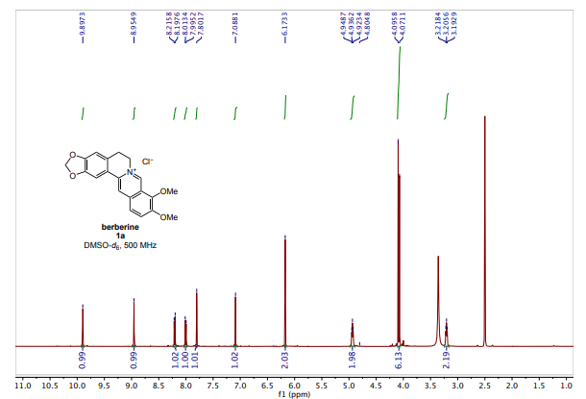

(500 MHz, DMSO-*d6*)

|  |  |
| --- | --- |
| Atom | 1H NMR(DMSO-*d6*), δ multiplicity (*J* in Hz)# |
| 1 | 7.80, s |
| 4 | 7.09, s |
| 5 | 3.21, t (6.4) |
| 6 | 4.93, t (6.3) |
| 8 | 9.90, s |
| 11 | 8.21, d (6.1) |
| 12 | 8.00 (9.1) |
| 13 | 8.95, s |
| OCH2O | 6.17, s |
| 9-OCH3 | 4.09, s |
| 10-OCH3 | 4.07 |

The 1H NMR spectra and data are cited from M. D. Clift, et al *Org. Lett.* **2018**, *20*, 4281-4284.

### P2. Synthesis of (2,4-Dichlorophenoxy)acetic Acid and Evaluation of Product Purity

**Questions**

1 The main side reaction is showed as follows

ClCH2COONa + NaOH → HOCH2COONa + NaCl

2.



m1: the weight of **2,4D**，M1: the molecular weight of **2,4D**;

m2: the weight of 2,4-dichlorophenol，M2: the molecular weight of 2,4-dichlorophenol**.**

3. Concentration of NaOH standard solution



Where, *m*1 is the mass of weighed potassium hydrogen phthalate (g), *M*1 is the molar mass of potassium hydrogen phthalate (204.22 g mol1), *V*1 is the volume of NaOH standard solution consumed by titration (mL).

Concentration of HCl standard solution



Where, *m*2 is the mass of weighed anhydrous sodium carbonate (g), *M*2 is the molar mass of anhydrous sodium carbonate (105.99 g mol1), *V*2 is the volume of HCl standard solution consumed by titration (mL).

Purity of product

 

Where, *m* is the calculated mass of product (g), *M* is the molar mass of product (221.04 g mol1), *c*(NaOH) is the concentration of NaOH standard solution (mol L1), c(HCl) is the concentration of HCl standard solution, *V*(HCl) is the volume of HCl standard solution consumed by titration (mL), *G* is the weighed mass of product.

4. The product is difficult to dissolve in water.

5. Sodium salt of the product (weak base) is titrated by HCl solution in procedure 11 and the pH at the ending-point is in the alkaline range.

### P3. Enzymatic Protein Digestion

1. By following Step 8 in the experiment procedure, the volumes of NaOH consumed in the titration (***B*n** , mL) can be summarized in a table.

|  |  |  |  |  |  |  |  |  |  |
| --- | --- | --- | --- | --- | --- | --- | --- | --- | --- |
| Samples | Casein **A** | | | Casein **B** | | | Casein **C** | | |
| 1 | 2 | 3 | 1 | 2 | 3 | 1 | 2 | 3 |
| Volume of NaOH  mL | *B*A1 | *B*A2 | *B*A3 | *B*B1 | *B*B2 | *B*B3 | *B*C1 | *B*C2 | *B*C3 |

Then the concentration (***C*n**) of amino acid in each sample is given by

***C*n** = 0.1 × ***B*n** / 15

Fill up the table with the concentration calculated

|  |  |  |  |  |  |  |  |  |  |
| --- | --- | --- | --- | --- | --- | --- | --- | --- | --- |
| Samples | Casein **A** | | | Casein **B** | | | Casein **C** | | |
| 1 | 2 | 3 | 1 | 2 | 3 | 1 | 2 | 3 |
| Amino acid concentration  mol L1 | *C*A1 | *C*A2 | *C*A3 | *C*B1 | *C*B2 | *C*B3 | *C*C1 | *C*C2 | *C*C3 |

2. The initial velocity of the reaction (*v*10、*v*20、*v*30) of enzymatic protein hydrolysis is given by plotting amino acid concentrations against time according to the data in the above table. Take Casein **A** as the example. One should be able to get a plot similar to the following one, where the vertical axis is the amino acid concentration (***C*An**), the horizontal axis is the time of the corresponding sample. Please note the line has to pass through (0,0).

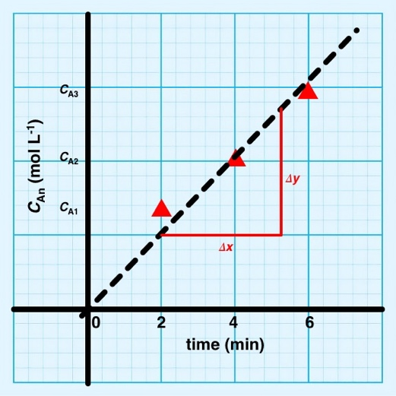

According to the plot, the initial velocity of the reaction of Casein **A** is given by

*v*10 = Δ*y* / Δ*x* / 60

Please note that the unit of *v*10 is mol L1 s1 .

Calculate *v*20, and *v*30 by following the same method.

3. First, calculate the reciprocal of all the casein concentrations and the initial velocity of the reaction. Summarize the results in a table.

|  |  |  |  |
| --- | --- | --- | --- |
| **Sample** | **Casein A** | **Casein B** | **Casein C** |
| Casein concentration (g L1)  **[*S*]** | 10 | 20 | 30 |
| **1/[*S*]** | 0.1 | 0.05 | 0.033 |
| Initial velocity of the reaction (mol L1 s1)  ***V*** | *v*10 | *v*20 | *v*30 |
| **1/*V*** | 1/*v*10 | 1/*v*20 | 1/*v*30 |

Plot **1/*V*** (y-axis) over **1/[*S*]** (x-axis)

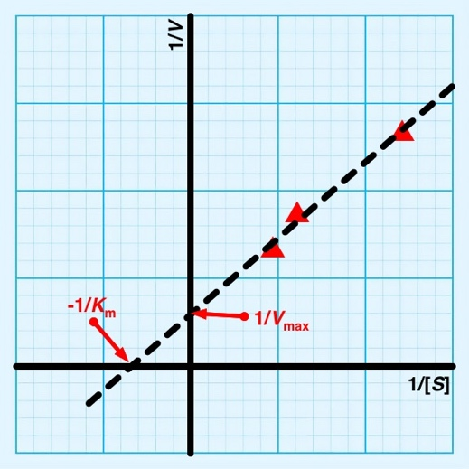

Read −**1/*K*m** and **1/*V*max** from the plot, calculate ***K*m** and ***V*max**

### P4. Synthesis of the Thermochromic Spin-crossover Materials

**Results**

|  |  |  |  |  |
| --- | --- | --- | --- | --- |
| Complex | Yield | Complex color at room temperature | Spin state of Fe2+ at room temperature | SC temperature |
| {[Fe(Htrz)3](BF4)2}n |  | Purple | low-spin |  |
| {[Fe(Htrz)3](ClO4)2}n |  | Purple | low-spin |  |

**Questions**

1. **Write** the reaction equation for procedure I and calculate the yield.

*n* Fe(BF4)2 + *3n* Htrz → {[Fe(Htrz)3](BF4)2}n ↓

2. **Write** the reaction equation for procedure II and calculate the yield.

*n* Fe(ClO4)2 + *3n* Htrz → {[Fe(Htrz)3](BF4)2}n ↓

3. According to the experiment results, the calculated magnetic moment (μ) of complexes {[Fe(Htrz)3](BF4)2}n and {[Fe(Htrz)3](ClO4)2}n at room temperature **should be** ( a ), respectively.

(a) 0, 0 (b) 0, 4.90 (c) 3.87, 3.87 (d) 4.90, 4.90

### P5. The Extraction of Indigo from Radix Isatidis and its Synthesis for Application in Tie-dyeing

**Questions**

1. Thiourea dioxide is firstly added in the dyeing process to increase the solubility of indigo in water and the firmness of binding fabric fibers , the indigo becomes indigo white, and its structure **is** (  **C** ); then after NaOH is added, its structure **becomes** ( **B** ) and after NaCl is added, its structure **is** ( **C**  ). Finally soaked in H2O2 solution, the structure **is** ( **A** ).

|  |  |  |
| --- | --- | --- |
|  |  |  |
| **A** | **B** | **C** |

2.



3. The order of solubility of A, B, C in water is ( **A** ) < ( **C** ) < ( **B** )

### P6. Synthesis of Carbon Dots Made from Kitchen Waste

**Questions:**

1. Answer: a, b, c, d

There are so much raw materials to be used for preparing carbon dots. Many carbon containing components in plants can be transformed into carbon dots through "top-down" or "bottom-up" approaches.

2. Answer: wrong

There is a partial energy loss when the electron transitions from the excited state to the ground state, resulting in the energy of the emitted light is less than that of the excited light. That is, the wavelength of the emitted light is greater than that of the excited light.

### P7. Synthesis and Purity Analysis of N-acetylphenylalanine in Aqueous Phase

Concentration of NaOH standard solution



Where, *m* is the mass of weighed potassium hydrogen phthalate (g), *M* is the molar mass of potassium hydrogen phthalate (204.22 g mol1), *V* is the volume of NaOH standard solution consumed by titration (mL).

Purity of product

， 

Where, *m* is the calculated mass of product (g), *M* is the molar mass of product (207.23 g mol1), *c*(NaOH) is the concentration of NaOH standard solution (mol L1), *V*(NaOH) is the volume of NaOH standard solution consumed by titration (mL), *G* is the weighed mass of product.

**Questions**

1. Using amino and carboxyl protective groups, it can not only prevent side reactions, but also make the reaction oriented; It can not only eliminate the zwitterionic form of amino acids, but also make amino acids more soluble in organic solvents.
2. With phenolphthalein as indicator, the end point color of titration changed from colorless to reddish, which was easy to be observed and recognized by human eyes. When litmus is used as an indicator, the ending-point of titration changes from red to purple and then to blue. The change of color is not easy to be observed by human eyes and it is difficult to determine the ending-point of titration.
3. After 30 seconds, the ending-point color of titration fades due to CO2 in the air.

### P8. Reaction Types and Chemical Logic (Virtual Experiment)

(https://prj15.xnfz.cmet.ustc.edu.cn/）

One group was randomly selected from the following 10 groups as the test questions.

| **No.** | **A** | **B** | **C** | **D** | **E** | **F** | **G** |
| --- | --- | --- | --- | --- | --- | --- | --- |
| **0** | NaOH | BaCl2 | Cu(NO3)2 | Na2CO3 | HCl | CoCl2 | CuSO4 |
| **1** | Cu(NO3)2 | NaOH | HCl | H2SO4 | BaCl2 | Na2CO3 | NaCl |
| **2** | NaCl | CuSO4 | H2SO4 | BaCl2 | Na2CO3 | NH3 | CoCl2 |
| **3** | HCl | NaCl | BaCl2 | Na2CO3 | CoCl2 | Cu(NO3)2 | NH3 |
| **4** | CuSO4 | BaCl2 | CoCl2 | NH3 | Na2CO3 | HCl | Cu(NO3)2 |
| **5** | NH3 | NaCl | CuSO4 | Na2CO3 | H2SO4 | BaCl2 | NaOH |
| **6** | BaCl2 | H2SO4 | Na2CO3 | HCl | CoCl2 | Cu(NO3)2 | NaOH |
| **7** | CoCl2 | NH3 | NaOH | CuSO4 | HCl | Na2CO3 | BaCl2 |
| **8** | Na2CO3 | CoCl2 | NH3 | H2SO4 | BaCl2 | NaOH | CuSO4 |
| **9** | H2SO4 | Na2CO3 | CoCl2 | NH3 | BaCl2 | NaOH | CuSO4 |

### 

### P9. Properties and Identification of Heavy Metal Ions (Virtual Experiment)

(https://prj16.xnfz.cmet.ustc.edu.cn/)

One group was randomly selected from the following 10 groups as the test questions.

|  |  |  |  |  |  |  |  |  |  |  |  |  |  |  |  |
| --- | --- | --- | --- | --- | --- | --- | --- | --- | --- | --- | --- | --- | --- | --- | --- |
| **No.** | **A** | **B** | **C** | **D** | **E** | **F** | **G** | **H** | **I** | **J** | **K** | **L** | **M** | **N** | **O** |
| **0** | NaOH | NaI | Na2S | NH3 | NaBr | FeCl3 | AgNO3 | Zn(NO3)2 | SrCl2 | Ni(NO3)2 | Cu(NO3)2 | Pb(NO3)2 | CrCl3 | FeSO4 | MnCl2 |
| **1** | Na2CO3 | NH3 | NaCl | Na2SO4 | Na2S | Hg2(NO3)2 | CoCl2 | MnCl2 | CrCl3 | Zn(NO3)2 | Hg(NO3)2 | AgNO3 | Ni(NO3)2 | SrCl2 | Cd(NO3)2 |
| **2** | NH3 | NaCl | Na2CO3 | NaOH | NaI | FeCl3 | Hg2(NO3)2 | MnCl2 | Hg(NO3)2 | CoCl2 | AgNO3 | Pb(NO3)2 | SrCl2 | FeSO4 | CrCl3 |
| **3** | NaCl | Na2S | NaBr | NH3 | NaI | Zn(NO3)2 | Pb(NO3)2 | AgNO3 | Hg2(NO3)2 | Cd(NO3)2 | Hg(NO3)2 | MnCl2 | FeSO4 | CoCl2 | FeCl3 |
| **4** | Na2SO4 | NH3 | NaI | NaOH | Na2CO3 | AgNO3 | Cu(NO3)2 | MnCl2 | SrCl2 | CoCl2 | Pb(NO3)2 | Ni(NO3)2 | FeCl3 | CrCl3 | FeSO4 |
| **5** | NaOH | NaBr | Na2CO3 | NH3 | Na2S | Cd(NO3)2 | FeCl3 | CoCl2 | FeSO4 | CrCl3 | Pb(NO3)2 | Hg(NO3)2 | Ni(NO3)2 | SrCl2 | Zn(NO3)2 |
| **6** | NaBr | NH3 | NaI | NaOH | NaCl | Cu(NO3)2 | FeCl3 | CoCl2 | FeSO4 | MnCl2 | Pb(NO3)2 | Hg(NO3)2 | Hg2(NO3)2 | SrCl2 | AgNO3 |
| **7** | Na2SO4 | NaCl | Na2CO3 | NH3 | Na2S | Cd(NO3)2 | MnCl2 | AgNO3 | FeSO4 | CrCl3 | Cu(NO3)2 | Hg(NO3)2 | Ni(NO3)2 | SrCl2 | Zn(NO3)2 |
| **8** | NH3 | NaI | Na2CO3 | Na2SO4 | Na2S | CoCl2 | MnCl2 | AgNO3 | FeSO4 | CrCl3 | FeCl3 | Hg2(NO3)2 | Ni(NO3)2 | SrCl2 | Pb(NO3)2 |
| **9** | NaBr | Na2S | NaI | Na2SO4 | NaCl | Cu(NO3)2 | FeCl3 | CoCl2 | Cd(NO3)2 | Zn(NO3)2 | Pb(NO3)2 | Hg(NO3)2 | Hg2(NO3)2 | SrCl2 | AgNO3 |