# 20th NATIONAL CHEMISTRY OLYMPIAD

##### FINAL TEST THEORY, PROBLEMS

**Tuesday 8 June 1999, 8.30 – 12.30 h**

**Philips Research & Philips CFT**

**Eindhoven**

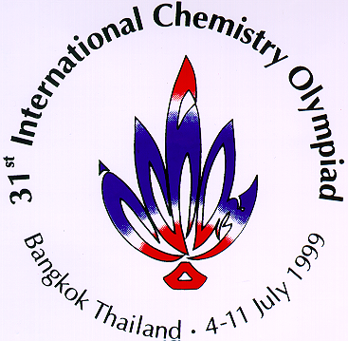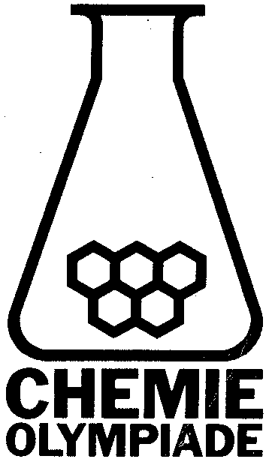

**This test has 40 questions divided over 11 problems.**

**The maximum score for this test is 120 points.**

**The maximum time to do this test is 4 hours.**

**Needed accessories: calculator.**

**Binas may not be used. Attachments: aminoacids, spectra, periodic system, formulas**

**Per problem the amount of points are listed that a correct answer will give.**

1. (2+2+2+2 = 8 points)

Product **I**, (E)-2-benzylidene-4,4-dimethyl-3-pentanone, is the condensation product of benzaldehyde (fenylmethanal) and 4,4-dimethyl-3-pentanone.

1. Give the structural formula of benzaldehyde and 4,4-dimethyl-3-pentanone.

During the formation of **I** a side product **II** with the same molecular mass is formed.

1. Give the structure and name of **II**.

The formation of **I** and **II** from benzaldehyde and 4,4-dimethyl-3-pentanon proceeds in two steps. First the base catalysed addition of benzaldehyde to 4,4-dimethyl-3-pentanon, followed by the elimination of water.

1. Give the structural formula in Fischer projection of all possible products formed during the first step.
2. Which two end products are to be expected if 4,4-dimethyl-3-pentanon is replaced by menthone **III**?



1. (2+2+2+2+2+2 = 12 points)

For many years now Philips has sold many fluorescence lamps like the well known Tl-lighting and low energy lamps. In these fluorescence lamps light is made by creating a gas discharge in the closed off discharge tube that is filled with mercury gas. It has been found that the efficiency of the light is optimal when the mercury pressure (*p*Hg) in the discharge tube is between 1 and 4 Pa. To realise this mercury pressure a droplet of mercury is placed in the discharge tube of the Tl-lighting.

For mercury the following is known:

the following formula describes the change of the Gibbs energy per mole Hg for the evaporation of liquid mercury (Hg(l) → Hg(g)):



where

61,5⋅103 J/mole

*p*° = 1 bar = 105 Pa

*R* = 8,314 J/mole K

It is also known that at standard pressure (1 bar) liquid mercury boils at 357°C (630K) and melts at −39°C.

1. Calculate with the information mentioned above , the evaporation entropy of liquid Hg per mole Hg at 1 bar.
2. Calculate the desired temperature interval where a droplet of mercury in a Tl-lighting has an optimal light efficiency. Also calculate the mercury pressure in the discharge tube at 25°C. Assume equilibrium between gaseous and liquid mercury.

Because the internal temperature of a compact fluorescence lamp (low energy lamp) is higher than that of Tl-lighting, not pure mercury, but a solution of mercury in another metal like indium (In) is used for low energy lamps. The following is known about dissolving Hg in liquid indium:

the following formula describes the change of the Gibbs energy per mole Hg for dissolving liquid mercury in liquid indium (Hg(l) → Hg(In)(l)):



where

−9,0⋅103 J/mole

and *χ*Hg is the molar fraction of Hg in the liquid In-Hg alloy.

1. Formulate an equation for the change of the Gibbs energy per mole Hg for the evaporation of liquid mercury out of a liquid In-Hg alloy with molar fraction Hg equal to *χ*Hg (Hg(In)(l) → Hg(g)).
2. Calculate the desired temperature interval of a liquid In-Hg alloy with χHg*=*0,03 so that the light efficiency is optimal, assuming equilibrium between gaseous mercury and mercury in the alloy. Also calculate the mercury pressure in the discharge tube at 25°C assuming that this In-Hg alloy does not freeze at this temperature.

In practice the In-Hg alloy freezes just below the melting point of pure indium that is 156°C. Then Hg dissolves in the crystal lattice of indium. It is known that the interaction-energy of Hg with In in the solid lattice is virtually the same as in the liquid alloy.

1. Explain if the mercury pressure at 25°C of the solid alloy is higher or lower than that of the “theoretical” liquid alloy.
2. Why are mercury alloys that freeze at temperatures just below the operational temperature of the light always used in practice?
3. (2+3+2 = 7 points)

Benzoquinone is a very good dienophile in the Diels-Alder reaction.

1. Give the structural formula of the product **A** that is created during the reaction of 1 mole benzoquinone with 1 mole 1,3-butadieen.

During the reaction of 2 moles 1,3-butadieen with 1 mole benzoquinone more products are created (think of stereoisomers).

1. Give the spatial structural formulas of these products.

If product **A** is treated with diluted acid or base, isomerisation to **B** takes place. In the infrared spectrum of product **A** there is a clear signal present around 1700 cm‑1 that isn’t present in the spectrum of **B**. In the spectrum of **B** a new absorption is visible at 3500 cm−1.

1. Give the structural formula of isomer **B.**



benzoquinone butadiene

1. (4+4+3 = 11 points)

One of the materials which are researched at the natlab (Philips' physical laboratory) is a special class of conjugated polymers, namely light-emitting polymers. Unlike the bulk polymers like polyethene these polymers are produced in small quantities and much research is done to try to improve these materials with modifications.



During the synthesis of these light-emitting materials various sulphur compounds are used. One of which is a sulfoxide. The characteristics of the sulfoxide group look a lot like a carbonyl group. But no keto-enol tautomerism is possible when the compound contains -hydrogen atoms like carbonyl compounds do.

A model compound of the light-emitting polymers can be synthesised in the following way.

A sulfoxide compound reacts with a base to intermediary **A**. This intermediary reacts with 4-methylbenzylchloride to compound **B**. With a thermal treatment this compound can be converted into the isomeric compounds **C** and **D**. During this thermal treatment a sulphur compound is released.



1. Fill in the missing intermediaries (**A**, **B**, **C** and **D**).

Compounds **C** and **D** are present as (monomer)links in the light-emitting polymer that could be used for example in displays.

There are two possible ways to make this polymer according to the above mentioned reaction.

1. Give the structural formulas of the reactants for both possibilities and give the spatial structural formulas of the light-emitting polymer.
2. Compare the polymers before and after the thermal treatment like they are created according to these two possibilities.
3. (4+8+4+3+3 = 22 points)

In a so called Li-ion battery Li+ ions are transported between the positive and the negative electrode. During this process Li+ is built in the crystalline lattice of both electrode materials, a process called intercalation.

In the current Li-ion batteries graphite and lithium cobaltate are used. The involved half reactions are:

C6 + Li+ + e-  LiC6 (1)

Li0,5CoO2 + 0,5 Li+ + 0,5 e-  LiCoO2 (2)

This problem is concerned with the energy content, that should be as high as possible, of this type of batteries, and of a similar type. In the following table necessary information is listed.

|  |  |  |  |  |
| --- | --- | --- | --- | --- |
| material | Δ*G*f (kJ mol−1) |  | element | molar mass |
| Li0,5CoO2 | −424 |  | Li | 6,939 |
| Li1,0CoO2 | −614 |  | O | 15,999 |
| LiC6 | −4 |  | Co | 58,933 |
|  |  |  | C | 12,011 |

Avogadro’s constant, *N*A = 6,022⋅1023 mole−1.

Faraday’s constant, *F* = 9,6485⋅104 C mole−1.

1. Give the equation of the reaction during the discharging of the battery. Calculate the battery potential.

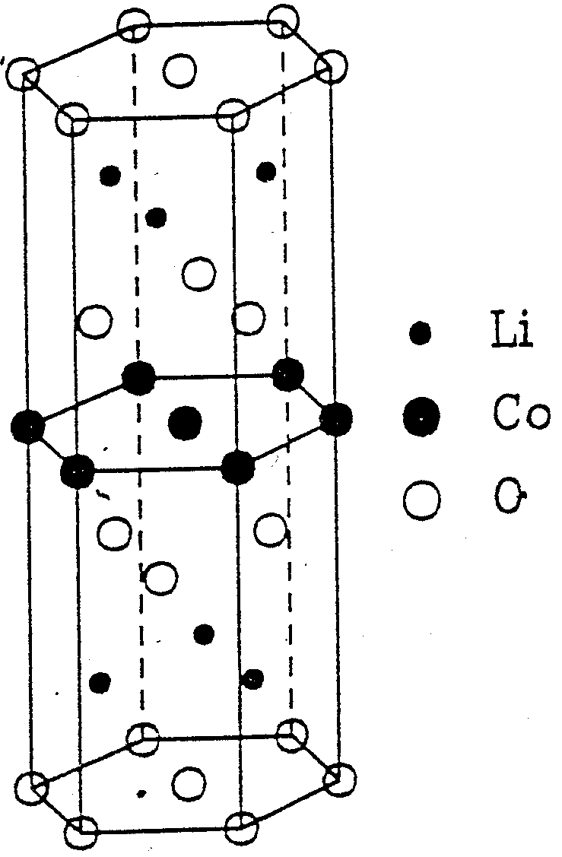

The structure of lithium cobaltate is derived from a close-packed structures of O2− ions. Li and Co occupy the octahedral holes, and form an alternating layer structure. Part of the LiCoO2 lattice (not the unit cell) is shown in the figure. The unit cell itself has the dimensions *a* = 2,82 Å, *c* = 13,98 Å.

1. Calculate the density of lithium cobaltate.

A manufacturer supplies batteries that consist of 1,0 cm3 graphite (density = 2,25 g cm−3) and 1,35 cm3 LiCoO2.

1. Calculate the total energy (kJ) that the battery can supply. Use ρ(LiCoO2) = 4,8 g cm−3 if you didn’t answer question 18.

To make the batteries smaller and lighter, the possibility is considered to replace graphite with metallic lithium. In a test 0,50 cm3 Li is used to try this. Li has a *bcc*-structure. The cell constant *a* = 3,51 Å.

1. Calculate the density of Li metal.
2. Calculate the total energy this battery can supply.
3. (3+4+3+4 = 14 points)

Simple boron- and aluminium compounds are electron deficient. This term reveals that the central B/Al atom does not have a octahedral surrounding. BF3 has a planar trigonal structure, with sp2 hybridised orbitals.

Some other compounds, such as BH3, AlCl3 and Al(CH3)3, have a different structure. Dimerisation occurs, and for example B2H6 is formed. In this case two H-atoms function as a bridge between the boron atoms. Boron then has a tetrahedral surrounding, and the orbitals are sp3 hybridised. Below two resonance structures of B2H6 are shown.



1. Give the "average" resonance structure. Give the bond order of the central B-H-B bridge. Draw a spatial structural formula of B2H6.

It is also possible to describe the B-H-B bridge with the M.O. theory. The other two H-atoms do not participate in the formation of this bond. They do not need to be drawn in the following questions.

1. Draw the possible ways the orbitals of B and H can overlap in the B–H–B bridge. Give the corresponding M.O. diagram.
2. How many electrons participate in the B-H-B bridge? Fill these in in the M.O. diagram from question 23. Show that the bond order is the same as in question 22.

In other molecules and ions so called ‘three-center’ molecular orbitals are also formed. An example is HF2−, or [F-H-F]−. Here 2s electrons from the fluoride-ions participate in the bond.

1. Give the M.O. diagram of [F-H-F]−, and complete this by filling in the valence electrons. Give the bond order.
2. (7 points)

The reaction 2 CrO42− + 2 H+  Cr2O72− + H2O has an equilibrium constant of 4,2⋅1014

The molar absorption coefficients  for the two main components in a solution of K2Cr2O7 in water are:

|  |  |  |
| --- | --- | --- |
| ● | Cr− | (Cr2O72−) |
| nm |  | |
|      | ⋅  ⋅  ⋅ | ⋅  ⋅  ⋅ |

⋅− mole  K2Cr2O7 is dissolved in water, diluted to 1,00 L and buffered at pH = 5,60.

1. Calculate according to the law of Lambert-Beer the absorption of the solution in a cell with a length of 1,00 cm at the three given wavelengths.
2. (2+2+4 = 8 points)

The compound 2,4-dinitrofluorbenzene reacts easily with nucleophilic compounds such as amines.

1. Give the structural formula of the product that is created during the reaction of a excess butylamine and 2,4-dinitrofluorobenzene
2. Explain how the nitro groups influence this reaction. Is the reactivity of 3,5-dinitrofluorobenzene greater than, smaller than or equal to that of 2,4-dinitrofluorobenzene? Explain your answer.

Eisenine is a modified tripeptide. Analysis has shown that it contains only one free carboxylic acid and does *not* react with 2,4-dinitrofluorobenzene. Complete hydrolysis of 1 mole eisenine results in the formation of 2 moles L-glutamic acid, 1 mole L-alanine and 1 mole ammoniac. L-alanine is the *C*-*terminal* aminoacid of eisenine.

1. Give the structural formula of eisenine that corresponds with these facts.

(the structural formulas of the important aminoacids is shown in the attachment)

1. (2+2+2 = 6 points)



D-glucose is a naturally abundant sugar. It is one of the many stereoisomers of 2,3,4,5,6-pentahydroxyhexanal with gross formula C6H12O6. Dissolved in water D-glucose is present in various cyclic structures and in an open form. The figure shows the Haworth projection of one of the possible cyclic structures.

In the presence of a base D-glucose can be converted into other sugars.

1. Give the Fischer projections of the two carbohydrates, in the open structure, that are formed first during the reaction of a solution of D-glucose in water with a base.

D-glucose is reduced by NaBH4 to D-glucitol.

1. Which characteristic group in D-glucose is then transformed?

D-glucitol is treated with an excess perjodate.

1. Give the structural formulas of the products formed during this reaction.
2. (1+3+2+2+2+2+3 = 15 points)

The following components are separated by gas-liquidchromatography. A 40 cm long packed column is used. The volume of the stationary fase of this packed column is 19,6 mL and that of the mobile fase 62,6 mL.

|  |  |  |
| --- | --- | --- |
| Component | *t*R, min | *W*, min |
| air (not delayed)  methylcyclohexane  methylcyclohexene  toluene | 1,9  10  10,9  13,4 | −  0,76  0,82  1,06 |

1. Calculate the flow speed of the gas in cm3 s−1
2. Calculate the average number of plates and the average plate distance.
3. Calculate the resolution of the separation of:

* methylcyclohexene and methylcyclohexane
* methylcyclohexene and toluene

1. Calculate the capacity factor for the three components.
2. Calculate the distribution factor for the three components.
3. Calculate the selectivity factor for:

* methylcyclohexene and methylcyclohexane
* methylcyclohexene and toluene

The resolution of the separation of methylcyclohexene and methylcyclohexane is too low.

1. How long must the column be to achieve a resolution of 1,5? Assume that the capacity and selectivity factors don’t change.
2. (10 points)

The UV, IR, MS, 1H-NMR and 13C-NMR spectra of a compound with empirical molecular formula C8H7OCl are shown below.

1. Give the structural formula of this compound. For every spectrum give the conclusion(s) you can draw from it.

## Chromatography formulas

|  |  |  |
| --- | --- | --- |
|  |  |  |
|  |  |  |

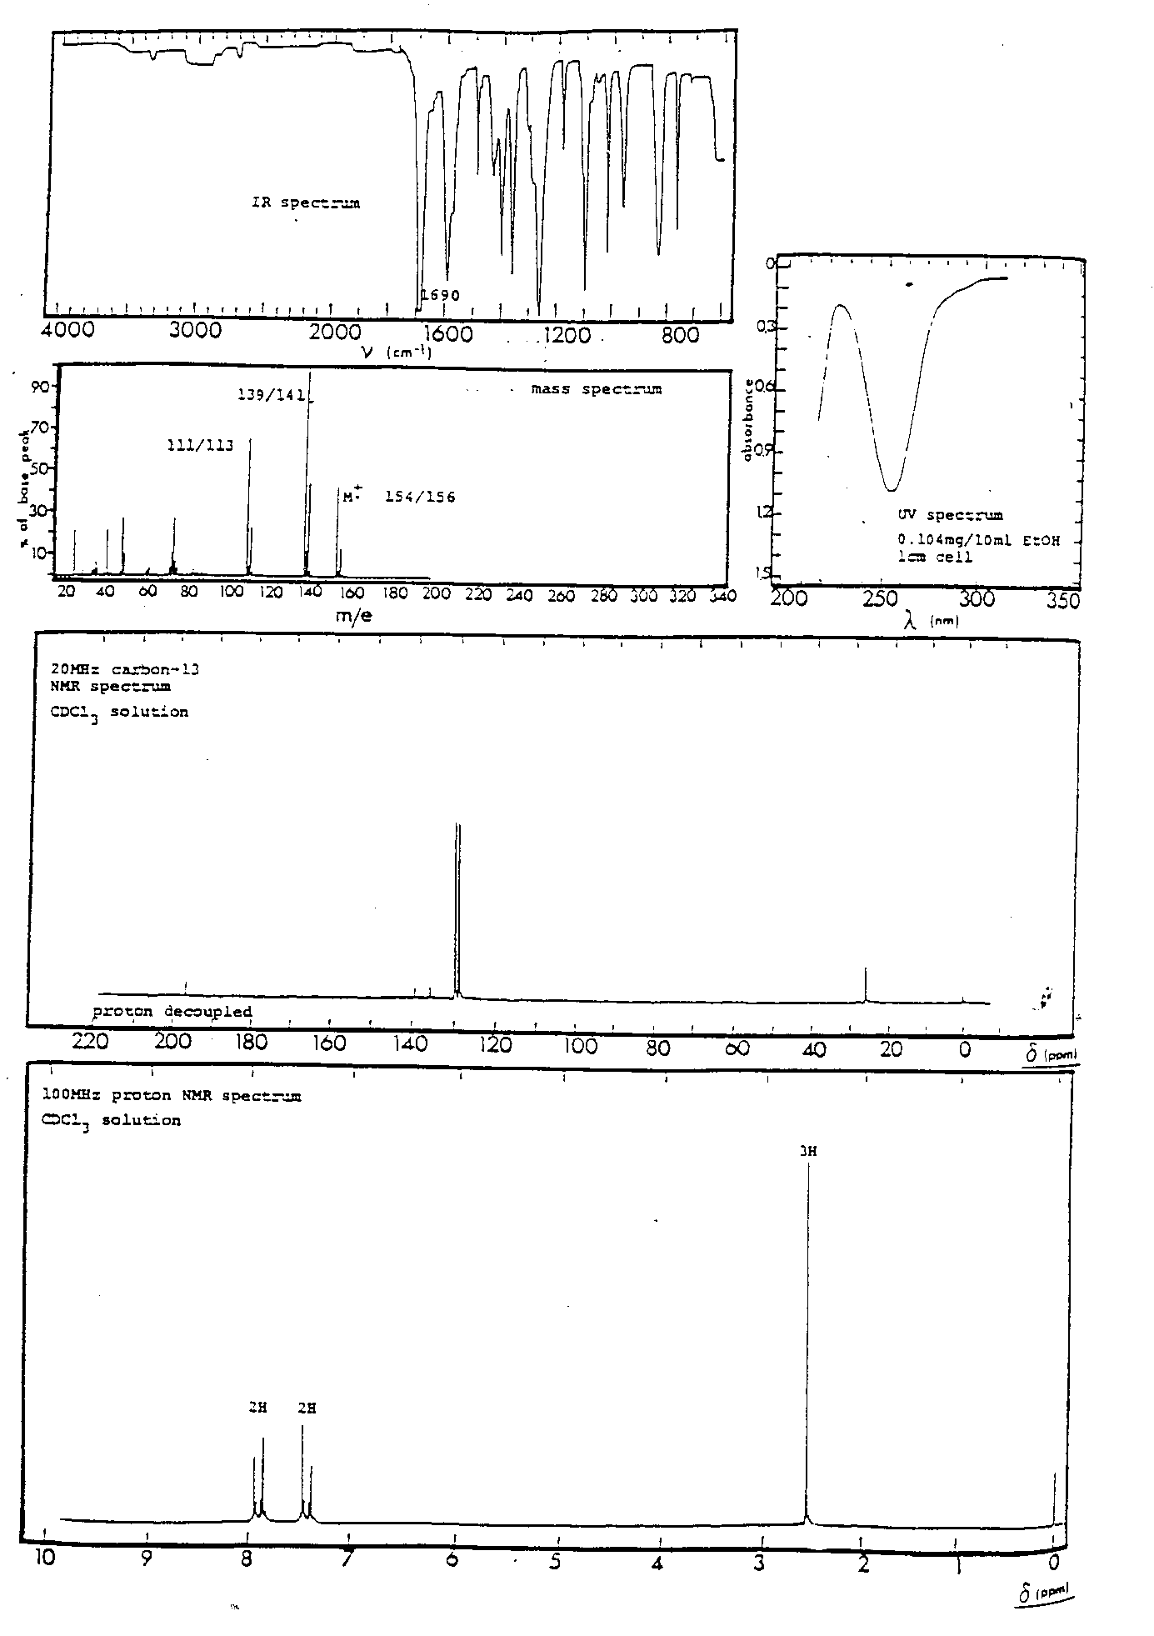

# 20e NATIONAL CHEMISTRY OLYMPIAD

##### FINAL TEST PRACTICUM

**Wednesday 9 June 1999, 13.30 – 17.30 u**

**Philips Research & Philips CFT**

**Eindhoven**

**This practical exam consists out of two parts: a synthesis and an analysis**

**For both parts, including answering the answer sheets you get two hours.**

**The maximum score per part is 20 points: so the maximum overall score is 40 points.**

**We mark too for skill in practising.**

**Overhand the answer sheets and the product of synthesis to the assistant in time.**

# Practical test synthesis

## Synthesis of a liquid crystal

Organic molecules with a long and narrow shape exhibit an interesting melting behaviour. Upon melting, a special phase is formed which is liquid but in which the molecules are still partially ordered like in crystal phase. For that reason it is called the liquid crystalline phase. Upon heating the liquid crystalline phase will change to a normal liquid phase in which the molecules are not ordered. The optical and electrical properties of these molecules in the liquid crystalline phase makes them suitable to make displays such as those found in watches, game boys, laptop computers and even telivision sets.

In this experiment the liquid crystal N-4-tolyl 4-hexyloxybenzaldimine will be synthesised and the transition temperatures from the crystalline to the liquid crystalline phase and from the liquid crystalline phase to the normal liquid phase will be determined.



### Synthetic procedure

Mix in a reaction tube 0.27 gram of 4-methylaminobenzene, 0.51 gram of 4-hexyloxybenzaldehyde, 5 mL of ethanol and 2 drops of glacial acetic acid. Heat the tube carefully in the flame for about one minute (be careful of bumping). Leave the tube for 10 minutes. Put the tube in a beaker with tap water. The crystals will grow in about 10 to 15 minutes. Filter the crystals off. Dry them on the filter by continuous suction for about 5 minutes. Weigh the product, and calculate the reaction yield. Bring the product in a screw tube and put your name on the tube.

### Determination of the melting point and transition from the liquid crystalline phase to the normal liquid phase.

The optical properties of crystals or liquid crystal phases are such that brought between crossed polarisers, light will pass the polarisers. In this way the melting point can be obtained. Light will not pass crossed polarisers when a normal liquid phaseis brought between polarisers. Thus, if the image becomes black, the normal crystal phase is formed.

Determine the melting point and the transition to the normal crystal phase in the polarising microscope. The heating element will be heating from 40°C to 80 °C at a rate of 10 °C per minute. Determine also the transition from the normal liquid phase to the liquid crystalline phase by cooling the heating element.

Hand over the product and a form containing:

* The reaction diagram
* The reaction yield
* The melting point
* The transition from the liquid crystalline phase to the liquid phase and
* The transition from the liquid phase to the liquid crystalline phase.

# Practical synthesis, answer sheet

# Name:

### Equation of the synthesis in structural formulas

### Yield and calculation

Mole %

Computation

### Melting point

°C

### The transition temperature from the liquid crystalline phase to the liquid phase

°C

### The transition temperature from the liquid phase to the liquid crystalline phase

°C

# Practical test analysis

## Determination of the ozon concentration in an oxygen flow

### Background.

At Philips Research is ozone (O3) an often applied means for thoroughly cleaning of surfaces. Ozone is very suited for oxidising in a clean way minor organic rests, adsorbed at surfaces, to remove them. So run several processes for the deposition of thin layers on these surfaces much smoother. Think especially of those processes by which one makes integrated circuits (IC-technology; chips).

Ozone has prepared by leading an oxygen flow through a so-called ozoniser. Through intensive radiation with UV light a small part of oxygen becomes ozone. After ozonisation oxygen contains some tens of percents O3, very suited for the cleaning in question.

### Procedure

Determine the O3 content in an oxygen flow after leaving an ozoniser by absorption of O3 in a solution of KI by which I2 is formed. The formed I2 is determined by a titration with a standardised solution of sodium thiosulphate.

The followed procedure of analysis is given below. The test consists out of a number of parts that are indicated clearly. Note the result of each part on the delivered answer sheet.

### Principle

In the figure is schematically indicated how the gas flow is streaming and how the absorption of ozone finds place.

ozonisator.wmf

Ozone is absorbed in a neutral solution of potassium iodide (KI) and, under conversion of O3 to O2, I2 is formed.

1. Give the equations of the reactions of ozone with the KI-solution and that of the formed iodine with the thiosulphate solution.

#### Calculation in advance

De bepaling wordt in tweevoud uitgevoerd. Hiertoe worden gelijke gasstromen simultaan door twee absorptievaatjes geleid (zie figuur). Beide absorptievloeistoffen worden daarna op identieke wijze getitreerd met een 0,01 M thiosulfaatoplossing.

De stroomsnelheid van zuurstof door beide absorptievaatjes afzonderlijk bedraagt ca 250 mL/min. De verwachte ozonconcentratie bedraagt ca 0,1 % (v/v), dus ca 1 mL O3 per liter zuurstof. Bij de titratie moet ca 10 mL thiosulfaatoplossing gebruikt worden.

1. Bereken hoeveel absorptietijd er ongeveer nodig is. Geef dit resultaat door aan de assistent bij de ozonabsorptie. (kamer WB 719)

#### Analyseprocedure

##### Absorptie ozon

Breng in elk van de twee absorptievaatjes een afgewogen hoeveelheid KI van ca 1 g. Voeg aan elk vaatje 50 mL demiwater toe m.b.v. een maatcylinder. Sluit de vaatjes af met het gasdoorleidgedeelte. Let er daarbij op dat vaatje A afgesloten wordt met stop A en vaatje B met stop B.

Sluit de slangen van de pomp (zie figuur) aan op de vaatjes. Let daarbij goed op de juiste aansluiting (richting gasflow!). Controleer de werking van de pomp door deze even aan te zetten. Laat de assistent de juiste flow (stroomsnelheid) instellen en zet daarna de pomp weer uit.

Sluit beide absorptievaatjes aan op het gasbuffervat (zie figuur). Voer, met de pomp nog uitgeschakeld, een meting uit van de gasflow van zuurstof die het buffervat verlaat. Gebruik hiervoor de zeepvliesflowmeter (zie figuur). Voer deze meting in duplo uit.

1. Noteer deze gasflow op het antwoordformulier als flow A (in mL/min.)

Start tegelijkertijd de pomp voor de gasabsorptie en de stopwatch voor het meten van de absorptietijd. Na ca 1 minuut wordt opnieuw de gasflow gemeten met de zeepvliesflowmeter. Voer deze meting in duplo uit. Let er op dat deze metingen binnen de totale absorptietijd moeten gebeuren!

1. Noteer deze gasflow op het antwoordformulier als flow B (in mL/min)

Schakel aan het eind van de absorptietijd de pomp uit.

##### Titratie van het gevormde I2

Breng de inhoud van elk absorptievaatje kwantitatief over in een erlenmeyer met ingeslepen stop. Gebruik daarbij een speciaal door de assistent verstrekt spuitflesje om de vloeistof uit het glasfritje van het absorptievaatje te verwijderen.

Vul een buret met een oplossing van 0,01 mol/L thiosulfaat.

Voeg 1 mL 2 M HCl-oplossing aan de erlenmeyer toe. Titreer met thiosulfaatoplossing tot kleurloos. Voeg aan het eind van de titratie enkele druppels zetmeel(stijfsel)oplossing toe en titreer tot de donkere kleur geheel is verdwenen.

1. Voer deze bepaling uit voor beide absorptievloeistoffen en noteer het resultaat op het antwoordformulier.

#### Berekening

Ga bij de berekeningen ervan uit dat de gassen zich als ideale gassen gedragen en neem een temperatuur aan van 20 oC en een druk van 1 atm (1,013⋅105Pa). Het molaire volume bij 273 K en 1 atm bedraagt 22,4 L/Mol.

1. Bereken voor beide absorptieexperimenten het gehalte ozon in de zuurstofstroom. Druk dit gehalte uit zowel in mg O3 per liter zuurstof als in volume %. Ga bij deze berekening ervan uit dat de gasflow door de absorptievaatjes (flow A-B) gelijk verdeeld is over beide vaatjes.
2. Bereken ook het ozongehalte uitgaande van de som van de titraties voor beide absorptievaatjes tezamen.

# Practicumtoets analyse, antwoordblad

# Naam:

1. Reactievergelijking van ozon met de KI-oplossing

Reactievergelijking van het gevormde jood met de thiosulfaatoplossing

1. Berekening van de benodigde absorptietijd

min

Berekening

1. Gasflow A

mL/min

1. Gasflow B

mL/min

1. Titratiegegevens

|  |  |  |
| --- | --- | --- |
|  | Absorptievloeistof 1 | Absorptievloeistof 2 |
| Eindstand buret | mL | mL |
| Beginstand buret | mL | mL |
| Verbruik | mL | mL |

1. Ozongehalte in de zuurstofstroom

|  |  |
| --- | --- |
| eerste bepaling | tweede bepaling |
| mg O3 per L O2 | mg O3 per L O2 |
| volume %. | volume %. |

Berekening

1. Ozongehalte uitgaande van de som van de titraties voor beide absorptievaatjes tezamen

vol%

Berekening