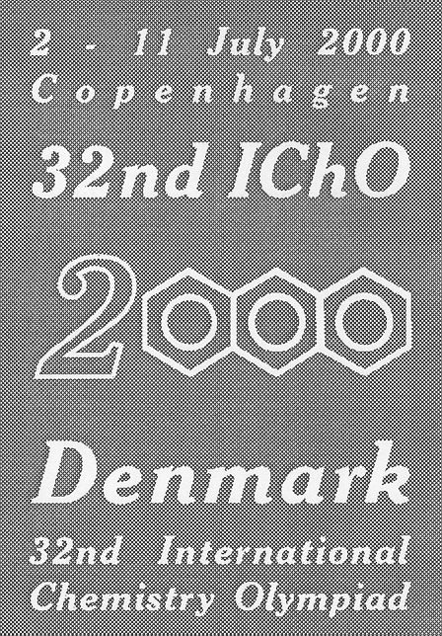

# 32nd International Chemistry Olympiad

# Copenhagen, Thursday, 6 July 2000

# Theoretical Examination

# Synthesis of Compounds with Wound Healing Properties

Shikonin is a red compound found in the roots of the plant *Lithospermum erythrorhizon*  whichgrowsin Asia. Extracts of the root have been used for centuries in folk medicine and are used today in ointments for healing of wounds.



|  |  |
| --- | --- |
| **1-1** How many stereoisomers of Shikonin are possible ? |  |

|  |  |  |
| --- | --- | --- |
| **1-2** Do all stereoisomers of Shikonin have the same melting point ? | yes | no |
| Mark with an X. |  |  |

The following sequence is part of a synthetic route to Shikonin:



|  |  |
| --- | --- |
| **1-3** Draw the structural formula of reagent **A**. |  |

**1-4** Indicate (by means of an X in the appropriate check-box) the correct IUPAC name for reagent **A**.

2-Methyl-2-pentenoyl chloride

1-Chloro-4-methyl-3-pentene

4-Methyl-3-pentenoyl chloride

4-Methyl-3-pentene-1-ol

4,4-Dimethyl-3-butenoyl chloride

|  |  |
| --- | --- |
| **1-5** Write the molecular formula of reagent **C**. |  |

Numerous Shikonin analogues have been synthesized with a view to obtaining more potent compounds. One reaction sequence is shown below:

1-6

|  |  |
| --- | --- |
| **1-6** Draw the structural formula of compound **E**. |  |

|  |  |
| --- | --- |
| **1-7** How many stereoisomers of compound **E,** if any, are possible |  |

Another route to useful Shikonin analogues is the following:

1-7W

|  |  |
| --- | --- |
| **1-8** Draw the structural formula of compound **F**. |  |

|  |  |
| --- | --- |
| **1-9** Draw the structural formula of compound **G**. |  |

# Bridge between Denmark and Sweden



On July 1, 2000, the combined tunnel and bridge connecting Denmark and Sweden was officially opened. It consists of a tunnel from Copenhagen to an artificial island, and a bridge from the island to Malmö in Sweden. The major construction materials employed are concrete and steel. This problem deals with chemical reactions relating to production and degradation of such materials.

Concrete is produced from a mixture of cement, water, sand and small stones. Cement consists primarily of calcium silicates and calcium aluminates formed by heating and grinding of clay and limestone. In the later steps of cement production a small amount of gypsum, CaSO4∙2H2O, is added to improve subsequent hardening of the concrete. The use of elevated temperatures during the final production may lead to formation of unwanted hemihydrate, CaSO4∙½H2O. Consider the following reaction:

CaSO4∙2H2O(s) → CaSO4∙½H2O(s) + 1½H2O(g)

The following thermodynamic data apply at 25 °C, standard pressure: 1.00 bar:

|  |  |  |
| --- | --- | --- |
| Compound | *H*/(kJ mol–1) (*ΔHf*) | *S*/(J K–1 mol–1) |
| CaSO4∙2H2O(s) | –2021.0 | 194.0 |
| CaSO4∙½H2O(s) | –1575.0 | 130.5 |
| H2O(g) | –241.8 | 188.6 |

Gas constant: *R*  = 8.314 J mol–1 K–1 = 0.08314 L bar mol–1 K–1

0 °C = 273.15 K.

1. Calculate Δ*H* (in kJ) for transformation of 1.00 kg of CaSO4∙2H2O(s) to CaSO4∙½H2O(s). Is this reaction endothermic or is it exothermic?

|  |
| --- |
| Mark with an X.: Endothermic  Exothermic |

1. Calculate the equilibrium pressure (in bar) of water vapour in a closed vessel containing CaSO4∙2H2O(s), CaSO4∙½H2O(s) and H2O(g) at 25 °C.

|  |
| --- |
|  |

1. Calculate the temperature at which the equilibrium water vapour pressure is 1.00 bar in the system described in problem 2-2. Assume that Δ*H* and Δ*S* are temperature independent.

|  |
| --- |
|  |

Corrosion of metals is associated with electrochemical reactions. This also applies for the formation of rust on iron surfaces, where the initial electrode reactions usually are:

(1) Fe(s) → Fe2+(aq) + 2e–

(2) O2(g) + 2H2O(l) + 4e– → 4OH–(aq)

An electrochemical cell in which these electrode reactions take place is constructed. The temperature is 25 ºC. The cell is represented by the following cell diagram:

Fe(s) ⏐ Fe2+(aq) ⏐⏐ OH–(aq), O2(g) ⏐ Pt(s)

Standard electrode potentials (at 25 ºC):

Fe2+(aq) + 2e– → Fe(s) *E* = – 0.44 V

O2(g) + 2H2O(l) + 4e– → 4OH–(aq) *E* = 0.40 V

Nernst factor: *R T* ln10 / *F* = 0.05916 volt (at 25 ºC)

Faraday constant: *F*  = 96485 C mol–1

1. Calculate the standard electromotive force (the standard cell voltage), *E*,   
   at 25 ºC.

|  |
| --- |
|  |

1. Write down the overall reaction which takes place during discharge of the cell under standard conditions.

|  |
| --- |
|  |

1. Calculate the equilibrium constant at 25 °C for the overall cell reaction.

|  |
| --- |
|  |

1. The overall reaction referred to above is allowed to proceed for 24 hours under standard conditions and at a constant current of 0.12 A. Calculate the mass of Fe converted to Fe2+ after 24 hours. Oxygen and water may be assumed to be present in excess.

|  |
| --- |
|  |

1. Calculate *E* for the cell at 25 °C for the following conditions:  
   [Fe2+] = 0.015 m, pHright-hand half-cell = 9.00, *p*(O2) = 0.700 bar.

|  |
| --- |
|  |

# Bioinorganic Chemistry

The square planar complex *cis*-diamminedichloroplatinum(II) is an important drug for the treatment of certain cancers.

1. Draw the structures of *cis*- and *trans*-diamminedichloroplatinum(II) and label each structure as *cis* or *trans*.

A number of ionic compounds are also compatible with the empirical formula Pt(NH3)2Cl2.

1. Write precise molecular formulas for all possible ionic compounds which comply with the following conditions: each compound has 1) empirical formula Pt(NH3)2Cl2, 2) is composed of discrete, monomeric ionic platinum(II) complex entities, and 3) contains only one type of cation and one type of anion. The answer must clearly reveal the composition of each discrete platinum(II) complex entity in each compound.
2. How many 5d electrons does the platinum(II) ion have?

The valence d-orbital energy splitting diagram for a square planar complex can be regarded as being derived from that for an octahedral complex in which the metal-ligand interactions due to the two ligands coordinated along the *z* axis vanish, while the bonds to the four remaining ligands (coordinated along the *x* and *y* axes) become stronger.

1. Which of the five 5d orbitals attain the highest energy (*i.e.* is the least likely to be occupied by electrons) in the general case of a square-planar Pt(II) complex?

Serum transferrin (abbreviated: Tf) is a monomeric protein whose main function in the human body is the transport of iron(III). Each transferrin molecule can bind up to two iron(III) ions with stepwise overall binding constants *K*1 and *K*2 at biological conditions (but at 25 °C) corresponding to the overall reactions:

FeIII + Tf  (FeIII)Tf *K*1 = 4.7  1020 M1

FeIII + (FeIII)Tf  (FeIII)2Tf *K*2 = 2.4  1019 M1

In the diferric protein, (FeIII)2Tf, the two iron(III) ions are bound at two similar, but non-identical sites, and the two possible monoferric protein products, (FeIII)Tf, can be denoted {FeIII.Tf} and {Tf.FeIII}. Their relative abundance at equilibrium is given by the constant *K* = [{Tf.FeIII}][{FeIII.Tf}]1 = 5.9.

1. Calculate the values of the two constants *K*1= [{FeIII.Tf}][FeIII]1[Tf]1 and *K*1= [{Tf.FeIII}][FeIII]1[Tf]1 , respectively, corresponding to the formation of each monoferric form of transferrin.

|  |
| --- |
|  |
|  |

1. Calculate the values of the two constants *K*2= [(FeIII)2Tf][FeIII]1[{FeIII.Tf}]1 and *K*2= [(FeIII)2Tf][FeIII]1[{Tf.FeIII}]1 respectively, corresponding to the formation of diferric transferrin from each of the monoferric forms

|  |
| --- |
|  |
|  |

The bound iron(III) ion at each binding site is surrounded by six donor atoms from various ligands. Thus, two oxygen atoms of a carbonate anion coordinate to the metal, and the following amino acid side chains from the protein primary structure also coordinate to the iron(III) ion with one potential donor atom each: one aspartate, one histidine and two tyrosine residues.

1. What is the total number of oxygen donor atoms that surround a 6-coordinate iron(III) ion in transferrin?

|  |
| --- |
|  |

# A naturally occurring compound

A naturally occurring compound **A** containing only C, H and O has the following elemental composition, percentage mass,

C: 63.2 %, H: 5.3%, O: 31.5%.

1. Derive the empirical formula of compound **A**.

|  |
| --- |
|  |

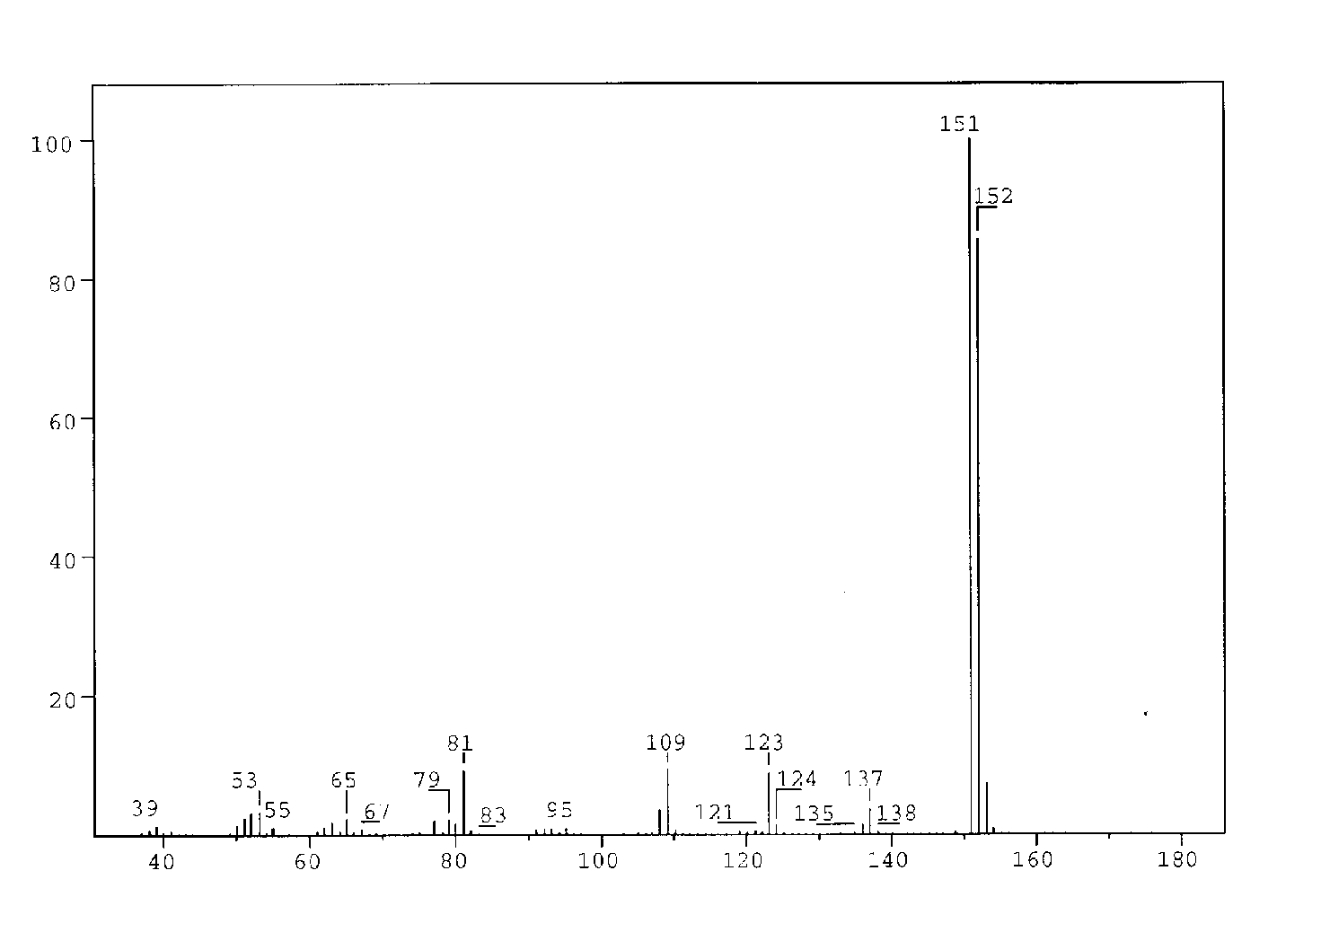

Figure 1

The mass spectrum of compound **A** is shown in Figure 1.

What is the molecular formula for compound **A**?

|  |
| --- |
|  |

A solution of **A** in ether is shaken with an aqueous solution of NaOH. After this, no **A** remains in the ether phase.

Another solution of **A** in ether is shaken with an aqueous solution of NaHCO3. **A** remains in the ether phase.

1. Which of the following classes of compounds does **A** belong to according to these experiments? Mark with an X.

alcohol  phenol  aldehyde  ketone

acid  ester  ether

Compound **A** gave rise to formation of a silver mirror with Tollens’ reagent (Ag(NH3)2+).

1. Which of the following functional groups does this indicate the presence of in **A**?  
   Mark with an X.

hydroxy group of an alcohol  hydroxy group of a phenol

carbonyl group of an aldehyde carbonyl group of a ketone

carboxylic group  ester group

alkoxy group of an ether

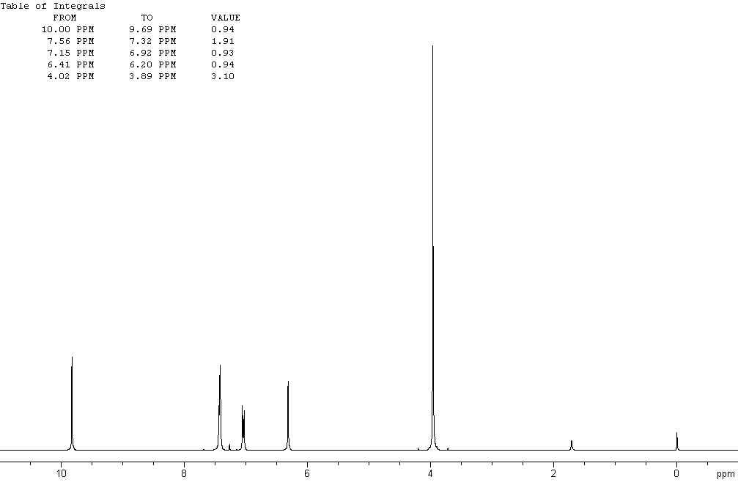

## Figure 2a

The 1H NMR spectrum of compound **A** recorded at 300 MHz is shown in Figure 2a (solvent CDCl3 (7.27 ppm), referencetetramethylsilane). The signals at 3.9, 6.3 and 9.8 ppm are singlets. Figure 2b is an expansion of the region 6.9 –7.6 ppm.

Selected chemical shift and coupling constant values are given in Table 1.

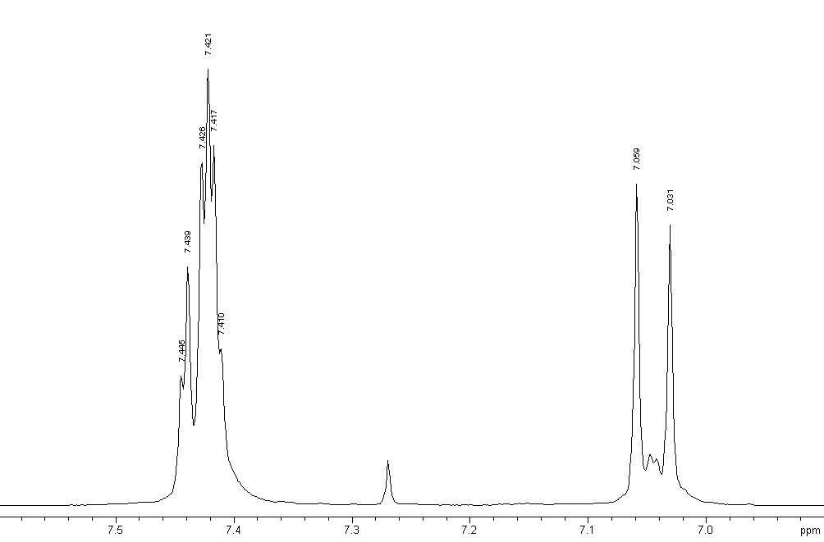

### Figure 2b

The signal at 6.3 ppm disappears when a drop of D2O is added.

1. Which of the following does this indicate? Mark with an X.

Exchange of carbon-bonded hydrogen

Exchange of oxygen-bonded hydrogen

Dilution effect

Hydrolysis

The same signal moves to a lower ppm value upon dilution with CDCl3.

1. Which of the following does this indicate?  
   Indicate the true statements (more than one).

Increased hydrogen bonding

Decrease in hydrogen bonding

Intermolecular hydrogen bonding

Intramolecular hydrogen bonding

No hydrogen bonding

1. Draw the four possible structural formulas for compound **A** based on the information given above

|  |  |  |  |
| --- | --- | --- | --- |
|  |  |  |  |

1. Give structural formulas for the fragments lost corresponding to the peaks at 137 and 123 mass units in the mass spectrum.

1. Two of the isomers have a lower p*K*a value than the others.Write the formulas for those.

|  |  |
| --- | --- |
|  |  |

|  |  |  |
| --- | --- | --- |
| **Table 1**  **1H Chemical Shift ** | | |
| **Hydrogens attached to carbon** | | |
| *Methyl* | CH3–C–  CH3–C=O–  CH3–O–R  CH3–OCOR | 0.9 – 1.6 ppm  2.0 – 2.4 ppm  3.3 – 3.8 ppm  3.7 – 4.0 ppm |
| *Methylene* | CH2–C–  CH2–C=O–  CH2–OR  CH2–OCOR | 1.4 – 2.7 ppm  2.2 – 2.9 ppm  3.4 – 4.1 ppm  4.3 – 4.4 ppm |
| *Methine* | CH– | 1.5 – 5.0 ppm  depending on the substituents. Generally  higher than for methyl  and methylene |
| *Alkene* |  | 4.0 - 7.3 ppm  depending on the substituent |
| Aldehyde | R­−CHO | 9.0 – 10.0 ppm |
| **Hydrogens attached to oxygen** | | |
| *Alcohols* | ROH | 0.5 -5.0 ppm |
| *Phenols* | ArOH | 4.0 - 7.0 ppm |
| *Carboxylic acids* | RCOOH | 10.0 - 13.0 ppm |
| **Selected spin-spin coupling constants** | | |
| *Alkanes*  (free notation) | H-C-C-H vicinal | 6 - 8 Hz |
| *Alkenes* | trans  cis  geminal | 11 - 18 Hz  6 - 12 Hz  0 - 3 Hz |
| *Aromates* | ortho  meta  para | 6 - 10 Hz  1 – 4 Hz  0 – 2 Hz |

# Protein and DNA

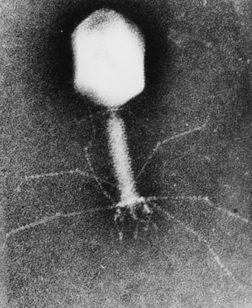

DNA is composed of 2’-deoxy-nucleotides carrying the bases adenine (A), guanine (G), cytosine (C) and thymine (T). The molar mass of the 2’-deoxy-nucleotide-5’-triphosphates is given in table 2:

|  |  |
| --- | --- |
| **Table 2**  **dNTP** | **Molar mass /g mol–1** |
| dATP | 487 |
| dGTP | 503 |
| dCTP | 464 |
| dTTP | 478 |

1. Calculate the molar mass of a double stranded DNA fragment consisting of 1000 base pairs with a uniform distribution of the four bases.

|  |
| --- |
|  |

This DNA fragment can be isolated and cloned by using the PCR method (polymerase chain reaction), in which a heat stable DNA polymerase enzyme multiplies the number of molecules of a specific piece of DNA in a cyclic process. Under optimal conditions the number of double-stranded DNA copies doubles in each cycle.

Using the PCR method you perform 30 cycles starting from a single double stranded DNA molecule.

1. Calculate the approximate mass of the DNA you obtain from this experiment.

|  |
| --- |
|  |

The bacteria-virus T4 enzyme - polynucleotide kinase (PNK) catalyzes the transfer of the terminal phosphate of ATP (-orthophosphate) to the 5'-hydroxyl termini of ribo- and deoxyribonucleotides:



PNK is commonly used to label DNA at the 5’-end with the radioactive phosphorus isotope 32P using ATP in which the -P (the outermost of the phosphorus atoms) is replaced with 32P. The amount of 32P and thus the amount of labelled DNA can be measured.

A 10 µL solution containing double stranded DNA is labelled 100% with [-32P]ATP by PNK. 37 days ago, the specific activity of [-32P]ATP was 10 Ci/mmol or 370 ·109 Bq/mmol. 32P has a half-life of 14.2 days, and during the decay a -particle is emitted. Now the labelled DNA emits 40000 -particles/s.

1. Calculate the concentration of the DNA solution.

|  |
| --- |
|  |

In an experiment in which PNK is incubated with [-32P]ATP and single stranded DNA, the reaction can be monitored by isolating labeled DNA and measuring the -particle emission.

Using this kind of measurements in a 1 mL experimental mixture, a labeling of   
9 nmol DNA/min was calculated. PNK has a catalytic rate constant (turnover number) of 0.05 s–1 and molar mass of 34620 g mol–1.

1. Calculate the concentration (in mg/mL) of PNK in the experimental mixture.

|  |
| --- |
|  |

Aromatic amino acids, tryptophan, tyrosine and phenylalanine absorb UV light of a wavelength between 240 nm and 300 nm.

In a protein containing several aromatic amino acids, the sum of the molar absorptivity per amino acid **amino acid, is approximately equal to the molar absorptivity, **protein , for the protein.

The molar absorptivity, **amino acid, at 280 nm for tyrosine, tryptophan and phenylalanine is 1400 m–1 cm–1, 5600 m–1 cm–1 and 5 m–1 cm–1, respectively. The absorbance of a 10 µm solution of PNK is 0.644 at 280 nm and with 1.00 cm light path. The amino acid sequence of PNK contains 14 tyrosines and 9 phenylalanines.

1. Calculate the number of tryptophan residues in a PNK molecule.

|  |
| --- |
|  |

# Hard Water

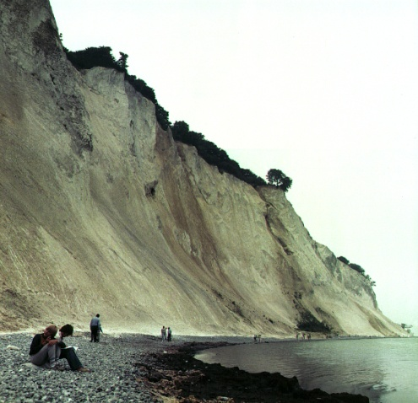

In Denmark the subsoil consists mainly of limestone. In contact with ground water con­taining carbon dioxide some of the calcium carbonate dissolves as calcium hydrogen carbonate. As a result, such ground water is hard, and when used as tap water the high content of calcium hydrogen carbonate causes problems due to precipita­tion of calcium carbonate in, for example, kitchen and bathroom environments.

Carbon dioxide, CO2, is a diprotic acid in aqueous solution. The p*K*a-values at 0 °C are:

CO2(aq) + H2O(l)  HCO3– (aq) + H+(aq) p*K*a1 = 6.630

HCO3– (aq)  CO32– (aq) + H+(aq) p*K*a2 = 10.640

The liquid volume change associated with dissolution of CO2 may be neglected for all of the following problems. The temperature is to be taken as being 0 °C.

1. The total concentration of carbon dioxide in water which is saturated with carbon dioxide at a carbon dioxide partial pressure of 1.00 bar is 0.0752 m.  
   Calculate the volume of carbon dioxide gas which can be dissolved in one litre of water under these conditions.

The gas constant *R*  = 8.314 J mol–1 K–1 = 0.08314 L bar mol–1 K–1

|  |
| --- |
| L |

1. Calculate the equilibrium concentration of hydrog­en ions and the equilibrium concentration of CO2 in water saturated with carbon dioxide at a carbon dioxide partial pressure of 1.00 bar.

|  |
| --- |
|  |

1. Calculate the equilibrium concentration of hydrogen ions in a 0.0100 m aqueous solution of sodium hydro­gen carbonate saturated with carbon dioxide at a carbon dioxide partial pressure of 1.00 bar.

|  |
| --- |
|  |

1. Calculate the equilibrium concentrati­on of hydrogen ions in a 0.0100 m aqueous solution of sodium carbonate saturated with carbon dioxide at a carbon dioxide partial pressure of 1.00 bar. Ignore water dissociation effects.

|  |
| --- |
|  |

1. The solubility of calcium carbonate in water at 0 °C is 0.0012 g per 100 mL of water. Calculate the concentration of calcium ions in a saturated solution of calcium carbonate in water.

|  |
| --- |
|  |

The hard groundwater in Denmark is formed via contact of water with limestone in the subsoil which reacts with carbon dioxide dissolved in the groundwater according to the equilibrium equation:

CaCO3(s) + CO2(aq) + H2O(l)   Ca2+(aq) + 2 HCO3– (aq)

The equilibrium constant, *K*, for this reaction is 10–4.25 m2 at 0 °C.

1. Calculate the concentration of calcium ions in water in equilibrium with calcium carbonate in an atmosphere with a partial pressure of carbon dioxide of 1.00 bar.

|  |
| --- |
|  |

1. A 0.0150 m solution of calcium ­hydroxide is saturated with carbon dioxide gas at a partial pressure of 1.00 bar. Calculate the concentration of calcium ions in the solution by considering the equilibrium equation given above in connection with problem 6-6.

|  |
| --- |
|  |

1. The calcium hydroxide solution referred to in problem 6-7 is diluted to twice the volume with water before saturation with carbon dioxide gas at a partial pressure of 1.00 bar. Calculate the concentration of calcium ions in the resulting solution saturated with CO2.

|  |
| --- |
|  |

1. Calculate the solubility product constant for calcium carbonate from the data given above.

|  |
| --- |
|  |



# 32nd International Chemistry Olympiad

# Copenhagen, Tuesday, 4 July 2000

# Practical Examination

At all times while you are in the laboratory you must wear safety eye glasses or your own glasses if they have been approved, and use the pipette filler bulb provided. You will receive only **ONE WARNING** from the laboratory lab. assistant if you remove your glasses or fill a pipette by mouth.

A second infringement will be considered a major fault incompatible with further experimental work, and you will be dismissed from the laboratory with a resultant zero score for the entire experimental examination.

Do not hesitate to ask a lab. assistant if you have any questions concerning safety issues.

1. Please carefully read the text of each experimental task and study the layout of the answer forms before you begin your experimental work.
2. Write your name and personal identification code (posted at your workstation) in the appropriate box of the answer sheets. Write your student code on all remaining sheets.
3. Work may begin only when the **START** command is given.
4. You have 5 hours to complete all of the experimental tasks, and record your results on the answer sheets. You must stop your work immediately after the STOP command is given. A delay in doing this by 3 minutes will lead to cancellation of the current task and will result in zero points for that task.
5. All results must be written in the appropriate areas on the answer sheets. Data written elsewhere will not be marked. Do not write anything on the back of your answer sheets. If you need more paper for working or a replacement answer sheet, request it from the lab. assistant.
6. When you have finished the examination, you must put all of your papers into the envelope provided, then you must seal the envelope. Only papers in the sealed envelope will be marked.
7. Do not leave the examination room until you are directed to do so. A receipt for your sealed envelope will be issued to you as you leave.
8. Use only the pen and calculator provided.
9. A copy of the Periodic Table of the Elements (Merck) is provided.
10. Use only the distilled water, except for cooling purposes and use the appropriate waste containers for disposal of chemical and other waste materials.
11. The number of significant figures in numerical answers must conform to the rules of evaluation of experimental errors. The inability to perform calculations correctly will result in penalty points, even if your experimental technique is flawless.
12. This examination (Laboratory Task 1 and Laboratory Task 2) has 7 pages of answer sheets.
13. An official English-language version is available only on request

# SAFETY

The rules described in the Preparatory Problems’ ”Safety Rules”, ”Safety Regulations” and ”Accidents and First Aid” should be followed strictly.

##### Gloves

Thionyl chloride is corrosive but the chemicals used in the procedures are not considered harmful in small scale. However, if you have problems with hypersensitivity you may wish to wear gloves. You will find four sizes of non-powdered nitrile gloves.

##### Disposal of waste chemicals, spills, equipment and glass ware

Residues from inorganic synthesis should be placed in the waste container labelled *”Residues from inorganic synthesis”.*

Residues from titration should be placed in the waste container labelled *”Residues from the titration”*.

Pasteurpipettes, 1 mL syringes used for thionyl chloride and contaminated gloves should be placed in the waste container labelled*”Solid non-halogenic organic compounds”*. The syringes should be flushed with water before disposal.

Organic filtrates and organic washing solutions should be placed in the waste container labelled *”Liquid non-halogenic organic compounds”*.

Syringes used for filtration should be flushed with water before disposal in the plastic sack labelled *“Syringes”*.

Broken glass should be placed in the waste container labelled*”Glass disposal”*.

Non-chemical waste and non-contaminated gloves should be placed in the unlabelled waste bucket.

##### Cleaning up

The lab bench should be wiped clean with a wet tissue.

#### R and S phrases European/Danish

|  |  |  |
| --- | --- | --- |
| **Acetone** | | |
| Formula: C3H6O  Molecular weight: 58.08  Boiling point: 56.2 °C  Melting point: -95.4 °C  Density: 0.79 g/cm3 | **F** | R11 Highly flammable.  S9 Keep container in a well-ventilated place.  S16 Keep away from sources of ignition.  S23 Do not breathe vapour.  S33 Take precautionary measures against static discharges. | |
|  | | |
| ***Tert*-Butyl methyl ether; 2-methoxy2-methylpropane; MTBE** | | |
| Formula: C5H12O  Molecular weight: 88.17  Boiling point: 54-56 °C  Melting point: -109 °C  Density: 0.758 g/cm3 | **F** | R11 Highly flammable. | |
|  | | |
| **Ethanol** | | |
| Formula: C2H6O  Molecular weight: 46.08  Boiling point: 78.5 °C  Melting point: -114 °C  Density: 0.785 g/cm3 | **F** | R11 Highly flammable.  S7 Keep container tightly closed.  S16 Keep away from sources of ignition. | |
|  | | |
| **Hydrogen chloride** (10-25 %) | | |
| Formula: HCl  Molecular weight: 36.46 |  | R36/37/38 Irritating to eyes, respiratory system, and skin.  S26 In case of contact with eyes, rinse immediately with plenty of water and seek medical advice. | |
|  | | |

|  |  |  |  |
| --- | --- | --- | --- |
| Methanol | | | |
| Formula: CH4O  Molecular weight: 32.04  Boiling point: 64.5 °C  Melting point: -97.8 °C  Density: 0.791 g/cm3 | **F**    **T** | R11 Highly flammable.  R23/25 Toxic by inhalation and if swallowed.  S16 Keep away from sources of ignition.  S24 Avoid contact with skin.  S45 In case of accident or if you feel unwell, seek medical advice immediately (show the label whenever possible.)  S33 Take precautionary measures against static discharges. | | |
|  | | | |
| **Oxalic acid; ethanedioic acid** | | | |
| Formula: C2H2O4  Molecular weight: 90.04 | **Xn** | R21/22 Harmful in contact with skin and if swallowed.  S24/25 Avoid contact with skin and with eyes | | |
|  | | | |
| **Potassium carbonate** | | | |
| Formula: K2CO3  Molecular weight: 138.21 | **Xi** | R36 Irritating to eyes.  S22 Do not breathe dust.  S26 In case of contact with eyes, rinse immediately with plenty of water and seek medical advice. | | |
|  | | | |
| **Potassium iodide** | | | |
| Formula: KI  Molecular weight: 166.0 |  | Not classified | | |
|  | | |

|  |  |  |
| --- | --- | --- |
| **Potassium permanganate** | | |
| Formula: KMnO4  Molecular weight: 158.04 | **O**  **Xn** | R8 Contact with combustible material may cause fire.  R22 Harmful if swallowed. | | |
|  | | | |
| **Serine** | | | |
| Formula: C3H7NO3  Molecular weight: 105.09 |  | Not classified. | | |
|  | | | |
| **Sodium thiosulfate** | | | |
| Formula: Na2S2O3  Molecular weight: 158.10 |  | Not classified | | |
|  | | | |
| **Sulfuric acid (5-15 %)** | | | |
| Formula: H2SO4  Molecular weight: 98.08 | **Xi** | R36/38 Irritating to eyes and skin. | | |
|  | | | |
| **Thionyl chloride** | | | |
| Formula: SOCl2  Molecular weight: 118.97  Boiling point: 79 °C  Melting point: -105 °C  Density: 1.631 g/cm3 | **C** | R14 Reacts violently with water.  R 37 Irritating to respiratory system.  S26 In case of contact with eyes, rinse immediately with plenty of water and seek medical advice.  S45 In case of accident or if you feel unwell, seek medical advice immediately (show the label whenever possible.) | | |

This experiment includes one preparation of a metal complex salt and two analyses of a provided sample of the same compound. The compound is a “classic” within inorganic photo chemistry.

# Preparation of potassium tris(oxalato)manganate(III) hydrate, K3[Mn(C2O4)3]·xH2O

**Note 1:** The [Mn(C2O4)3]3– ion is photosensitive and should therefore be protected from light as far as possible. Also, the thermal stability of the title compound is low.

**Note 2:** Before starting the synthesis, write down the thermometer reading in ice-water.

The synthesis comprises a reduction of manganese(VII) to manganese(II) with oxalic acid at 70 - 75 °C. After the addition of the sufficient amount of potassium ions in form of potassium carbonate, manganese(III) is formed by the addition of manganese(VII) at a temperature below 2 °C.

2 MnO4–(aq) + 8 C2O4H2(aq)  2 Mn2+(aq) + 10 CO2(g) + 3 C2O42–(aq) + 8 H2O(l)

C2O4H2(aq) + CO32–(aq)  C2O42–(aq) + CO2(g) + H2O(l)

4 Mn2+(aq) + MnO4–(aq) + 11 C2O42–(aq) + 4 C2O4H2(aq) 

5 [Mn(C2O4)3]3–(aq) + 4 H2O(l)

Dissolve 5.00 g of C2O4H2·2H2O in 35 mL of water in a 150 mL beaker by heating to 70 °C. Slowly add 1.00 g of KMnO4 with magnetic stirring. The temperature must not exceed 70 - 75 °C. When the mixture is colourless, add 1.10 g of K2CO3 in small portions and cool the mixture in ice. When the temperature of the mixture has fallen to 25 - 30 °C, add 25 g of crushed ice. Meanwhile, cool the hotplate with a beaker containing ice. Maintain the temperature of the reaction mixture not more than 2 °C above your reported temperature of ice-water while adding 0.24 g of KMnO4 in small portions with vigorous stirring. Stir for another 10 min and filter off the white precipitate and unmelted ice, if any, using the 60 mL filter syringe (See procedure A p. 13). Collect the filtrate in a 250 mL beaker cooled in ice. Add 35 mL of ice-cold ethanol to the cherry-red filtrate (just swirl the beaker; stirring will lead to the formation of tiny crystals), wrap the beaker in aluminium foil and cool it in ice for 2 h (swirl the beaker three or four times during this period).

Clean the filter - first with 4 m HCl, then with water. Collect the cherry-red crystals by filtration using the 60 mL filter syringe, wash first with 2  5 mL of ethanol and then with 2  5 mL of acetone, and dry the product in air and protect it from light for at least one hour. A brown vial with lid should be taken to be tared by the lab. assistant. When dry, the product is placed in the vial. Write name and student code on the vial. Then close the vial and take it and your answer sheet to the lab. assistant who will weigh your sample. The theoretical yield is 7.6 mmol.

1. Record the yield in grams.
2. Suggest a molecular formula of the white precipitate which is removed in the first filtration.

**Analysis of the provided sample of K3[Mn(C2O4)3]·xH2O for oxidizing ability**

**Note 3:** The burette contains a cleanser and should therefore be rinsed 3 - 4 times with water before use.

Manganese(III) is reduced to manganese(II) by iodide ions and the triiodide ions formed are then titrated with thiosulfate.

2 MnIII(aq) + 3 I–(aq)  2 MnII(aq) + I3–(aq)

I3–(aq) + 2 S2O32–(aq)  3 I–(aq) + S4O62–(aq)

In a 250 mL conical flask dissolve 1.0 g of KI in 25 mL of demineralized water and add 10 mL of 4 m HCl. Immediately after an accurately preweighed sample (approx. 200 mg) of the provided complex is transferred (as much as possible is poured directly into the liquid in small portions before the residue is washed down) quantitatively with demineralized water to the flask. Titrate the I3– formed with the standardized, approx. 0.025 m Na2S2O3 solution. When the brown colour has faded to light yellow, add 2 mL of starch indicator solution and continue the titration until the colour changes from blue to colourless.

1. Calculate the molar mass of the analyzed compound from the titration data.

**Analysis of the provided sample of K3[Mn(C2O4)3] · xH2O for reducing ability**

**Note 4:** The burette should be rinsed 2 - 3 times with water before this titration.

Manganese(III) is reduced to manganese(II) by the oxalate ligands, and excess oxalate is titrated with permanganate.

2 [Mn(C2O4)3]3–(aq) + 10 H+(aq)  2 Mn2+(aq) + 2 CO2(g) + 5 C2O4H2(aq)

5 C2O4H2(aq) + 2 MnO4–(aq) + 6 H+(aq)  10 CO2(g) + 2 Mn2+(aq) + 8 H2O(l)

Transfer an accurately preweighed sample (approx. 200 mg) of the provided complex quantitatively with demineralized water to a 250 mL conical flask. Add 25 mL of 2 m sulfuric acid and heat the solution to 75 - 80 °C. Without further heating, titrate with the standardized, approx. 0.025 m KMnO4 solution. Near the end of the titration add the titrant slowly, until one drop gives the solution a rose colour which does not fade on standing for 0.5 min.

1. Calculate the molar mass of the analyzed compound from the titration data.

The results of the two types of analysis may differ by up to 10 %. Use only the result from the titration with KMnO4 for the following calculation.

1. Calculate the value of x in the formula K3[Mn(C2O4)3]· xH2O and the yield of your preparation in percent of the theoretical yield.

# Synthesis of Amino Acid Methyl Ester Hydrochloride

*In the synthesis of peptides, one amino acid is reacted with another to form an amide bond between them. In order to ensure that the individual amino acids do not form amide bonds with themselves and that only one product is formed, the amino group in the first amino acid and the carboxyl group in the second amino acid are masked before the peptide synthesis.*

The procedure described below can be used for masking the carboxylic acid groups in amino acids before peptide formation.



The experiment should be performed in a ventilated hood since thionyl chloride is an irritant and since irritating gases are evolved during the reaction.

Thionyl chloride is a corrosive acid chloride. Avoid contact with skin and eyes. Splashes in eyes or on skin should be flushed immediately with water. Thionyl chloride in larger amounts reacts violently with water.

**Procedure**

Absolute methanol (2.0 mL) is transferred quickly to a dry test tube which is then closed with a piece of aluminium foil. The foil is used as a lid througout the subsequent manipulations with the tube. This protects the content from moisture from the air. The methanol is cooled in an ice-bath for 1-2 min. Thionyl chloride, handle with care, see above (0.52 mL) is drawn up into a 1 mL graduated syringe with polyethylene tube tip, as described in separate procedure B, and is cautiously added to the methanol over a period of approximately 5 min.

The mixture is kept at 0 °C for approx. 2 min. (*S*)-Serine (0.210 g, weighed sample provided) is added and the mixture is kept at room temperature for approx. 2 min before gently heating to boiling (using a sand bath) for 10 min. All material should then have dissolved.

The mixture is cooled in an ice-bath for approx. 2 min. Dry *tert*.-butyl methyl ether (10 mL) is then added. The inside wall of the test tube is scratced at the surface region of the solution with a glass spatula for about 1 min., and the test tube is then left in the ice-bath for a further 5-15 min for crystallization. The separated crystals are then isolated by filtration as described in separate procedure A. The filtrate is collected in a 100 mL beaker.

The crystals are washed two times on the filter, each time with 1 mL of *tert*.-butyl methyl ether. The filter cake is finally pressed with the piston, and the crystals are pre-dried by pumping air through the filter cake with the piston.

The solid is then collected on a piece of filter paper in order to absorb residual solvent. When dry, the residue is placed in a tared plastic sample tube with lid (Eppendorf tube) found in the box. The sample tube is then closed and weighed.

Write name and student code on the sample tube and submit it to the lab. assistant.

**PROCEDURE A**

**Filtration procedures**

*Modified syringes are used for filtration in the laboratory tasks.[1] A 60 mL syringe with a disc of porous polypropylene is used in task 1, while a 10 mL syringe with a disc of filtration paper is used in task 2. The procedure is sketched on Fig. 1.*

**Filtration procedure for laboratory task 1**

The provided filter syringe to be used in this experiment is made from a 60 mL standard medical polypropylene syringe from which the piston has been temporarily removed and a 3 mm hole drilled at the 35 mL mark.

With a plastic spatula a disc of porous polypropylene, which fits tightly inside the syringe, is pressed down to be positioned at the base of the syringe.

The mixture to be filtered is applied without the piston inserted.

Drops of solution may be moved downwards by tapping the syringe against a solid surface,

The piston is now placed in the syringe and gently pressed down while keeping the hole closed with a finger so to promote the passage of solvent through the filter. When the piston reaches just above the hole, the finger is removed from the hole, and the piston is drawn back again to the top position. This cycle can then be repeated a couple of times, until the filter cake looks dry. Remember to close the drilled hole, when the piston is moved downwards and to open the hole, when the piston is moved upwards.

The filter cake can be washed and the washing solution pressed out using similar cycles.

Solvent remaining in the outlet can be sucked up with a small piece of tissue paper.

The solid is then removed from the syringe and collected on a piece of weighing paper for drying.

**Filtration procedure for laboratory task 2**

The provided filter syringe to be used in this experiment is made from a 10 mL standard medical polypropylene syringe from which the piston has been temporarily removed and a 3 mm hole drilled at the 5.5 mL mark.

A piece of filter paper which fits snuggly in the syringe is pressed down to the bottom with the piston.

Filtration and washing are then performed as described for task 1. Before removing the filter cake the piston is withdrawn. A piece of filter paper fitting the syringe is then pressed all the way down to the filter cake using the piston. The filter cake is pressed by means of the piston. Then the piston is then drawn back and out the syringe (slowly, until the hole is reached). This leaves the filter cake between two pieces of filter paper.

Solvent remaining in the outlet can be sucked up with a small piece of tissue paper.

The filter cake is cautiously pushed out of the syringe using an straightened-out metal paper clip introduced through the outlet of the syringe. The solid material is then removed from the syringe, if possible as a coherent plug. The residue is collected on a piece of filter paper for drying by using a small metal spatula. Filter paper from the filtration can be fixed with the paper clip tip while adhering solid is removed using the spatula.

**Small Scale Filt S-2**

# Fig. 1 MICRO-SCALE FILTRATION IN PLASTIC SYRINGE

1. Fill the syringe from above with suspension to be filtered. The syringe can be filled to the level of the hole. Replace piston..
2. Close hole and press piston for filtration.
3. Stop before passing the hole.
4. Open hole and draw piston back.
5. Repeat steps 2-4 a couple of times.
6. Remove piston and place filter paper on top of the filter cake.
7. Press piston against filter cake.
8. Push filter cake out with straightened- out paper clip.

**PROCEDURE B**

**Procedure for administering liquid reagents using a graded syringe**

*In the present procedure the syringe used is fitted with a polyethylene tube on its tip in order to avoid needles which can cause dangerous injections*

Suck a slight excess of the liquid reagent up in the syringe by withdrawing its piston.

Turn the syringe upside down, keeping the tip of the polyethylene tube in the storage flask with the liquid. Never draw in the tube.

Let air in the syringe collect in its upper part. Slight tapping may be necessary.

Press the piston forward to remove the air, then press the piston further to the desired volume of the liquid. During all these operations the tip of the polyethylene tube is kept in the storage flask with the liquid so that excess of the liquid goes back to the flask.

Transfer the syringe to the reaction flask and add the desired volume as described in the recipe.

Excess of liquid in the syringe is washed out before disposal of the syringe.

Syringe Fig

**Fig. 2** MEASURING VOLUMES OF LIQUIDS USING A SYRINGE

* Suck up a slight excess of liquid in syringe.
* Turn syringe upside down; the tip of the tube is kept in the storage bottle. Air in the syringe is accumulated at its top.
* Air in the syringe is removed by pressing the piston. Press further until desired volume of liquid is left in the syringe. The tip of the tube is kept in the storage bottle.
* Turn syringe, place tip of the tube in the receiver flask and press piston until desired volume of liquid has left the syringe.

**At the work bench:**

1 beaker, 600 mL

2 beakers, 250 mL

1 beaker, 150 mL, low type

1 beaker, 100 mL

2 conical flasks, 250 mL

1 measuring cylinder, 50 mL

1 measuring cylinder, 10 mL

2 test tubes, 17 cm, 2 cm dia.

5 Pasteur pipettes, polyethylene

1 filter syringe, 60 mL

1 filter plate, polypropylene for this

2 filter syringes, 10 mL

5 paper filters for this

1 syringe, 1 mL

1 polyethylene tube, 10 cm for this

1 thermometer, 10 - 110 C

1 thermometer clamp

1 plastic bowl, 20 cm dia.

1 magnetic stirrer with heating plate

1 stirring magnet, 3 cm

1 plastic wash-bottle with demineralized water

1 spatula, metal

1 spatula, plastic, 25 cm

1 spatula, glass, 20 cm

1 stand with wooden block

1 burette clamp

1 burette, 25 mL with stopper

1 funnel, plastic, 3.5 cm dia.

1 bottle with sand

1 wooden holder for test tubes

2 filter papers, 10 cm dia.

1 dish cloth

1 vial for the product

1 label

2 Eppendorf tubes

1 paper clip

vials with: KMnO4, 1.00 g

KMnO4, 0.24 g

C2O4H2·2H2O, 5.00 g

K2CO3, 1.10 g

K3[Mn(C2O4)3]·xH2O, 6 portions of 0.2 g accurately weighed

(*S*)- serine. 0.2 g accurately weighed

flasks with: ethanol, 50 mL

acetone, 10 mL

abs. methanol, 5 mL

thionyl chloride, 2 mL

tert.- butylmethylether (MTBE), 12 mL

**Available in the laboratory**:

gloves, nitrile (without powder)

analytical balance

balance

magnetic stirring bar retriever

pair of scissors

weighing paper (Pergamyn) 10 × 10 cmaluminium foil

aluminium foil

speed marker

kitchen roll

crushed ice

KI

HCl, 4 m

H2SO4, 2 m

starch indicator solution

standardized Na2S2O3 solution

standardized KMnO4 solution

**Preparation of K3[Mn(C2O4)3] · xH2O**

|  |  |
| --- | --- |
| **1.** Thermometer reading in ice-water/0C: | °C |

**2.** Describe colour and crystal appearance of the product:

**2-1.** Is your product violet

**2-2.** brown

**2-3.** grey

**2-4.** colourless (white)

**2-5.** pink

**2-6.** red

**3.**

**3-1.** Is your product needles

**3-2.** a powder

**3-3.** irregular lumps

**3-4.** flakes

**3-5.** an oil

|  |  |
| --- | --- |
|  | Lab. ass. initials |

|  |  |
| --- | --- |
| Mass of vial with product/g: ________________ | Lab. ass. initials |
| Mass of empty vial (including lid and label) /g: ________________ | Lab. ass. initials |

|  |
| --- |
| **1-A** Practical yield/g: |

|  |
| --- |
| **1-B** Suggested molecular formula of the white precipitate: |

**Penalty!**

|  |  |
| --- | --- |
| Additional portion of compound received | Student’s initials  Lab. assistant’s init |

**Analysis of K3[Mn(C2O4)3] · xH2O for oxidizing ability**

Batch number of the provided sample: ______   
Concentration of standard Na2S2O3/mol L-1: _________________

## Colour of the label (circle one): white light grey dark grey

|  |  |  |  |
| --- | --- | --- | --- |
| **Titration number** | **1** | **2** | **3** |
| Sample No. (see label) |  |  |  |
| Mass of sample ***m***/g |  |  |  |
| Final burette reading /mL |  |  |  |
| Initial burette reading/mL |  |  |  |
| Volume of Na2S2O3, ***V***/mL |  |  |  |
| Molar mass/g mol-1: |  |  |  |

Show the calculation for one titration:

|  |
| --- |
| **1-C** Molar mass/g mol-1: |

**Penalty!**

|  |  |
| --- | --- |
| Additional portion of compound received | Student’s initials  Lab. assistant’s init |

**Analysis of K3[Mn(C2O4)3] · xH2O for reducing ability**

Batch number of the provided sample: ______   
Concentration of standard KMnO4/mol L-1: __________________

**Colour of the label (circle one):** **yellow red blue**

|  |  |  |  |
| --- | --- | --- | --- |
| **Titration number** | **1** | **2** | **3** |
| Sample No. (see label) |  |  |  |
| Mass of sample, ***m***/g |  |  |  |
| Final burette reading/mL |  |  |  |
| Initial burette reading/mL |  |  |  |
| Volume of KMnO4, ***V***/mL |  |  |  |
| Molar mass/g mol-1: |  |  |  |

|  |
| --- |
| Show the calculation for one titration: |

|  |
| --- |
| **1-D** Molar mass/g mol-1 |

|  |
| --- |
| **1-E** Calculate the value of x in the formula K3[Mn(C2O4)3]· xH2O and the yield of your preparation in percent of the theoretical yield |

**Penalty!**

|  |  |
| --- | --- |
| Additional portion of compound received | Student’s initials  Lab. assistant’s init |

# Synthesis of Amino Acid Methyl Ester Hydrochloride

|  |  |
| --- | --- |
| Mass of serine. Sample No. (see label) |  |

**1.** Record the following data:

|  |  |
| --- | --- |
| Mass of tube with product/g: ________________ | Lab. ass. initials |
| Mass of empty tube including lid/g: ________________ | Lab. ass. initials |

**1-1.** The mass of your product: 

**1-2.** The calculated theoretical yield: 

**1-3.** The yield obtained as a percentage of the theoretical: 

**2.** Describe colour and crystal appearance of the product:

**2-1.** Is your product yellowish

**2-2.** greyish or brownish

**2-3.** white

**3.**

**3-1.** Is your product needles

**3-2.** a powder

**3-3.** irregular lumps

**3-4.** flakes

**3-5.** an oil

**4.** Which of the following is the IUPAC name of the product ?

**4-1.** 1-Hydroxy-2-aminopropanoic acid methyl ester hydrochloride

**4-2.** Methyl-2-amino-3-hydroxypropanoate hydrochloride

**4-3.** Methyl serinate hydrochloride

**4-4.** Hydroxymethylaminoacetic acid methyl ester hydrochloride

**5.** Write the equation for the reaction between thionyl chloride and methanol

|  |
| --- |
|  |

**6.** Which of the products from this reaction will catalyze the ester formation?

|  |
| --- |
|  |

1. What will be the approximate pH of a saturated aqueous solution of the product, if pure ? Mark with an X.

|  |  |  |  |
| --- | --- | --- | --- |
| 1 | 4 | 7 | 10 |
|  |  |  |  |

**8.** Indicate by means of a cross in the appropriate box which is the best way to dispose of 5 mL of thionyl chloride:

**8-1.** Pour into the sink and flush with plenty of water.

**8-2.** Pour it directly into the container for inorganic chemical waste.

**8-3.** Pour it slowly into diluted aqueous ammonia and then into the waste container.

**8-4.** Pour diluted aqueous ammonia into it and then pour the mixture into the waste container.

In the procedure, *tert.*-butyl methyl ether is used instead of diethyl ether.

**9.** Indicate by means of a cross in the appropriate box which one of the following statements is WRONG:

**9-1** Diethyl ether and *tert.*-butyl methyl ether have similar solubility characteristics

**9-2.** Diethyl ether has a lower boiling point than *tert.*-butyl methyl ether

**9-3.** Diethyl ether has a higher flash point (higher ignition temperature) than *tert.*-butyl methyl ether

**9-4.** *tert.*-Butyl methyl ether is less soluble in water than diethyl ether

**Penalty!**

|  |  |
| --- | --- |
| Additional portion of serine received | Student’s initials  Lab. assistant’s init. |

1. The method is described in *J. Chem. Ed.* **2000**, *77,* in press.