Text language:

Translator countries (if more than one):

Please do not translate this part and provide the required information in English.

**35th International Chemistry Olympiad**

**Athens, Greece**

**Theoretical Examination**

**Thursday, 10 July 2003**

The exam paper consists of 29 numbered pages in addition to this cover page and two appendix pages containing Fundamental Constants, useful expressions and conversion factors, and the Periodic Table of the Elements. Furthermore, you are provided with 5 yellow sheets of scratch paper, a pen and a scientific calculator.

Write your name at the top of this page and your code on every sheet. You should enter your answers in the space provided next to each question. Show all relevant work (calculations, structures, etc.) in the space provided. Give results with appropriate units. Do not write on the back side of the exam sheets.

You may separate your sheets from the clip while working on the exam, but you should assemble them in the proper order before putting them back in the envelope provided. You have 5 hours to work on the exam.

The exam consists of 35 questions divided in four sections:

|  |  |  |  |  |
| --- | --- | --- | --- | --- |
| Section | Category | Questions | Points |  |
| A | General | 1 – 24 | 30.5 |  |
| B | Physical | 25 – 30 | 33.0 |  |
| C | Organic | 31 – 33 | 35.0 |  |
| D | Inorganic | 34 – 35 | 27.5 |  |
| Totals |  | 35 | 126.0 |  |

Questions 1 – 24 receive between 1 and 3 points each, as indicated on each question. No points are given or taken for incorrect or missing answers in multiple choice questions. In most questions, mark with √ your answer (only one) or circle the letters Y or N for correct or incorrect choices, unless instructed otherwise.

Questions 25 – 35 receive between 2 and 15 points per question as indicated on each one of them.

*Good luck*.

### SECTION A: General

**QUESTION 1** (1 point)

The molar solubility *s* (mol/L) of Th(IO3)4 as a function of the solubility product Ksp of this sparingly soluble thorium salt is given by the equation:

(a) *s* = (Ksp/ 128)1/4  ( )

(b) *s* = (Ksp/ 256)1/5  ( )

(c) *s* = 256 Ksp1/4  ( )

(d) *s* = (128 Ksp)1/4  ( )

(e) *s* = (256 Ksp)1/5  ( )

(f) *s* = (Ksp/128)1/5 / 2 ( )

**QUESTION 2** (1 point)

Which one of the following equations must be used for the exact calculation of [H+] of an aqueous HCl solution at any concentration cHCl? (Kw = 1×10−14 M2).

(a) [H+] = cHCl ( )

(b) [H+] = cHCl + Kw/[H+]( )

(c) [H+] = cHCl + Kw ( )

(d) [H+] = cHCl − Kw/[H+]( )

**QUESTION 3** (1 point)

The molar mass of glucose (C6H12O6) is 180 g/mol and NA is the Avogadro constant. Which one of the following statements is not correct?

(a) An aqueous 0.5 M solution of glucose is prepared by dissolving 90 g of glucose to give 1000 mL of solution. ( )

(b) 1.00 mmol amount of glucose has a mass of 180 mg. ( )

(c) A 0.0100 mole amount of glucose comprises of 0.0100×24×NA atoms. ( )

(d) 90.0 g glucose contain 3×NA atoms of carbon. ( )

(e) 100 mL of a 0.10 M solution contain 18 g of glucose. ( )

**QUESTION 4** (1 point)

If the density of a liquid compound B is ρ (in g/cm3), M is the molar mass of B and NA is the Avogadro constant, then the number of molecules of B in 1 litre of this compound is:

(a) (1000 × ρ ) / (M × NA) ( )

(b) (1000 × ρ × NA) / M ( )

(c) (NA × ρ) / (M × 1000) ( )

(d) (NA × ρ × M) / 1000 ( )

**QUESTION 5** (1 point)

The equilibrium constant of the reaction:

Ag2CrO4(s) + 2Cl(aq)− equilleft 2AgCl(s) + CrO42−(aq)

is given by the equation:

(a) K = Ksp(Ag2CrO4) / Ksp(AgCl) 2 ( )

(b) K = Ksp(Ag2CrO4) Ksp(AgCl) 2 ( )

(c) K = Ksp(AgCl) / Ksp(Ag2CrO4) ( )

(d) K = Ksp(AgCl) 2 / Ksp(Ag2CrO4) ( )

(e) K = Ksp(Ag2CrO4) / Ksp(AgCl) ( )

# QUESTION 6 (1 point)

How many mL of 1.00 M NaOH must be added to 100.0 mL of 0.100 M H3PO4 solution to obtain a phosphate buffer solution with pH of about 7.2? (The pK values for H3PO4 are pK1 = 2.1, pK2 = 7.2, pK3 = 12.0)

(a) 5.0 mL ( )

(b) 10.0 mL ( )

(c) 15.0 mL ( )

(d) 20.0 mL ( )

**QUESTION 7** (1.5 point)

Solutions containing H3PO4 and/or NaH2PO4 are titrated with a strong base standard solution. Associate the contents of these solutions with the titration curves (pH vs. volume of titrant) shown in the figure. (for H3PO4: pK1 = 2.1, pK2 = 7.2, pK3 = 12.0)

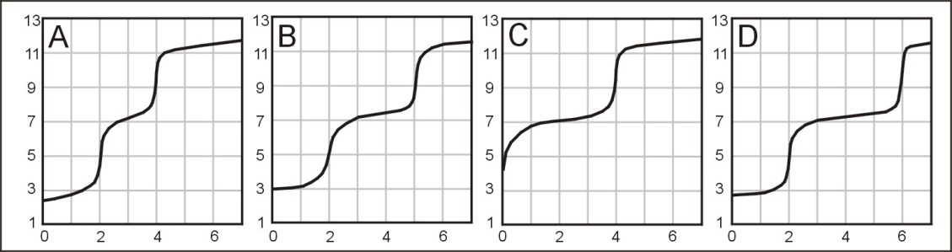

pH

Volume of titrant (mL)

(case a) The sample contains H3PO4 only.

Curve A ( ), Curve B ( ), Curve C ( ), Curve D ( )

(case b) The sample contains both in a mole ratio H3PO4 : NaH2PO4 2:1.

Curve A ( ), Curve B ( ), Curve C ( ), Curve D ( )

(case c) The sample contains both in a mole ratio H3PO4 : NaH2PO4 1:1.

Curve A ( ), Curve B ( ), Curve C ( ), Curve D ( )

**QUESTION 8** (1 point)

A fuel/oxidant system consisting of N,N-dimethylhydrazine (CH3)2NNH2 and N2O4 (both liquids) is commonly used in space vehicle propulsion. Components are mixed stoichiometrically so that N2, CO2 and Η2Ο are the only products (all gases under the reaction conditions). How many moles of gases are produced from 1 mol of (CH3)2NNH2?

(a) 8 ( )

(b) 9 ( )

(c) 10 ( )

(d) 11 ( )

(e) 12 ( )

**QUESTION 9** (1 point)

The complete electrolysis of 1 mol of water requires the following amount of electric charge (F is the Faraday constant):

(a) F ( )

(b) (4/3) F ( )

(c) (3/2) F ( )

(d) 2 F ( )

(e) 3 F ( )

**QUESTION 10** (2.5 points)

Identify particle X in each of the following nuclear reactions:

(case a) 6830Zn + 10n → 6528Ni + X alpha ( ), beta ( ), gamma ( ), neutron ( )

(case b) 13052Te + 21H → 13153I + X alpha ( ), beta ( ), gamma ( ), neutron ( )

(case c) 21482Pb → 21483Bi + X alpha ( ), beta ( ), gamma ( ), neutron ( )

(case d) 2311Na + 10n → 2411Na + X alpha ( ), beta ( ), gamma ( ), neutron ( )

(case e) 199F + 10n → 209F + X alpha ( ), beta ( ), gamma ( ), neutron ( )

**QUESTION 11** (1 point)

10.0 mL of 0.50 M HCl and 10.0 mL of 0.50 M NaOH solutions, both at the same temperature, are mixed in a calorimeter. A temperature increase of ΔT is recorded. Estimate the temperature increase if 5.0 mL of 0.50 M NaOH were used instead of 10.0 mL. Thermal losses are negligible and the specific heats of both solutions are taken as equal.

(a) (1/2) × ΔT ( )

(b) (2/3) × ΔT ( )

(c) (3/4) × ΔT ( )

(d) ΔT ( )

**QUESTION 12** (1 point)

Natural antimony consists of the following 2 stable isotopes: 121Sb, 123Sb. Natural chlorine consists of the following 2 stable isotopes: 35Cl, 37Cl. Natural hydrogen consists of the following 2 stable isotopes: 1H, 2H. How many peaks are expected in a low resolution mass spectrum for the ionic fragment SbHCl+?

(a) 4 ( )

(b) 5 ( )

(c) 6 ( )

(d) 7 ( )

(e) 8 ( )

(f) 9 ( )

**QUESTION 13** (1 point)

The smallest diffraction angle of a monochromatic beam of X-rays in a certain experiment is 11.5°. Based on this we must expect a beam of X-rays diffracted at:

(a) 22.0 degrees ( )

(b) 22.5 degrees ( )

(c) 23.0 degrees ( )

(d) 23.5 degrees ( )

(e) 24.0 degrees ( )

(f) 24.5 degrees ( )

# QUESTION 14 (1 point)

The undissociated form of a weak organic acid HA can be extracted from the aqueous phase by a water-immiscible organic solvent according to the scheme:

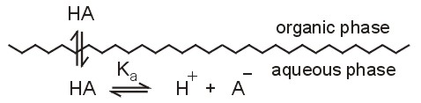

Regarding this extraction, are the following statements correct (Y) or not (N)?

(a) The distribution constant (KD) of the acid HA depends on the pH of

the aqueous phase. Y N

(b) HA can be efficiently extracted only from acidic aqueous solutions. Y N

(c) The distribution ratio (D) of the acid HA depends on the pH of the

aqueous phase. Y N

(d) The distribution ratio (D) of the acid HA depends mainly on its

concentration. Y N

**QUESTION 15** (1 point)

Regarding Beer's law, are the following statements correct (Y) or not (N)?

(a) The absorbance is proportional to the concentration of the

absorbing compound. Y N

(b) The absorbance is linearly related to the wavelength of the incident light.

Y N

(c) The logarithm of transmittance is proportional to the concentration of the absorbing compound. Y N

(d) The transmittance is inversely proportional to the logarithm of absorbance.

Y N

(e) The transmittance is inversely proportional to the concentration of the

absorbing compound. Y N

**QUESTION 16** (1 point)

Calculate the corresponding wavelength in nanometers (nm) for monochromatic radiation with the following numerical characteristics

(case a) 3000 Å 150 nm ( ), 300 nm ( ), 600 nm ( ), 5000 nm ( )

(case b) 5×1014 Hz 150 nm ( ), 300 nm ( ), 600 nm ( ), 5000 nm ( )

(case c) 2000 cm−1 150 nm ( ), 300 nm ( ), 600 nm ( ), 5000 nm ( )

(case d) 2×106 GHz 150 nm ( ), 300 nm ( ), 600 nm ( ), 5000 nm ( )

**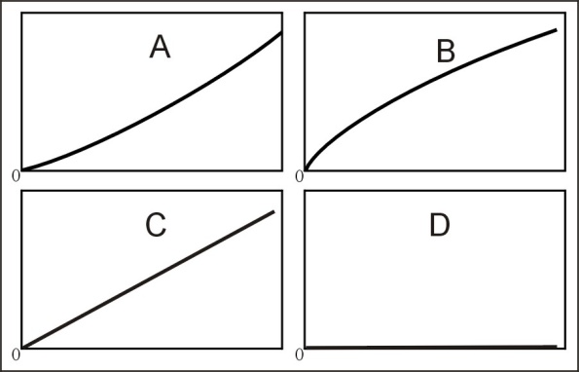QUESTION 17** (2.5 points)

Absorbance

Total concentration of HX

The absorbance of solutions of the weak acid HX were obtained. Associate the expected form of the resulting working curve with those shown in figure, under the following conditions:

(case a) Pure aqueous solutions of HX were used. Only the undissociated species HX absorb. Curve A ( ), Curve B ( ), Curve C ( ), Curve D ( )

(case b) Pure aqueous solutions of HX were used. Only the anionic species X− absorb. Curve A ( ), Curve B ( ), Curve C ( ), Curve D ( )

(case c) All solutions of HX contain an excess of a strong base. Only the undis­so­cia­ted HX species absorb. Curve A ( ), Curve B ( ), Curve C ( ), Curve D ( )

(case d) All solutions of HX contain an excess of a strong acid. Only the undissociated HX species absorb. Curve A ( ), Curve B ( ), Curve C ( ), Curve D ( )

(case e) Pure aqueous solutions of HX were used. Both HX and X− absorb. Measurements were obtained at a wavelength where the molar absorptivities of X− and HX are equal and different than zero.

Curve A ( ), Curve B ( ), Curve C ( ), Curve D ( )

**QUESTION 18** (1 point)

Which of the following acids is the strongest?

(a) perchloric acid, HClO4 ( )

(b) chloric acid, HClO3 ( )

(c) chlorous acid, HClO2 ( )

(d) hypochlorous, HClO ( )

(e) All of them are equally strong because they all contain chlorine ( )

**QUESTION 19** (1 point)

Which structure describes best the crystal system of iron in which the coordination number is 8?

(a) simple cubic ( )

(b) body-centered cubic ( )

(c) cubic closest packed ( )

(d) hexagonal closest packed ( )

(e) none of the above ( )

**QUESTION 20** (1 point)

Which of the following elements has the **largest third ionization energy**?

(a) B ( )

(b) C ( )

(c) N ( )

(d) Mg ( )

(e) Al ( )

**QUESTION 21** (1 point)

Which second period (row) element has the first six ionization energies (IE in electron volts, eV) listed below?

|  |  |  |  |  |  |
| --- | --- | --- | --- | --- | --- |
| IE1 | IE2 | IE3 | IE4 | IE5 | IE6 |
| 11 | 24 | 48 | 64 | 392 | 490 |

(a) B ( )

(b) C ( )

(c) N ( )

(d) O ( )

(e) F ( )

**QUESTION 22** (3 points)

Silver metal exists as a face-centered cubic (fcc) packed solid.

1. Draw an fcc unit cell.
2. How many atoms are present in the fcc unit cell?
3. The density of silver has been determined to be 10.5 g/cm3 . What is the length of each edge of the unit cell?
4. What is the atomic radius of the silver atoms in the crystal?

**QUESTION 23** (1 point)

Are the following statements correct (Y) or not (N)?

(a) HF boils at a higher temperature than HCl. Y N

(b)HBr boils at a lower temperature than HI Y N

(c)Pure HI can be produced by reacting concentrated sulfuric acid with KI.  
 Y N

(d)Ammonia solutions are buffer solutions because they contain the conjugate pair NH3 – NH4+. Y N

(e)Pure water at 80°C is acidic. Y N

(f)During electrolysis of an aqueous KI solution with graphite electrodes, the pH near the cathode is below 7. Y N

**QUESTION 24** (2 points)

Under certain conditions of concentration and temperature HNO3 reacts with Zn and its reduction products are NO2 and NO in a molar ratio 1:3. How many moles of HNO3 are consumed by 1 mol of Zn?

1. 2.2 ( )
2. 2.4 ( )
3. 2.6 ( )
4. 2.8 ( )
5. 3.0 ( )
6. 3.2 ( )

**SECTION B: Physical**

**QUESTION 25: Muon** (8 points)

The muon (μ) is a subatomic particle of the lepton family which has same charge and magnetic behavior as the electron, but has a different mass and is unstable, i.e., it disintegrates into other particles within microseconds after its creation. Here you will attempt to determine the mass of the muon using two rather different approaches.

1. (3 points) The most common spontaneous disintegration reaction for the muon is :

μ → e + + νμ,

where is the electron antineutrino, and νμ the muon neutrino. In a given experiment using a stationary muon, + νμ, carried away a total energy of 2.000×10-12 J, while the electron was moving with a kinetic energy of 1.4846x10-11 J. Determine the mass of the muon.

1. (5 points) Many experiments have studied the spectroscopy of atoms that have captured a muon in place of an electron. These exotic atoms are formed in a variety of excited states. The transition from the third excited state to the first excited state of an atom consisting of a 1H nucleus and a muon attached to it was observed at a wavelength of 2.615 nm. Determine the mass of the muon.

# QUESTION 26: CO spectrum (5 points)

Rotational energy levels of diatomic molecules are well described by the formula EJ = B J (J+1), where J is the rotational quantum number of the molecule and B its rotational constant. B is related to the reduced mass μ and the bond length R of the molecule through the equation .

In general, spectroscopic transitions appear at photon energies which are equal to the energy difference between appropriate states of a molecule (h ν = ΔE). The observed rotational transitions occur between adjacent rotational levels, hence ΔE = EJ+1 – EJ = 2 B (J+1). Consequently, successive rotational transitions that appear on the spectrum (such as the one shown here) follow the equation h (Δν) = 2 B.

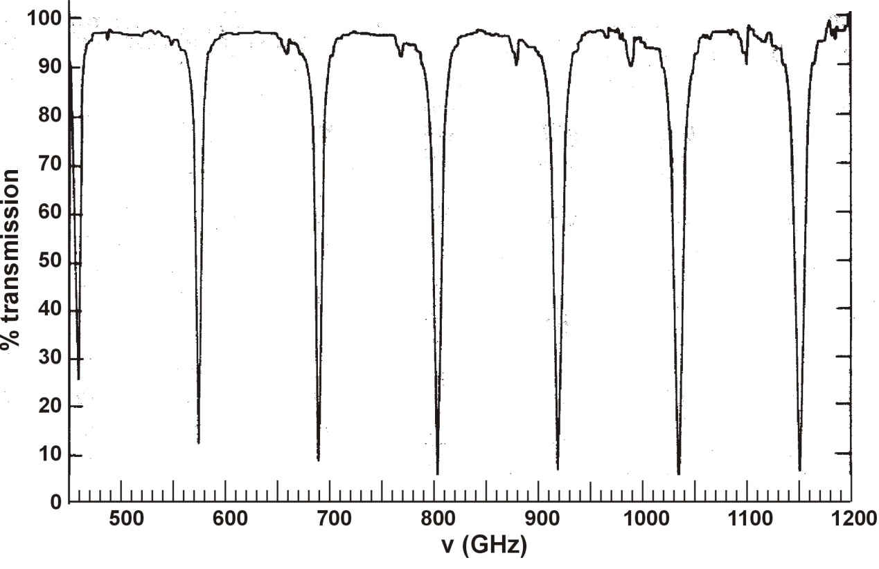

% Transmittance

By inspecting the spectrum provided, determine the following quantities for 12C16O with appropriate units:

1. Δν
2. B
3. R

**QUESTION 27: Hydrogen molecule** (6 points)

In the following graph are presented potential energy curves of the H2 molecule and its cation H2+.



Using the information provided on this graph, give numerical answers with appropriate units to the following questions:

1. What are the equilibrium bond lengths of H2 and H2+?
2. What are the binding energies of H2 and H2+?
3. What is the ionisation energy of the H2 molecule?
4. What is the ionisation energy of the H atom?
5. If we use electromagnetic radiation of frequency 3.9.1015 Hz in order to ionise H2, what will be the velocity of the extracted electrons? (ignore molecular vibrational energy)

QUESTION 28: Cryoscopy (4 points)

Chemists often need a bath in which to carry out a process that has a temperature below the water freezing point (0 °C) and well above the CO2 sublimation point (−78 °C). In this case they mix water ice prepared at its melting point and NaCl. Depending on the quantities used temperatures as low as −20 °C can be reached.

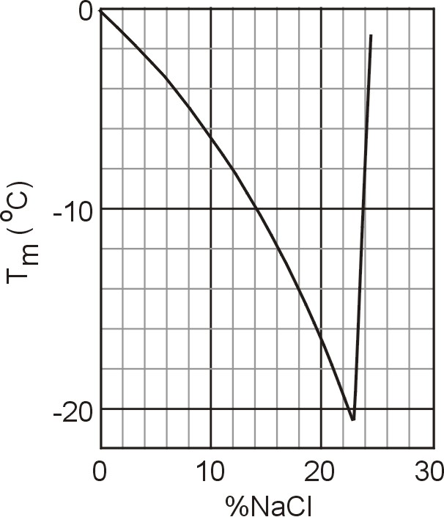We prepare a cold bath mixing 1 kg of ice at 0 °C with 150 g of NaCl in a thermally insulated container. Circle the letters Y or N to indicate if the following statements are correct (Y) or not (N).

1. The mixing process is spontaneous

Y N

1. The change of entropy during the mixing process is negative Y N
2. This diagram depicts the freezing point of aqueous solutions of NaCl as a function of the composition of the solution (per cent by weight). What is is the freezing point of the bath based on the diagram?
3. If an equal mass of MgCl2 were used instead of NaCl, would the freezing point be higher? Y N

# QUESTION 29: Pool (5 points)

A very large swimming pool filled with water of temperature equal to 20oC is heated by a resistor with a heating power of 500 W for 20 minutes. Assuming the water in the pool is not in any contact with anything besides the resistor, determine the following quantities:

1. The heat delivered to the water
2. Is the change of entropy of the resistor positive, negative, or zero?

(i) ΔSres > 0 ( )

(ii) ΔSres = 0 ( )

(iii) ΔSres < 0 ( )

1. Is the change of entropy of the water positive, negative, or zero?

(i) ΔSpool > 0 ( )

(ii) ΔSpool = 0 ( )

(iii) ΔSpool < 0 ( )

1. Is the change of entropy of the system positive, negative, or zero?

(i) ΔStotal > 0 ( )

(ii) ΔStotal = 0 ( )

(iii) ΔStotal < 0 ( )

1. Is the process reversible? Y N

# QUESTION 30: Gas velocity (5 points)

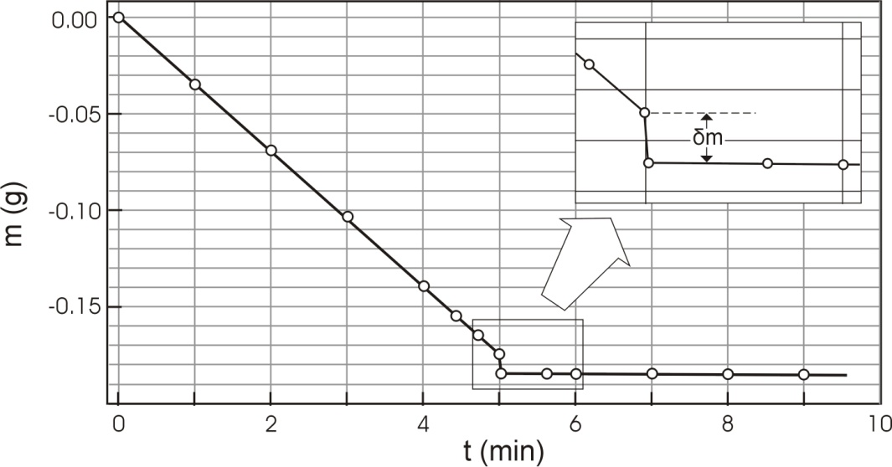The experiment described here gives a simple way to determine the mean velocity u of the molecules in the gas phase of a volatile liquid. A wide shallow container (a Petri dish) half filled with ethanol is placed on an electronic balance with its lid next to it and the balance is zeroed at time t=0. Balance readings are recorded as shown on the diagram. At t = 5 min the lid is placed over the dish. The liquid no longer evaporates, but the trapped molecules push against the lid, hence lowering the measurement of the balance by δm. Therefore, the force exerted on the lid is f = δm g. The force is also equal to the rate of change of the momentum of the evaporating molecules, i.e., f = ½ u dm/dt. Using the data provided determine the mean velocity of ethanol molecules at 290 K. Assume g = 9.8 m s−2.

**SECTION C: Organic**

#### Problem 31: Ester identification (15 points)

2.81 g of an optically active diester **A**, containing only C, H and O were saponified with 30.00 mL of a 1.00 M NaOH solution. Following the saponification, the solution required 6.00 mL of a 1.00 M HCl solution to titrate the unused NaOH, only. The saponification products were an optically inactive dicarboxylic acid **B**, MeOH and an optically active alcohol **C**. Alcohol **C** reacted with I2/NaOH to give a yellow precipitate and C6H5COONa.

The diacid **B** reacted with Br2 in CCl4 to give a single, optically inactive product (compound **D**).

Ozonolysis of **B** gave only one product.

1. Determine the molecular mass of compound **A**.

|  |
| --- |
| M**A** = |

2. Give the structural formulas of **A**, **B**, and **C** without stereochemical information.

|  |  |  |
| --- | --- | --- |
| A | B | **C** |
|  |  |  |

3. Give the possible stereochemical formulas (with bold and dashed bonds) for **C**.

|  |
| --- |
| **Possible Stereochemical Formulas for C** |
|  |

4. Give the stereochemical formula for **D**, using a Fischer projection.

|  |
| --- |
| **Stereochemical Formula for D** |
|  |

5. Give the stereochemical formula for **B**.

|  |
| --- |
| **Stereochemical Formula for B** |
|  |

The diester **A** also reacted with Br2 in CCl4 and was converted to a mixture of two compounds (**E**, **F**) both optically active.

6. Give all the possible stereochemical formulas for **E** and **F**, using Fischer projections. Name all the stereogenic centers as either *R* or *S* on all the formulas.

|  |  |
| --- | --- |
| **Possible Stereochemical Formula(s) for E** | **Possible Stereochemical Formula(s) for F** |
|  |  |

If we use Na18OH for the saponification of compound **A**, would the oxygen isotope be incorporated in (either or both of) the products **B** and **C**?

7. Mark the correct answer:

1. Only **B** ( )
2. Only **C** ( )
3. Both **B** and **C** ( )

**Problem 32: NMR puzzle** (9 points)

An organic compound **A** (C8H10) gives the following chain of reactions:



Bromination

**A** (C8H10) **B** (C8H9Br)

Reduction (CH3)3CO-K+

(N2H4 + NaOH)

**F** (C8H8O) **C** (C8H8)

Oxidation Ozonolysis

(Pyridinium

(i.O3, ii.Zn/H3O+)

chlorochromate,

PCC)

i.CH3MgBr

ii.H3O+

**E**  **D** (C7H6O) (+ HCHO 🠙 )

Based on the 1H-NMR spectra given, draw the structures of compounds **A**, **B**, **C**, **D**, **E** and **F**, and match the groups of the hydrogen atoms of each compound to the corresponding 1H-NMR peaks, as shown in the example. (1 point per structure and ½ point for each complete peak assignment)

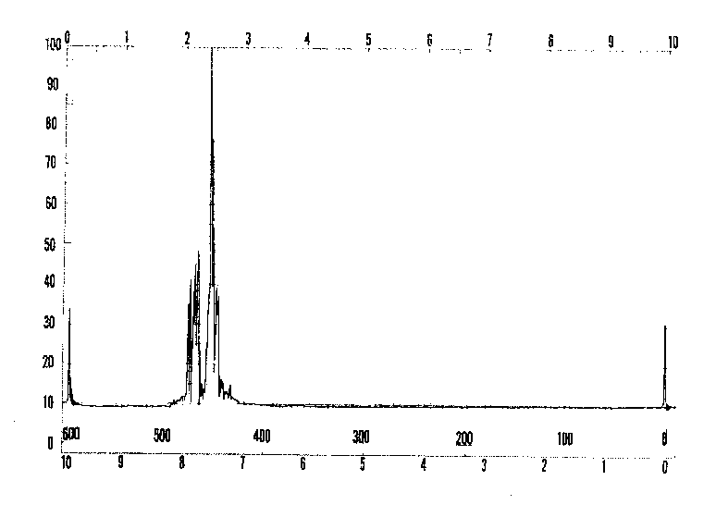

E2

E3

E4

E1



D2

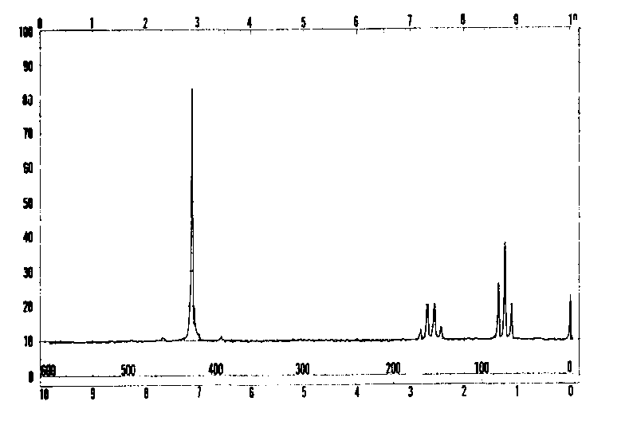

A1

A2

A3

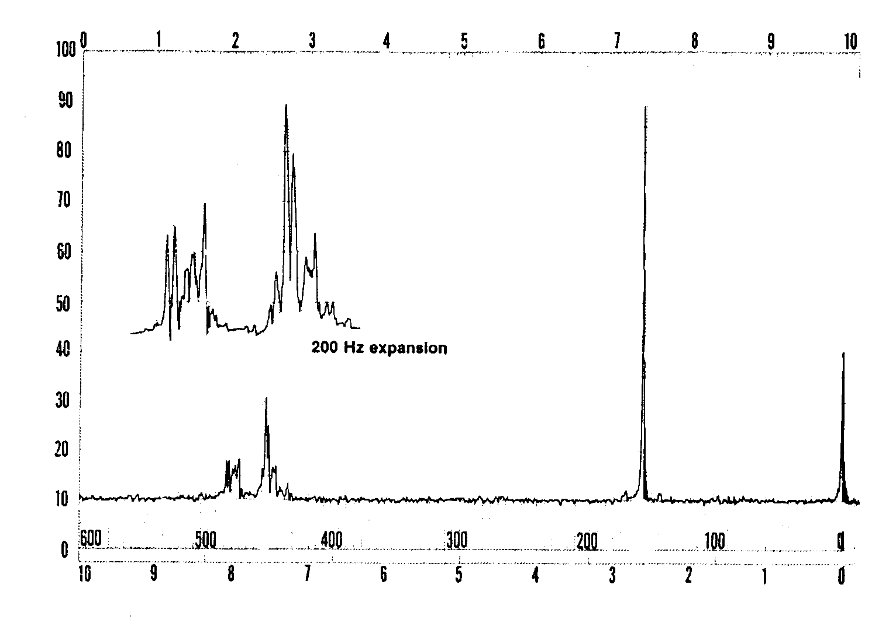

F2

F1

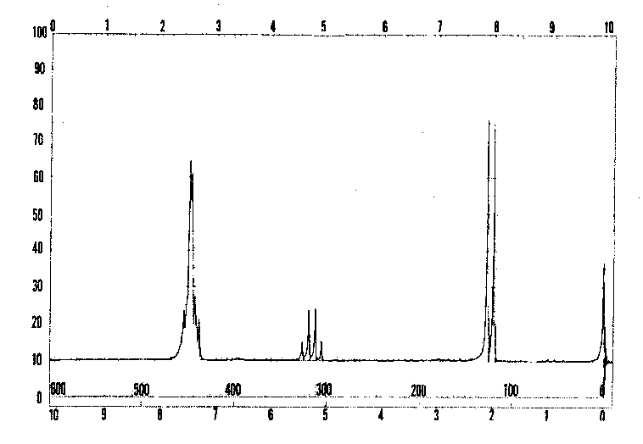

B1

B3

B2

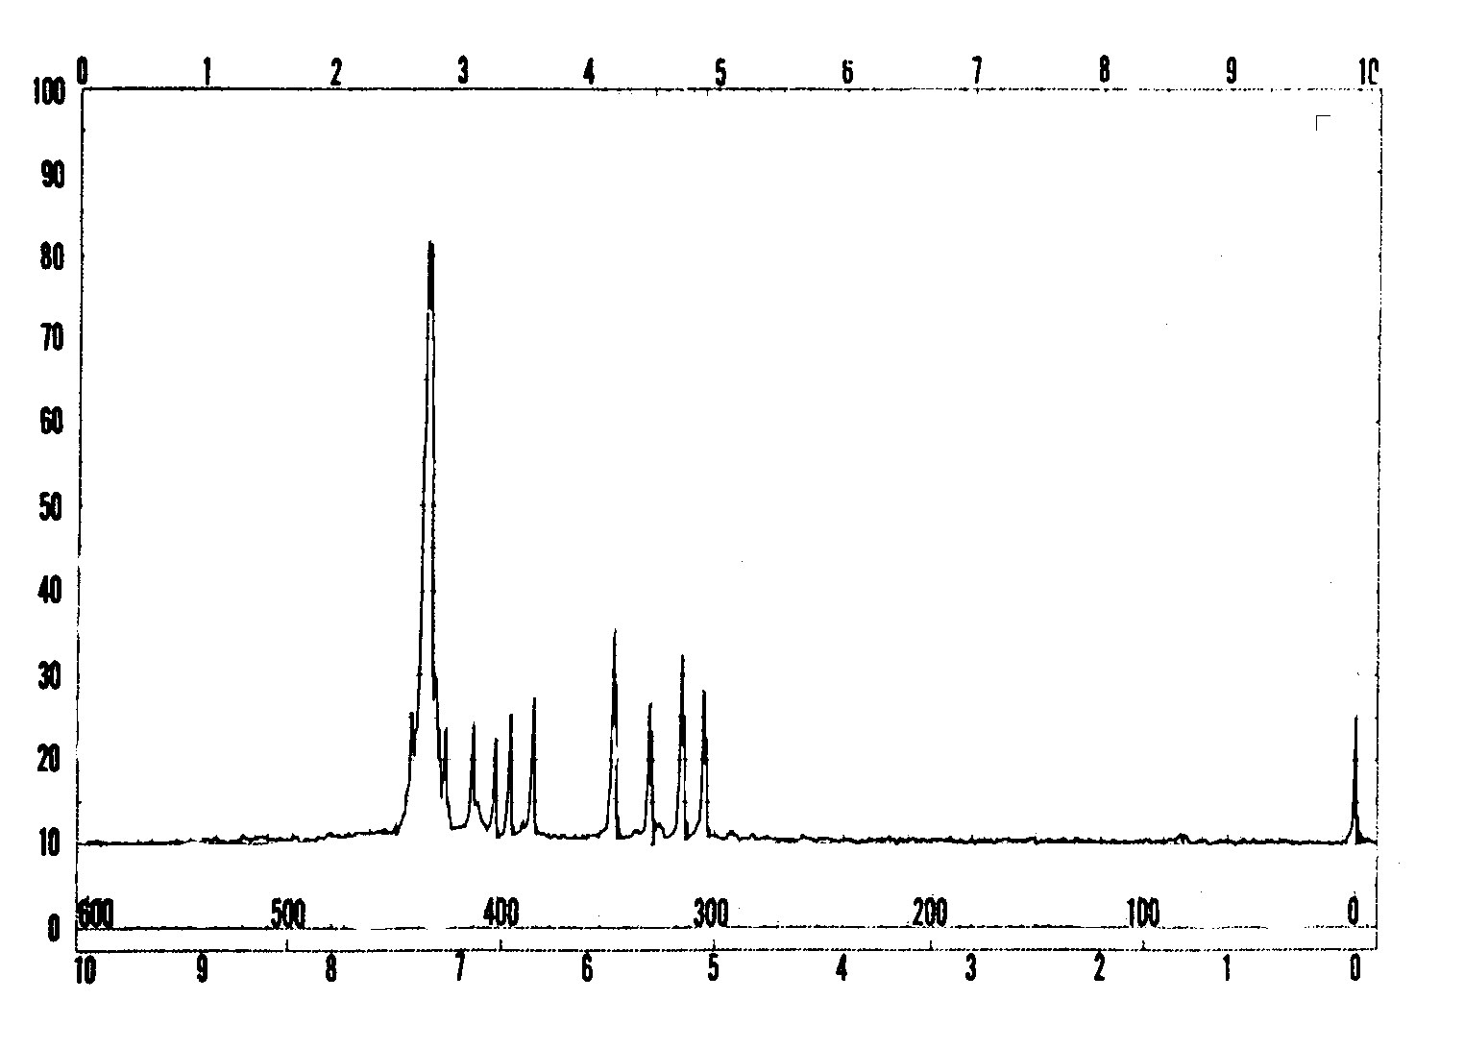

C1

C2

C3

Integration 5 : 1 : 2

**General remarks:** NMR spectra were recorded in CDCl3 on a 60 MHz Perkin Elmer Spectrometer. Under ordinary conditions (exposure to air, light and water vapour) acidic impurities may develop in CDCl3 solutions and catalyse rapid exchange of some particular protons.

D1

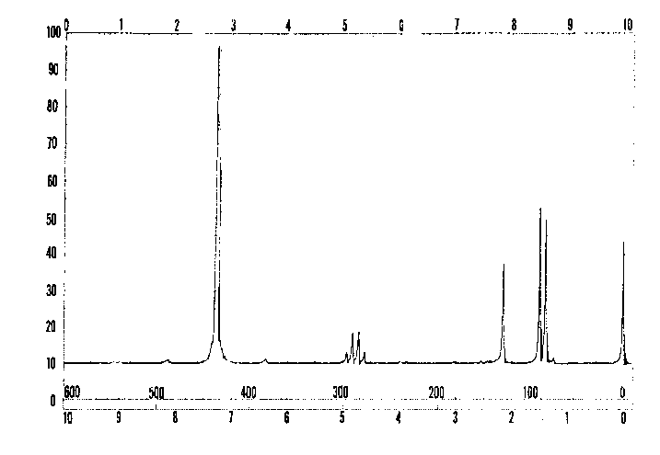

## EXAMPLE

X1 X2

CH3OH

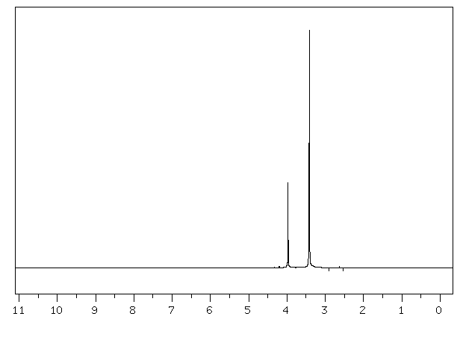

X1

X2

**Problem 33: Peptides** (11 points)

***A***

***F***

***C***

***E***

***D***

***B***

Racemization of -aminoacids and peptides can occur by an -enolization mechanism and both heat and the presence of strong bases greatly accelerate the process:



intermediate

1. Draw stereochemical formulas I and II (with bold and dashed bonds) for the aminoacid components of the mixture that has reached equilibrium through the -enolization mechanism described above operating on each of the following hydroxyaminoacids A and B:

Α: serine (R = −CH2OH)



B: (2*S*,3*R*)-threonine (R = )

A

#### II

#### I

B

#### II

#### I

2. Mark the box that corresponds to the correct definition of the relationship between the structures you have drawn in each of the above cases A and B.

enantiomeric diastereomeric

A I, II

enantiomeric diastereomeric

B I ,II

During peptide synthesis, in order to form a new peptide bond the carboxyl group has to be activated, that is, it must bear a good leaving group, represented in a simplified scheme below:



It is at this stage of the synthesis that a second racemization mechanism may occur; the amidic carbonyl oxygen is five atoms away from the activated carboxyl group and can intramolecularly attack the activated carboxyl forming a five membered cyclic intermediate (an azalactone) which quickly equilibrates its hydrogen at the stereogenic center, represented in a simplified scheme below:



intermediate

**C**

azalactone azalactone

3. Write a structure for the intermediate **C** that interconverts the two azalactones and thus explains the scrambling of the stereochemistry at the stereogenic center:

Intermediate **C**

Azalactones are very reactive substances that can still react with the amino group of an aminoacid. Therefore, the coupling reaction can proceed to completion albeit affording racemized or epimerized products.

4. If *N*-benzoyl glycine, C9H9NO3, is warmed to 40˚C with acetic anhydride it is converted into a highly reactive substance, C9H7NO2. (P1)

A: Propose a structure for this substance.

**P1**

B: Write the reaction product (s) of the substance you proposed above with *S*-alanine ethyl ester (P2) (the side chain R of the aminoacid alanine is a methyl group) using stereochemical formulas (with bold and dashed bonds) for both reactants and product.

Product

**P2**

**P1**

+

**SECTION D: Inorganic**

## QUESTION 34: Aluminium

(Total number of points for this Question: 22. Points marked for each subquestion)

One of the largest factories in Greece, located near the ancient city of Delphi, produces alumina (Al2O3) and aluminium metal using the mineral bauxite mined from the Parnassus mountain. Bauxite is a mixed aluminium oxide hydroxide – AlOx(OH)3−2x where 0<x<1.

Production of Al metal follows a two-stage process:

(i) Bayer process: Extraction, purification and dehydration of bauxite (typical compositions for industrially used bauxites are Al2O3 40-60%, H2O 12-30%, SiO2 free and combined 1-15%, Fe2O3 7-30%, TiO2 3-4%, F, P2O5, V2O5, etc., 0.05-0.2%). This involves dissolution in aqueous NaOH, separation from insoluble impurities, partial precipitation of the aluminium hydroxide and heating at 1200oC. Complete and balance the following chemical reactions of stage (i)

Al2O3 + OH− + → [Al(OH)4(H2O)2]−

SiO2 + OH− → SiO2(OH)22−

SiO2(OH)22− +  → CaSiO3↓ +

[Al(OH)4(H2O)2]− → ↓ + OH−  + H2O

Al(OH)3 → Al2O3 +

ii) Héroult-Hall process: Electrolysis of pure alumina dissolved in molten cryolite, Na3AlF6. Typical electrolyte composition ranges are Na3AlF6 (80-85%), CaF2 (5-7%), AlF3 (5-7%), Al2O3 (2-8% intermittently recharged). Electrolysis is carried out at 940oC, under constant pressure of 1 atm, in a carbon-lined steel cell (cathode) with carbon anodes. Balance the main reaction of the electrolysis:

Al2O3(l) + C(anode) → Al(l) + CO2(g)

Since cryolite is a rather rare mineral, it is prepared according to the following reaction. Complete and balance this reaction:

HF + Al(OH)3 + NaOH → Na3AlF6 +

During the electrolysis process several parallel reactions take place that degrade the graphite (C) anodes or reduce the yield.

iii) By using the thermodynamic data given below, which are taken to be independent of temperature, determine the thermodynamic quantities ΔH, ΔS and ΔG at 940°C for the reaction:

C(graphite) + CO2(g) → 2CO(g).

|  |  |  |  |  |  |  |
| --- | --- | --- | --- | --- | --- | --- |
|  | Al(s) | Al2O3(s) | C (graphite) | CO(g) | CO2(g) | O2(g) |
| ΔfHo (kJ.mol−1) | 0 | −1676 | 0 | −111 | −394 |  |
| So (J.K-1.mol−1) | 28 | 51 | 6 | 198 | 214 | 205 |
| ΔfusH (kJ.mol−1) | 11 | 109 |  |  |  |  |

iv) At the same temperature and using the data from the table in part (iii) determine the quantities ΔH and ΔG for the reaction

2Al(l) + 3CO2(g) → Al2O3(l) + 3CO(g)

given that ΔS = –126 J K–1 mol–1. (Show your calculations)

v) Pure aluminium is a silvery-white metal with a face-centered cubic (fcc) crystal structure. Aluminium is readily soluble in hot concentrated hydrochloric acid producing the cation [Al(H2O)6]3+, as well as in strong bases at room temperature producing hydrated tetrahydroxyaluminate anion, [Al(OH)4]−(aq). In both cases liberation of H2 occurs. AlF3 is made by treating Al2O3 with HF gas at 700oC, while the other trihalides, AlX3, are made by the direct exothermic reaction of Al with the corresponding dihalogen. Write all 4 chemical reactions described above.

vi) The AlCl3 is a crystalline solid having a layer lattice with 6-coordinate Al(III), but at the melting point (192.4oC) the structure changes to a 4-coordinate molecular dimer, Al2Cl6. The covalently bonded molecular dimer, in the gas phase and at high temperature, dissociates into trigonal planar AlCl3 molecules.

For the molecular dimer Al2Cl6, in the gas phase, two different Al ⎯ Cl distances (206 and 221 pm) were measured. Draw the stereostructure of the dimer, and write down the corresponding Al ⎯ Cl distances.

vii) What is the hybridization of the Al atom(s) in Al2Cl6 and AlCl3?

# QUESTION 35: Kinetics (10 points)

The acid-catalyzed reaction CH3COCH3 + I2 → CH3COCH2I + HI was found to be first order with respect to hydrogen ions. At constant hydrogen ion concentration the time needed for the concentration of iodine to be reduced by 0.010 mol L-1 was measured under various concentrations of the reactants.

1. Based on the information provided in the table, fill in the blanks.

|  |  |  |
| --- | --- | --- |
| [CH3COCH3] | [I2] | Time |
| (mol L−1) | (mol L−1) | (min) |
| 0.25 | 0.050 | 7.2 |
| 0.50 | 0.050 | 3.6 |
| 1.00 | 0.050 | 1.8 |
| 0.50 | 0.100 | 3.6 |
| 0.25 | 0.100 | … |
| 1.50 | … | … |
| … | … | 0.36 |

1. Derive the rate law for the reaction and calculate the rate constant.
2. Calculate the time needed for 75% of CH3COCH3 to react in excess I2.
3. Show graphically the dependence of the rate on [CH3COCH3] and on [I2], for fixed initial concentration of the other reagents.

1. If the rate is doubled by raising the temperature by 10°C from 298 K, calculate the activation energy for this reaction.

Fundamental constants

|  |  |  |  |
| --- | --- | --- | --- |
| **Quantity** | **Symbol** | **Value** | **Unit** |
| Speed of light | c | 299 792 458 | m s-1 |
| Permeability of vacuum | μ0 | 4π x 10-7 =  12.566 370 614…x 10-7 | N A-2 |
| Permittivity of vacuum | ε0 | 1/μ0c2 =  8.854 187 817 x 10-12 | C2 m-2 N-1  or F m-1 |
| Planck constant | h | 6.626 068 76 x 10-34 | J s |
| Electron charge | e | 1.602 176 462 x 10-19 | C |
| Electron mass | me | 9.109 381 88 x 10-31 | kg |
| Proton mass | mp | 1.672 621 58 x 10-27 | kg |
| Avogadro constant | NA | 6.022 141 99 x 1023 | mol-1 |
| Faraday constant | F | 96 485.3415 | C mol-1 |
| Boltzmann constant | k | 1.380 650 3 x 10-23 | J K-1 |
| Molar gas constant | R | 8.314 472 | J K-1 mol-1 |
| Atomic mass unit | u | 1.660 538 73 x 10-27 | kg |

Source: *Physics Today* **55** BG6 (2002)

Common unit conversions

The unit 1 M is commonly used as an abbreviation for 1 mol dm-3.

1 L = 1 dm3 = 1000 cm3

1 Å = 10-10 m

1 cal = 4.184 J

Useful formulas



, 

2 *d* sin*θ* = n *λ* Kinetic Energy  

Text language: English

Translator countries (if more than one):

**35th International Chemistry Olympiad**

**Athens, Greece**

**Practical Examination**

**Tuesday, 8 July 2003**

Introductory Remarks

* At all times while you are in the laboratory you should wear safety spectacles or your own spectacles if they have been approved. Use only a pipette filler bulb for pipetting. Eating of any kind of food is strictly prohibited in the laboratory.
* Participants are expected to work safely, to behave socially and to keep equipment and work environment clean. Do not hesitate to ask a laboratory assistant if you have any questions concerning safety issues.
* When you enter the laboratory, check the place of the safety shower.
* Work may only begin when the start signal is given.
* You have **5** hours to complete all of the experimental tasks, and record your results on the answer sheets. There will be a pre-warning 15 minutes before the end of your time. You must stop your work immediately after the stop command is given. A delay in doing this by 5 minutes will lead to cancellation of the current task and will result in zero points for that task.
* **This practical examination comprises two experiments. In order to use the available time efficiently, you will start working on the organic chemistry experiment up to the point where you are instructed to work on the analytical chemistry experiment. Then you will finish the work on the organic chemistry experiment.**
* Write your name and personal identification code (posted at your work station) in the appropriate box of the answer sheets.
* All results must be written in the answer boxes on the answer sheets. Data written elsewhere will not be marked. Do not write anything in the back of your answer sheets. If you need more paper for working or a replacement answer sheet, request it from the laboratory assistant.
* When you have finished the examination, you must put all papers into the envelope provided. Only papers in the envelope will be marked.
* Do not leave the examination room until you have permission to do so.
* Use only the tools provided.
* The number of significant figures in numerical answers must conform to the rules of evaluation of experimental error. The inability to perform calculations correctly will result in penalty points, even if your experimental technique is flawless.
* The examination has 3 pages of answer sheets.
* An official English-language version is available only on request.

# Disposal of waste chemicals, spills, and glassware

Organic filtrates and organic washings and any other waste should be placed in the waste beaker or bottle.

Use the appropriate waste containers for disposals of chemical and other waste materials.

Broken glass should be placed in the waste bucket. There is a one-point penalty for broken glassware or replaced samples.

# Cleaning up

The lab bench should be wiped clean with a wet tissue.

**Organic Chemistry Experiment**

**Synthesis of the dipeptide *N*-acetyl-*L*-prolinyl-*L*-phenylalanine methyl ester   
(Ac-*L*-pro-*L*-phe-OCH3)**

**Glassware and equipment**

|  |  |  |
| --- | --- | --- |
| Round-bottomed flask (50 mL) | 1 |  |
| Septum | 1 |  |
| Support stand | 1 |  |
| Clamp holder | 1 |  |
| Clamp | 1 |  |
| Syringe polyethylene (5 mL) + needle | 3 |  |
| Polypropylene powder funnel | 1 |  |
| Glass funnel | 1 |  |
| Separating funnel (50 mL) | 1 |  |
| Erlenmeyer flask (50 mL) | 3 |  |
| Spatula | 1 |  |
| Pair of forcepts | 1 |  |
| Measuring cylinder (50 mL) | 1 |  |
| Weighing paper | 1 | (Located near the balances) |
| Fritted glass funnel | 1 |  |
| Sample vial | 1 |  |
| Screw cap bottle (large) for TLC | 1 |  |
| Thin layer plate (3-7 cm) | 1 | Located at the end of the bench |
| Capillary tubes for TLC (in sample tube) | 2 | Located at the end of the bench |
| Thermometer | 1 |  |
| Filter flask (100 mL) | 1 |  |
| Filter rubber adaptor | 1 |  |
| Eppendorf | 1 |  |
| Stationery (pen, pencil) |  |  |
| Beaker (250 mL) | 1 |  |

**Chemicals**

|  |  |
| --- | --- |
| Dichloromethane | 30 mL |
| *N*-Acetyl-*L*-proline (Ac-L-Pro) | 1.50 g (in a vial) |
| *L*-Phenylalanine methylester hydrochloride (HCl.*L*-Phe-OMe) | 2.15 g (in a vial) |
| Isobutyl chloroformate | 1.5 mL (Located at the end of the bench) |
| *N*-Methylmorpholine | 2.4 mL |
| Methanol |  |
| Sodium hydrogen carbonate (NaHCO3) 1% | 40 mL |
| Hydrochloric acid (HCl) 0.2M | 40 mL |
| Anhydrous sodium sulfate | 2 g |
| Cotton wool |  |
| Diethyl ether | 30 mL provided by the laboratory assistant |
| Wash bottle with acetone (for rinsing) | 500 mL |
| TLC eluant (chloroform-methanol-acetic acid (7:0.2:0.2) | 15 mL provided by the laboratory assistant |
| Ice/sodium chloride cold bath [−20oC - −15oC] | Provided by the laboratory assistant |
| Compound **B** | In Eppendorf labelled **B** |

**Risk and Safety Information**

**Acetone**



|  |  |
| --- | --- |
| Formula | C3H6O |
| Molecular weight | 58.08 |
| Melting point | −95 oC |
| Boiling point | 56 oC |
| Density | 0.79 g/cm3 |

|  |  |
| --- | --- |
| R11 | Highly flammable |
| S9 | Keep container in a well-ventilated place |
| S16 | Keep away from sources of ignition |
| S23 | Do not breathe vapour |
| S33 | Take precautionary measures against static discharges |



**Hydrochloric acid**

|  |  |
| --- | --- |
| Formula | HCl |
| Molecular weight | 36.46 |
| Density | 1.200 g/cm3 |

|  |  |
| --- | --- |
| R34 | Causes burns |
| R37 | Irritating to respiratory system |
| S26 | In case of contact with eyes, rinse immediately with plenty of water and seek medical advise |
| S36 | Wear suitable protective clothing |
| S45 | In case of accident or if you feel unwell, seek medical advice immediately (show the label where possible) |

**Methanol**



|  |  |
| --- | --- |
| Formula | CH4O |
| Molecular weight | 32.04 |
| Melting point | −98 oC |
| Boiling point | 65 oC |
| Density | 0.79 g/cm3 |

|  |  |
| --- | --- |
| R11 | Highly flammable |
| R23-25  sign_toxic | Toxic by inhalation, in contact with skin and if swallowed |
| R39/23/24/25 | Toxic: danger of very serious irreversible effects through inhalation, in contact with skin and if swallowed |
| S7 | Keep container tightly closed |
| S16 | Keep away from sources of ignition-No smoking |
| S36/37 | Wear suitable protective clothing and gloves |
| S45 | In case of accident or if you feel unwell, seek medical advice immediately (show the label where possible) |

**Dichloromethane**



|  |  |
| --- | --- |
| Formula | CH2Cl2 |
| Molecular weight | 84.93 |
| Melting point | −97 oC |
| Boiling point | 40 oC |
| Density | 1.325 g/cm3 |



|  |  |
| --- | --- |
| R40 | Limited evidence of a carcinogenic effect |
| S23-24/25 | Do not breathe fumes. Avoid contact with skin and eyes |
| S36/37 | Wear suitable protective clothing and gloves |

**Isobutyl Chloroformate**



|  |  |
| --- | --- |
| Formula | C5H9O2Cl |
| Molecular weight | 136.58 |
| Boiling point | 128.8 oC |
| Density | 1.053 g/cm3 |

|  |  |
| --- | --- |
| R10 | Flammable |
| R23 | Toxic by inhalation |
| R34 | Causes burns |
| S26 | In case of contact with eyes, rinse immediately with plenty of water and seek medical advice |
| S45 | In case of accident or if you feel unwell, seek medical advice immediately (show label where possible) |
| S36/37/39 | Wear suitable protective clothing, gloves and eye/face protection |

**N-Methylmorpholine**

|  |  |
| --- | --- |
| Formula | C5H11NO |
| Molecular weight | 101.15 |
| Melting point | −66 oC |
| Boiling point  sign_corros | 115-116 oC/750torr |
| Density | 0.920g/cm3 |

|  |  |
| --- | --- |
| R11 | Highly flammable |
| R34 | Causes burns |
| R20/21/22  sign_flam | Harmful by inhalation, in contact with skin and if swallowed |
| S16 | Keep away from sources of ignition-No smoking |
| S26 | In case of contact with eyes, rinse immediately with plenty of water and seek medical advice |
| S45 | In case of accident or if you feel unwell, seek medical advice immediately (show label where possible) |
| S36/37/39 | Wear suitable protective clothing, gloves and eye/face |

***L*-Phenylalanine methyl ester hydrochloride**

|  |  |
| --- | --- |
| Formula | C10H13NO2.HCl |
| Molecular weight | 215.68 |
| Melting point | 158-162 oC |
| Density | 0.920g/cm3 |

***N*-Acetyl-*L*-proline**

|  |  |
| --- | --- |
| Formula | C7H11NO3 |
| Molecular weight | 157.17 |

**Diethyl ether (Ether)**

|  |  |
| --- | --- |
| Formula  sign_flam | C4H10O |
| Molecular weight | 74.12 |
| Melting point | -116 oC |
| Boiling point | 34.6 oC |
| Density | 0.706 g/cm3 |

|  |  |
| --- | --- |
| R12 | Extremely flammable |
| R19 | May form explosive peroxides |
| R22 | Harmful if swallowed |
| R66 | Repeated exposure may cause skin dryness or cracking |
| R67 | Vapours may cause drowsiness and dizziness |
| S9 | Keep container in a well-ventilated place |
| S16 | Keep away from sources of ignition-No smoking |
| S29 | Do not empty into drains |
| S33 | Take precautionary measures against static discharges |

**Materials available for general use**

Cleaning paper

Sponge

Waste container

**Equipment for general use**

Flash evaporator

Balance

UV lamp

**Synthesis of the dipeptide *N*-acetyl-*L*-prolinyl-*L*-phenylalanine methyl ester   
(Ac-*L*-Pro-*L*-Phe-OCH3)**

# Introduction

Peptide synthesis is now a well-refined art and many of their synthetic procedures can be readily adapted to the elementary laboratory. Interest in peptides, always high, has heightened even more with the recent discovery of the importance of the so-called “opiate” peptides as well as of other biological active peptides.

In this experiment the one-pot procedure for synthesizing the title dipeptide from its components, suitably protected amino acids, is described.

## Reactions

**STEP 1**



**STEP 2**





1 *N*-methylmorpholine (NMM) =

2 DCM = Dichloromethane

**Procedure**

**STEP 1**

Place the 1.50 g (0.0095 mol) sample of *N*-acetyl-*L*-proline (labelled **AcPro**), which you have been given, into a 50-cm3 round-bottomed flask. Add 20 cm3 dichloromethane (labelled **DCM**) in the graduated cylinder. Use some of the 20 cm3 DCM to wash out the AcPro vial and add the remaining DCM also into the round-bottomed flask. Plug the flask with a septum, clamp it loosely to a support stand and cool it to –15 °C to –20 °C in the ice/sodium chloride cold bath provided by the supervisor. Allow approximately 5 minutes for cooling. Add 1.2 cm3 (0.0109 mol) of *N*-methylmorpholine (labelled **NMM**) to the flask, by means of a syringe. Then, slowly add 1.5 cm3 (0.0116 mol) isobutylchloroformate (labelled **IBCF**) to the flask by means of a second syringe. During the addition, swirl the reaction mixture gently by hand, and continue swirling for another 10 min. The temperature should remain in the range –20o to –15oC.

## STEP 2

Remove the septum and quickly add all the *L*-phenylalanine methyl ester hydrochloride (2.15 g, 0.0100 mol), (labelled **HCl·H2NPheOCH3**) using the polypropylene powder funnel. Plug the flask again with the septum. Immediately add 1.2 cm3 (0.0109 mol) of *N*-methylmorpholine (labelled **NMM**) using a third syringe, while the reaction mixture is swirled by hand. *ATTENTION: Leave the needle* *part of the syringe in the septum for the remainder of the reaction*. Allow the reaction to proceed for 60 min at –15 °C to –20 °C, swirling periodically by hand.

**During this waiting period you are highly advised to start working on the Analytical Chemistry experiment.**

After 60 min at –20oC to –15oC, remove the 50 cm3 round-bottomed flask from the ice/sodium chloride bath and place the flask in the 250 cm3 beaker and let it warm up to room temperature. Transfer the contents of the flask into the 50 cm3 separating funnel by means of the glass funnel. Rinse the flask with a small amount of dichloromethane (3-5 cm3), which is in a vial (labelled **DCM**). Wash the organic layer successively with two 20 cm3 portions of 0.2 M aqueous HCl solution, two 20 cm3 portions of 1% aqueous NaHCO3 solution (read caution comment in next paragraph) and finally one 10 cm3 portion of saturated solution of sodium chloride (labelled **brine**).

# Important

*After each washing allow the separating funnel to stand for enough time, so that the two phases separate completely. Also, take into consideration that the organic phase (DCM) is always the lower layer and contains the product. All the aqueous washings are collected in the same Erlenmeyer flask (empty if necessary).* ***CAUTION: Keep in mind, also, that during washing with 1% NaHCO3, the CO2 liberated is exerting pressure on the separating funnel stopper, so be sure to let the gas out through the stopcock before and after each shaking, while holding the funnel upside down.***

*Before continuing, wash the glass funnel, the 50 cm3 cylinder and the 50 cm3 round-bottomed flask with water and then dry them with acetone. Your supervisor will show you where to dispose of the water and the acetone.*

Pour the organic layer into a clean 50 cm3 Erlenmeyer flask. Add the anhydrous sodium sulfate, which is in a vial labelled **Na2SO4**, to the Erlenmeyer flask containing the organic layer. The organic phase should become clear. Filter it through the cleaned and dried funnel, whose stem you have previously stuffed with a small piece of cotton to trap any solids, into the cleaned and dried 50 cm3 round-bottomed flask. Rinse the Erlenmeyer flask with a small amount of dichloromethane (3-5 cm3). Removal of the organic solvent is done under reduced pressure, using a rotary evaporator apparatus. This will be done for you by a laboratory supervisor, who will add 20 cm3 of diethylether to the residue in your flask, which will cause precipitation of your product. After cooling for 5 minutes in the ice bath, scrape the walls of the flask with a spatula, filter by suction the crystallized dipeptide through a fritted glass funnel. Wash twice with diethylether (5 cm3 each time).

Leave the product on the filter under suction for at least 3 minutes. Then collect it on weighing paper, weigh it in the presence of a supervisor and then transfer it into a sample vial and label it with your student code. Write the mass of your product (**C**) on the label and on your answer sheet (on the next page).

### TLC- Analysis

You have two Eppendorfs, one empty and one with a tiny amount of substance **B**. Put a small amount of **C** into the empty Eppendorf, and dissolve both **B** and **C** in a few drops of methanol. Use the supplied capillary tubes to apply small samples of these solutions to the TLC plate. Develop the TLC plate with a solution of chloroform-methanol-acetic acid (7:0.2:0.2) as eluant. The appropriate amount of eluant has been placed in the proper vial by the supervisor.

After the elution, analyze the TLC-plate using a UV-lamp. Clearly mark the starting line, solvent front and the UV-active spots.

Draw the diagram in the box on the answer sheet. Determine the Rf values.

Finally place the TLC-plate in a small plastic bag with a sealing strip and put it in an envelope provided by the supervisor. Write your student code on the envelope.

The examination committee will check the quality of the *N*-acetyl-*L*-prolinyl-*L*-phenylalanine methyl ester that you have prepared by determining its angle of optical rotation and consequently its specific rotation, [a]tD, using an accurate polarimeter apparatus.

#### Answer Sheet 1

**Synthesis of *N*-Acetyl-*L*-prolinyl-*L*-phenylalanine methyl ester (Ac-*L*-Pro-*L*-Phe-OCH3)**

|  |  |  |  |  |  |  |  |
| --- | --- | --- | --- | --- | --- | --- | --- |
| Box | 1 | 2 | 3 | 4 | 5 | 6 | 7 |
| Points | 10 | 3 | 2 | 2 | 2 | 10 | 2 |

|  |  |
| --- | --- |
| **1** Mass of **Ac-*L*-Pro-*L*-Phe-OCH3** obtained (product **C**):  Calculate the yield of Ac-*L*-Pro-*L*-Phe-OCH3 **C:**  Yield % = | g |

|  |
| --- |
| 1. Draw the TLC diagram   0  1  2  3  4  5  6  7  8  9  10  11  12  13 cm  **B**  **C**  base line also indicate the front  of the solvent |

|  |  |
| --- | --- |
| 1. *R*f value of ***L*-phenylalanine methyl ester hydrochloride** (material **B)** |  |

|  |  |
| --- | --- |
| 1. *R*f value of **Ac-*L*-Pro-*L*-Phe-OCH3** (product **C)** |  |

**Answer Sheet 2**

|  |  |
| --- | --- |
| 1. Conclusions from the TLC analysis:   Compound **C:**  Is pure  Contains some **B**  Contains several contaminants  No conclusion |  |

|  |  |
| --- | --- |
| 6 Specific rotation of the dipeptide Ac-*L*-Pro-*L*-Phe-OCH3 C (to be measured later by the examination committee) = |  |

|  |
| --- |
| **7** During the reaction between the phenylalanine methylester **B** and the activated mixed anhydride intermediate (step 2) the formation of the desired dipeptide product **C** is usually accompanied by a byproduct the correct structure of which is one of the three structures **I**, **II**, **III** given below. Circle the Roman numeral corresponding to the correct structure. |

Analytical Chemistry Experiment

TITRATION OF ASCORBIC ACID WITH POTASSIUM IODATE

Introduction

**Ascorbic acid** (vitamin C, C6H8O6, symbolized below as AscH2) is a weak acid and undergoes the following dissociation steps:

AscH2 equilleft AscH− + H+ Ka1 = 6.8×10−5

AscH− equilleft Asc2− + H+ Ka2 = 2.7×10−12

Ascorbic acid is readily oxidized to **dehydroascorbic acid** according to the half reaction:

C6H8O6 equilequal C6H6O6 + 2H+ + 2e−



Ascorbic acid (C6H8O6) Dehydroascorbic acid (C6H6O6)

A typical titrant used for the redox titration of ascorbic acid is potassium iodate, KIO3. If the titration is carried out in 1 M HCl medium, then the reaction proceeds as follows:

3C6H8O6 + IO3− equilleft 3C6H6O6 + I− + 3H2O

The end point is detected by the reaction of the first excess of iodate with iodide ions already present in the solution, producing I2 which colours starch indicator blue:

IO3− + 5I− + 6H+ equilleft 3I2 + 3H2O

# Principle of the method

Ascorbic acid will be titrated by using a solution of potassium iodate of known concentration. The titration will be carried out in 1 M HCl, while starch solution will be used as indicator to detect the end point.

# Solutions

1. Solution of potassium iodate of known concentration.

Make a note here of the concentration written on the bottle:

Molarity of KIO3 = M

1. Solution of 2 M HCl
2. Starch solution

###### Risk and Safety Information

**Potassium iodate**

|  |  |  |
| --- | --- | --- |
| Formula | | KIO3 |
| Molecular weight | | 214.00 |
| Melting point | | 560 oC |
| Density | | 3.930 g/cm3 |
| R8 | Contact with combustible material may cause fire | | |
| R36/38 | Irritating to eyes and skin | | |
| R42/43 | May cause sensitisation by inhalation and skin contact | | |
| R61 | May cause harm to the unborn child | | |
| S17 | Keep away from combustible material | | |
| S22 | Do not breathe dust | | |
| S45 | In case of accident or if you feel unwell, seek medical advice immediately (show label where possible) | | |
| S36/37/39 | Wear suitable protective clothing, gloves and eye/face protection | | |

**Ascorbic acid**

|  |  |
| --- | --- |
| Formula | C6H8O6 |
| Molecular weight | 176.13 |
| Melting point | 193oC (dec.) |

# Glassware

1. One 50 mL burette

2. One burette stand

3. One burette clamp

4. One 250-mL volumetric flask

5. Three 250-mL conical flasks

6. One graduated cylinder (25 or 50 mL)

7. One dropper

8. One 500-mL wash bottle (polyethylene, squeeze type) with deionized water

9. One 25.00-mL pipette

10. One pipette-filling bulb

# Procedure

# Preparation of burette

Rinse the burette with deionized water at least three times. Rinse twice with solution of potassium iodate and fill. Record the initial volume of titrant (Vinitial).

# Titration of unknown sample

Obtain the unknown solution in a clean 250-mL volumetric flask. Record batch number of solution given. Dilute to the mark with deionized water and shake well. Use a pipette to transfer 25.00 mL of this solution into a 250-mL conical flask. Use a graduated cylinder to transfer 25 mL of 2 M HCl into the same flask and shake well. Add 40 drops of starch solution and titrate the solution with potassium iodate up to a permanent blue colour. Record final volume of titrant (Vfinal) (titration 1). Repeat the procedure as many times as necessary. Calculate the concentration of ascorbic acid (mg C6H8O6/mL of solution). Each time refill the burette with solution of potassium iodate.

**Results** (8 points) **Answer Sheet 3**

Batch number of solution given

|  |  |  |  |
| --- | --- | --- | --- |
| Titration No | Vinitial  mL | Vfinal  mL | V  mL |
|  |  |  |  |
|  |  |  |  |
|  |  |  |  |
|  |  |  |  |
|  |  |  |  |
|  |  |  |  |
|  |  |  |  |
|  |  |  |  |
|  |  |  |  |
| Final volume | | |  |

|  |  |
| --- | --- |
| mg C6H8O6 / mL |  |

# Questions

(2 points)

1. If the titration of ascorbic acid is carried out in 5 M HCl medium, then the reaction proceeds as follows:

C6H8O6 + IO3− + H+ + Cl− equilleft C6H6O6 + ICl + H2O

Balance the above reaction.

2. If V1 and V2 are the volumes of KIO3 solution (titrant) required for the titration of 25.00 mL of the ascorbic acid solution given to you, in 1 and 5 M HCl, respectively, then the two volumes are related by the following relationship: (Circle the correct answer)

a. V2 = (3/2) V1

b. V2 = (2/3) V1

c. V2 = V1

d. none of the above