**Chemistry for Life,**

**Chemistry for better Life**



##### Theoretical Test

**2006. 7. 7**

**Gyeongsan, Korea**

General Directions

* Write your name and code number on each page of the answer sheet.
* You have 5 hours to finish the task. Failure to stop after the STOP command may result in zero points for the task.
* Write answers and calculations within the designated box.
* Use only the pen and the calculator provided.
* There are 30 pages of Problems and 5 pages of Answer Sheet.
* An English-language version is available.
* You may go to the restroom with permission.
* After finishing the examination, place all sheets including Problems and Answer Sheet in the envelope and seal.
* Remain seated until instructed to leave the room.

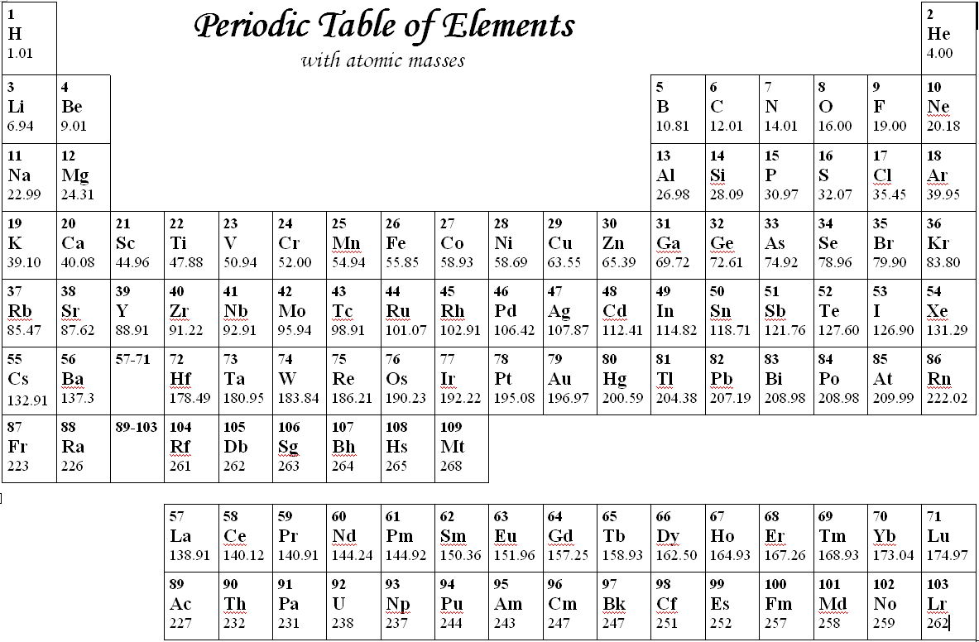

Constants and useful formulas

**Gas constant R = 8.314 J K-1 mol-1**

**Faraday constant F = 96485 C mol-1**

**Use as standard pressure: p = 1.013∙105 Pa**

**Use as standard temperature: T = 25°C = 298.15 K**

**Avogadro’s number NA = 6.022∙1023 mol-1**

**Planck constant h = 6.626∙10-34 J s**

**Speed of light c = 3.00∙108 m s-1**

**ΔG = ΔH - TΔS ΔG = - nFE**

**ΔG0 = - RT∙lnK ΔG = ΔG0 + RT∙lnQ with Q *= ***

**Δ*H(T1)* = Δ*H*0 + (*T1* - 298.15 K)∙*Cp*  (Cp = constant)**

**Arrhenius equation *k* = A ∙**

**Ideal gas law *pV = nRT***

**Nernst equation *E = E0 + ***

**Beer- Lambert Law *A* = log= *ε∙c∙d***

**V(cylinder) = πr2h**

**A(sphere) = 4π*r* 2**

**V(sphere) = π*r* 3**

**1 J = 1 N m 1 N = 1 kg m s-2 1 Pa = 1 N m-2**

**1 W = 1 A V = 1 J s-1 1 C = 1 A s**

**1. Avogadro's number (5 pts)**

Spherical water droplets are dispersed in argon gas. At 27oC, each droplet is 1.0 micrometer in diameter and undergoes collisions with argon. Assume that inter-droplet collisions do not occur. The root-mean-square speed of these droplets was determined to be 0.50 cm/s at 27oC. The density of a water droplet is 1.0 g/cm3.

1-1. Calculate the average kinetic energy (mv2/2) of this droplet at 27oC. The volume of a sphere is given by (4/3) π r3 where r is the radius.

If the temperature is changed, then droplet size and speed of the droplet will also change. The average kinetic energy of a droplet between 0oC and 100oC as a function of temperature is found to be linear. Assume that it remains linear below 0oC.

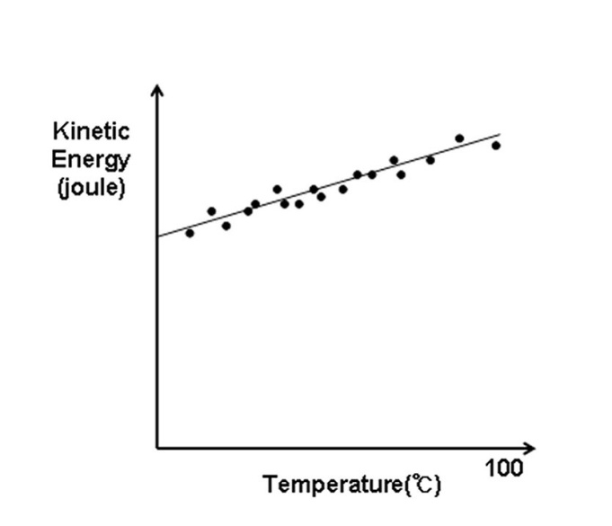

At thermal equlibrium, the average kinetic energy is the same irrespective of particle masses (equipartition theorem).

The specific heat capacity, at constant volume, of argon (atomic weight, 40) gas is 0.31 J g-1 K-1.

1-2. Calculate Avogadro's number without using the ideal gas law, the gas constant, Boltzmann’s constant).

**2. Detection of Hydrogen (5 pts)**

Hydrogen is prevalent in the universe. Life in the universe is ultimately based on hydrogen.

2-1. There are about 1023 stars in the universe. Assume that they are like our sun (radius, 700,000 km; density, 1.4 g/cm3; 3/4 hydrogen and 1/4 helium by mass). Estimate the number of stellar protons in the universe to one significant figure.

In the 1920s, Cecilia Payne discovered, by spectral analysis of starlight, that hydrogen is the most abundant element in most stars.

2-2. The electronic transition of a hydrogen atom is governed by ∆*E*(*n*i→*nf*) = -C(1/*nf*2 - 1/*n*i2), where *m* and *n* are principle quantum numbers, and C is a constant. For detection of the ∆*E*(*3*→*2*) transition (656.3 nm in the Balmer series), the electron in the ground state of the hydrogen atom needs to be excited first to the *n* = 2 state. Calculate the wavelength (in nm) of the absorption line in the starlight corresponding to the ∆*E*(*1*→*2*) transition.

2-3. According to Wien's law, the wavelength (*λ*) corresponding to the maximum light intensity emitted from a blackbody at temperature *T* is given by *λT* = 2.9×10-3 m K. Calculate the surface temperature of a star whose blackbody radiation has a peak intensity corresponding to the *n* = 1 → *n* = 2 excitation of hydrogen.

The ground state of hydrogen is split into two hyperfine levels due to the interaction between the magnetic moment of the proton and that of the electron. In 1951, Purcell discovered a spectral line at 1420 MHz due to the hyperfine transition of hydrogen in interstellar space.

2-4. Hydrogen in interstellar space cannot be excited electronically by starlight. However, the cosmic background radiation, equivalent to 2.7K, can cause the hyperfine transition. Calculate the temperature of a blackbody whose peak intensity corresponds to the 1420 MHz transition.

2-5. Wien generated hydrogen ions by discharge of hydrogen gas at a very low pressure and determined the e/m value, which turned out to be the highest among different gases tested. In 1919, Rutherford bombarded nitrogen with alpha-particles and observed emission of a positively charged particle which turned out to be the hydrogen ion observed by Wien. Rutherford named this particle the “proton”. Fill in the blank.

**3. Interstellar Chemistry (5 pts)**

Early interstellar chemistry is thought to have been a prelude to life on Earth. Molecules can be formed in space via heterogeneous reactions at the surface of dust particles, often called the interstellar ice grains (IIGs). Imagine the reaction between H and C atoms on the IIG surface that forms CH. The CH product can either desorb from the surface or further react, through surface migration, with adsorbed H atoms to form CH2, CH3, etc.

Depending on how energetically a molecule “jumps” from its anchored site, it either leaves the surface permanently (desorption) or returns to a new position at the surface (migration). The rates of desorption and migratory jump follow the Arrhenius formula, *k* = *A* exp(-*E*/R*T*), where *k* is the rate constant for desorption or migratory jump, *A* the jumping frequency, and *E* the activation energy for the respective event.

**3-1.** Desorption of CH from the IIG surface follows first-order kinetics.Calculate the average residence time of CH on the surface at20 K. Assume that *A* = 1 x 1012 s-1 and *E*des = 12 kJ mol-1.

**3-2.** Consider the shortest time it would take for one CH unit to move from its initial position to the opposite side of an IIG by successive migratory jumps. Assume that the activation energy for migration (*E*mig) is 6 kJ mol-1, and the IIG is a sphere with a 0.1 μm radius. Each migratory jump laterally advances the molecule by 0.3 nm. Show work and choose your answer from (a)-(e) below.

(a) *t* ≤ 1 day (b) 10 day ≤ *t* ≤ 102 yr (c) 103 yr ≤ *t* ≤ 106 yr

(d) 107 yr≤ *t* ≤ 1010 yr (e) *t* ≥ 1011 yr

**3-3.** Consider the reaction of CO with H2 to form H2CO. The activation energy on a metal catalyst is 20 kJ mol-1, which produces formaldehyde at a rate of 1 molecule/s per site at 300 K. Esitmate the rate of formaldehyde formation per site if the reaction takes place at 20 K.

**3-4.** Which is a set of all true statements? Circle one.

1. Most CH species desorb from the IIG surface before encountering other reactants by surface migration.
2. IIGs can assist transformation of simple molecules to more complex ones in interstellar space.
3. For a reaction on the IIG to occur at an appreciable speed during the age of the Universe (1 x 1010 yr), the reaction energy barrier must be absent or negligible.

(a) (b) (c) (a, b) (a, c) (b, c) (a, b, c)

**4. The Chemistry of DNA (5 pts)**

4-1. In 1944 Oswald Avery isolated a genetic material and showed, by elemental analysis, that it was a sodium salt of deoxyribonucleic acid. A segment of DNA with formula mass of 1323.72 is shown.

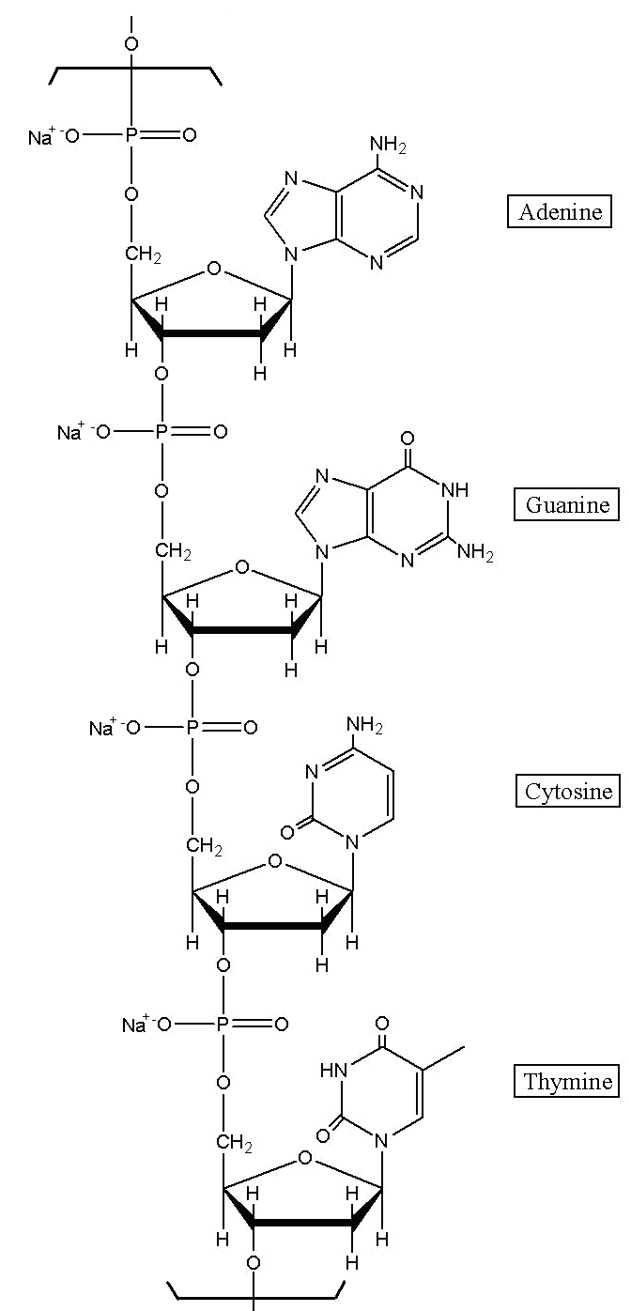

Assuming that equimolar amounts of the four bases are present in DNA, write the number of H atoms per P atom. Calculate, to 3 significant figures, the theoretical weight percentage of H expected upon elemental analysis of DNA.

4-2. Chargaff extracted the separated bases and determined their concentrations by measuring UV absorbance. The Beer-Lambert law was used to obtain the molar concentration. Chargaff discovered the following molar ratio for bases in DNA:

       adenine to guanine = 1.43         thymine to cytosine = 1.43

       adenine to thymine = 1.02         guanine to cytosine = 1.02

Chargaff’s discovery suggested that the bases might exist as pairs in DNA. Watson and Crick mentioned in their celebrated 1953 paper in *Nature*: "It has not escaped our notice that the specific pairing we have postulated immediately suggests a possible copying mechanism for the genetic material."

Draw structures of the specific pairing found in DNA. Indicate hydrogen bonds. Omit the sugar-phosphate backbone.

4-3. Mutation can occur through base pairings different from the above. Draw structures of any three alternative base pairs.

4-4. The plausibility of the formation of purine and pyrimidine bases in the prebiotic atmosphere of the Earth from HCN, NH3, and H2O has been demonstrated in the laboratory. Write the minimum number of HCN and H2O molecules required for formation of the following compounds.



**5. Acid-Base Chemistry**  **(5 pts)**

**5-1.** Calculate [H+], [OH-], [HSO4-], and [SO42-] in a 1.0 x 10-7 M solution of sulfuric acid (*K*w = 1.0 x 10-14, *K*2 = 1.2 x 10-2 at 25oC). In your work you may use mass- and charge-balance equations. Answer with two significant figures.

**5-2.** Calculate the volume of 0.80 M NaOH solution that should be added to a 250 mL aqueous solution containing 3.48 mL of concentrated phosphoric acid in order to prepare a pH 7.4 buffer. Answer with three significant figures. (H3PO4 (aq), purity = 85 % wt/wt, density = 1.69 g/mL, FW = 98.00) (p*K*1 = 2.15, p*K*2 = 7.20, p*K*3 = 12.44).

**5-3.** The efficacy of a drug is greatly dependent on its ability to be absorbed into the blood stream. Acid-base chemistry plays an important role in drug absorption.

H

+ A

HA

HA

H

+

+ A

Membrane

**Stomach**

**pH = 2.0**

**Blood**

**pH = 7.4**

H

+

+ A

-

HA

HA

H

+ A

-

Membrane

Assume that the ionic form (A-) of a weakly acidic drug does not penetrate the membrane, whereas the neutral form (HA) freely crosses the membrane. Also assume that equilibrium is established so that the concentration of HA is the same on both sides. Calculate the ratio of the total concentration ([HA] + [A-]) of aspirin (acetylsalicylic acid, p*K* = 3.52) in the blood to that in the stomach.

**6. Electrochemistry (5 pts)**

Water is a very stable molecule, abundant on earth and essential for life. As such, water was long thought to be a chemical element. However, soon after the invention of a voltaic cell in 1800, Nicholson and Carlyle decomposed water into hydrogen and oxygen by electrolysis.

**6-1.** Water can be thought of as hydrogen oxidized by oxygen. Thus, hydrogen can be recovered by reduction of water, using an aqueous solution of sodium sulfate, at a platinum electrode connected to the negative terminal of a battery. The solution near the electrode becomes basic. Write a balanced half-reaction for the reduction of water.

**6-2.** Water can also be thought of as oxygen reduced by hydrogen. Thus, oxygen can be recovered by oxidation of water at the Pt electrode connected to the positive terminal. Write a balanced half-reaction for the oxidation of water.

**6-3.** When copper is used at both electrodes, gas is generated only at one electrode during the initial stage of electrolysis. Write the half-reaction at the electrode that does not generate gas.

Another species in solution that can be reduced is sodium ion. The reduction of sodium ion to metallic sodium does not occur in aqueous solution, because water is reduced first. However, as Humphrey Davy discovered in 1807, sodium can be made by electrolysis of fused sodium chloride.

**6-4.** Based on these observations, connect the half-reactions with the standard reduction potential (in volts).

Reduction of copper ion (Cu2+) · -------------------- ·   +0.340

Reduction of oxygen            ·                         ·   -2.710

Reduction of water             ·                         ·   -0.830

Reduction of sodium ion (Na+)      ·                         ·   0.000

Reduction of hydrogen ion    ·                         ·   +1.230

The electrode potential is affected by other reactions taking place around the electrode. The potential of the Cu2+/Cu electrode in a 0.100 M Cu2+ solution changes as Cu(OH)2 precipitates. Answer with 3 significant figures for the following problems. The temperature is 25oC. Note that Kw = 1.00 x 10-14 at 25oC.

**6-5.** Precipitation of Cu(OH)2 begins at pH = 4.84. Determine the solubility product of Cu(OH)2.

**6-6.** Calculate the standard reduction potential for Cu(OH)2(s) + 2e- → Cu(s) + 2OH-.

**6-7.** Calculate the electrode potential at pH = 1.00.

Lithium cobalt oxide and specialty carbon are active ingredients for the positive and negative electrodes, respectively, of a rechargeable lithium battery. During the charge/recharge cycles, the following reversible half-reactions occur.

        LiCoO2  Li1-x CoO2 + x Li+ + x e-

        C + x Li+ + x e-  CLix

The total amount of energy a battery can store is rated in mAh. A battery rated at 1500 mAh can power a device drawing 100 milliamps for 15 hours.

**6-8.** Graphite has lithium intercalation sites between its layers. Assuming a maximum 6:1 carbon-to-lithium intercalation stoichiometry, calculate the theoretical charge capacity of 1.00 gram of graphite to intercalate lithium. Answer in mAh/g with 3 significant figures.

**7. Hydrogen Economy (4 pts)**

Hydrogen is more energy-dense than carbon, by mass. Thus, historically there has been a move toward fuel with higher hydrogen content: coal → oil → natural gas → hydrogen. Cost-effective production and safe storage of hydrogen are two major hurdles to the successful inauguration of a hydrogen economy.

**7-1.** Consider hydrogen in a cylinder of 80 MPa at 25 oC. Using the ideal gas law, estimate the density of hydrogen in the cylinder in kg/m3.

**7-2.** Calculate the ratio between heat generated when hydrogen is burned and heat generated when the same weight of carbon is burned. The difference comes to a large extent from the fact that the most abundant isotope of hydrogen has no neutron and hydrogen has no inner electron shell. Δ*H*fo [H2O(l)] = -286 kJ/mol, Δ*H*fo [CO2(g)] = -394 kJ/mol.

**7-3.** Calculate the theoretical maximum work produced by the combustion of 1 kg hydrogen (a) from the electric motor using hydrogen fuel cell and (b) from the heat engine working between 25 oC and 300 oC. The efficiency (work done/heat absorbed) of an ideal heat engine working between *T*cold and *T*hot is given by [1 – *T*cold/*T*hot].

*S*o298[H2(g)] = 131 J/(K mol)

*S*o298[O2(g)] = 205 J/(K mol)

*S*o298[H2O(l)] = 70 J/(K mol).

If the fuel cell is working at 1 W and the standard potential difference, how long will the electric motor run at what current?

**8. Chemistry of Iron Oxides (5 pts)**

The nucleus of iron is the most stable among all elements and, therefore, iron accumulates at the core of massive red giant stars where nucleosynthesis of many elements essential for life (such as C, N, O, P, S, etc.) takes place. As a result, among heavy elements iron is quite abundant in the universe. Iron is also abundant on Earth.

**8-1.** Development of a technology for reducing iron oxide to iron was a key step in human civilization. Key reactions taking place in the blast furnace are summarized below.

C(*s*) + O2(*g*) → CO2(*g*) ΔH◦ = -393.51 kJ(/mol) ----- ①

CO2(*g*) + C(*s*) → 2CO(*g*) ΔH◦ = 172.46 kJ(/mol) ----- ②

Fe2O3(*s*) + CO(*g*) → Fe(*s*) + CO2(*g*)ΔH◦ = ? ------------------- ③

**8-1-1.** Indicate the reducing agent in each reaction.

**8-1-2.** Balance reaction ③ and calculate the equilibrium constant of reaction ③ at 1200 oC. (ΔHf◦(Fe2O3(*s*)) = -824.2 kJ/mol, S°(J/mol/K): Fe(*s*) = 27.28, Fe2O3(*s*) = 87.40, C(*s*) = 5.74, CO(*g*) = 197.674, CO2(*g*) = 213.74)

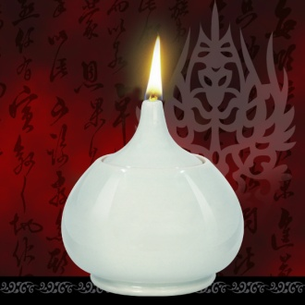

**8-2.** In the manufacture of celadon pottery, Fe2O3 is partially reduced in a charcoal kiln to mixed oxides of Fe3O4 and FeO. The amount of the different oxides seems to be related to the “mystic” color of celadon ceramics.

Fe3O4 (magnetite) itself is a mixed oxide containing Fe2+ and Fe3+ ions and belongs to a group of compounds with a general formula of AB2O4. The oxide ions form a face-centered cubic array. The figure shows the array of oxygens (gray circles) and representative sites for divalent A and trivalent B cations. The dark circle represents a tetrahedral site and the white circle an octahedral site.

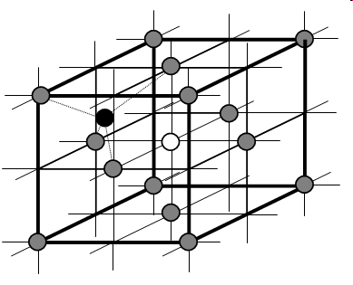

**8-2-1.** How many available octahedral sites for iron ions are there in one AB2O4 unit? Certain sites are shared by neighboring units.

AB2O4 can adopt a normal- or an inverse-spinel structure. In normal-spinel structure, two B ions occupy two of the octahedral sites and one A occupies one of the tetrahedral sites. In an inverse-spinel structure, one of the two B ions occupies a tetrahedral site. The other B ion and the one A ion occupy octahedral sites.

**8-2-2.** What percentage of available tetrahedral sites is occupied by either Fe2+ or Fe3+ ion in Fe3O4?

**8-2-3** Fe3O4 has an inverse-spinel structure. Draw the crystal field splitting pattern of Fe2+ and fill out the electrons. The electron pairing energy is greater than the octahedral field splitting.

**9. Photolithographic process (5 pts)**

Photolithography is a process used in [semiconductor device fabrication](http://en.wikipedia.org/wiki/Fabrication_%28semiconductor%29) to transfer a pattern from a [photomask](http://en.wikipedia.org/wiki/Photomask) to the surface of a [substrate](http://en.wikipedia.org/wiki/Wafer_%28electronics%29). In a typical photolithography process, light is projected, through a mask that defines a particular circuitry, onto a silicon wafer coated with a thin layer of photoresist.

9-1. The earliest photoresists were based on the photochemistry that generates a reactive intermediates from bis(aryl azide). Patterning becomes possible through the cross-linking reaction of the nitrenes generated from the azides.



9-1-1. Draw two possible Lewis structures of CH3-N3, the simplest compound having the same active functional group of bis(aryl azide). Assign formal charges.

9-1-2. Draw the Lewis structure of nitrene expected from CH3-N3.

9-1-3. Draw the structures for two possible products, when this nitrene from CH3-N3 reacts with ethylene gas (CH2CH2).

9-2. Photoresists consisting of Novolak polymers, utilizes acid to change their solubility. The acid component can be produced photochemically from diazonaphthaquinone. In fact, “Novolaks” have been the representative “positive” photoresists of the modern microelectronic revolution.



When irradiated, diazonaphthaquinone undergoes photochemical decomposition followed by rearrangement eventually producing a carboxylic acid.



9-2-1. Draw three Lewis structures of diazoacetaldehyde (see below), the simplest compound having the same active functional group of diazonaphthaquinone. Indicate formal charges.



diazoacetaldehyde

9-2-2. Draw a Lewis structure of the rearranged intermediate, A (see below), generated from diazoacetaldehyde after losing N2. A satisfies Lewis’ octet rule and reacts with water to form acetic acid, CH3CO2H.



9-3. Advanced photoresists were invented in 1982 based on chemical amplification. The most popular chemical amplification for positive-tone involves the acid catalyzed deprotection of poly(*p*-hydroxystyrene) resin protected by various acid-sensitive protecting groups such as *t*-butyloxycarbonyl (*t*-BOC).



The thermal decomposition of carbonate ester itself normally occurs well above 150℃.

9-3-1. Two plausible mechanisms have been suggested for this decomposition reaction having relatively high activation energy. Draw expected intermediates and products from this reaction.



9-3-2. In the presence of a trace amount of acid, the reaction temperature can be reduced to below 100℃. Draw expected intermediate F from the following chemical amplification processbased on using *t*-BOC.



**10. Natural Products – Structural Analysis (9 pts)**

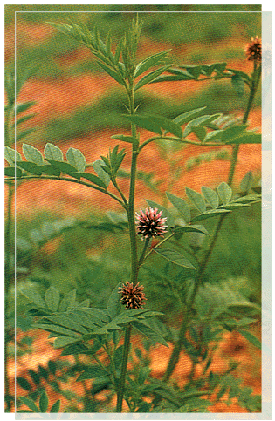 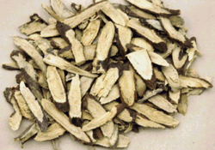

Licorice (Glycyrrhizia. Uralensis) Licorice Root

The flavor extracted from the licorice root is 50 – 150 times sweeter than table sugar.

The most important and abundant compound responsible for the sweetness and medicinal effects of licorice is *glycyrrhizin* (C42H62O16).

*Glycyrrhizin* requires three equivalents of NaOH to effect neutralization.

``When *glycyrrhizin* was subjected to acid hydrolysis, *Glycyrrhizinic* *acid* (**A** (C30H46O4)) and **B** (C6H10O7) were obtained in a 1:2 molar ratio (figure 1).

**Figure 1**.



When *glycyrrhizin* was methylated with methyl iodide (MeI) at every possible site before hydrolysis, hydrolysis produced **A’** (methyl glycyrrhizinate), **C** and **D** (figure 2). B, C and D exist as mixtures of anomers.

**Figure 2.**



Methylation of **C** and **D** with MeI produced the same isomeric mixture of compounds, **J** (figure 3.)

**Figure 3.**



**C** was reduced with LiAlH4 to give **K**, and **L** was produced by the reduction of **K**. Oxidative cleavage of vicinal diol of **L** with NaIO4 produced **M** and two equivalents of formaldehyde. Reduction of **M** produced **N**. The structure and stereochemistry of **N** was confirmed by the synthesis of **N** from D-(-)-tartaric acid through methylation followed by reduction (figure 4). A 1H-NMR spectrum of **L** showed two distinct peaks for methyl groups. (There is no symmetry in L)

**Figure 4.**



**10-1.** Complete structures for **L , M, and N** in the answer sheet.

**10-2.** How many structures for **C** are possible? Complete possible structures for **C**.

To determine the correct structure of **C**, following set of reactions were performed.

**J** was reduced to **E,** and acid hydrolysis of **E** produced **F**. Reduction of **F** generated **G,** and **G** was oxidized with NaIO4 to **H** with formation ofone equivalent of formaldehyde. **I** was obtained from **H** through reduction. Among all compounds from **A** to **I**, only **I** was optically inactive (figure 5).

**Figure 5**



**10-3**. Complete structures for **G** and **I**.

**10-4**. Which one is the correct structure for **C** among ones you have drawn in **10-2**?

**10-5.** Complete structures for **B, D,** and **J**.

**10-6.** Complete the structure for Glycyrrhizin.

**11. Enzyme Reaction (7 pts)**

Shikimic acid biosynthesis is an important pathway for amino acids, alkaloids and heterocyclic natural product production. Nature converts shikimic acid to chorismic acid through a cascade of enzymatic reactions. Then chorismate mutase catalyzes the conversion of chorismic acid to prephenic acid at the branch point for the biosynthesis of aromatic amino acids such as tyrosine and phenylalanine.



**11-1.** During the transformation of shikimic acid to chorismic acid, dehydration is occurring. Choose the hydroxyl group in shikimic acid that is lost through above dehydration among all possible reactions.

**11-2.** Chorismate mutase rearranges chorismic acid into prephenic acid without changing the molecular formula. Chorismic acid becomes prephenic acid through the Claisen rearrangement, a concerted pericyclic process like the Cope rearrangement as shown below:



Based on the following spectral data, propose the structure of prephenic acid.

1H-NMR (D2O, 250 MHz):  6.01 (2H, d, J = 10.4 Hz), 5.92 (2H, dd J = 10.4, 3.1 Hz), 4.50 (1H, t, J = 3.1 Hz), 3.12 (2H, s). Note that there are three protons, which have been exchanged by D2O very fast, and two protons at  3.12, which are exchanged slowly in prephenic acid.  13C-NMR (D2O, 75 MHz):  203, 178, 173, 132 (for two identical carbons), 127 (for two identical carbons), 65, 49, 48.

, chemical shift; H, integrals; d, doublet; dd, doublet of doublet; J, coupling constant; t, triplet; s, singlet

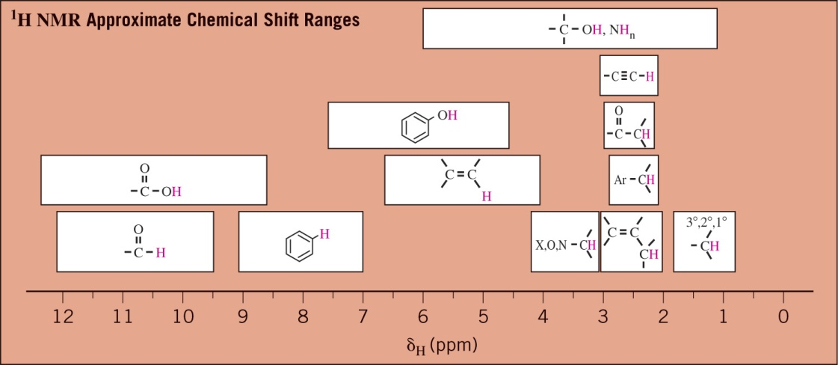

Chorismate mutase is believed to stabilize the transition state of Claisen rearrangement. Thus it is an interesting target for inhibitor design. Inhibitors, called transition state analog (TSA)s that resemble the transition state (TS, *e.g.*, the species in brackets “[ ]” above) of the reaction are designed to occupy the active site. Several inhibitors were designed and synthesized, and among them eight turned out to be potent inhibitors of the enzyme. The lower the IC50 (inhibitor concentration of 50% of the enzymatic activity) value, the better the inhibitor.



**11-3.** Choose all correct statements based on the structures and IC50 values of above inhibitors. Increase of factor 5 is considered to be important.

(a) Configuration of the hydroxyl group plays an important role in the TS and inhibitor design.

(b) The presence of both carboxylic groups is important in the TS and inhibitor design.

(c) Transition state of the reaction contains two six-membered rings with one chair and one twist-boat conformation.

(d) **7** and **8** can be distinguished on the basis of the 1H-NMR of Ha.

**11-4.** Draw the transition state of the transformation of chorismic acid to prephenic acid based on the TSA structures and their IC50 values.

**11-5.** Compared with the uncatalyzed thermal conversion, chorismate mutase accelerates conversion of chorismic acid to prephenic acid 1.0 x 106 fold at 25oC by lowering the activation energy of the reaction. Calculate the decrease in activation energy of chorismate mutase at 25oC.

*H*≠uncat is 86,900 J/mol for the thermal conversion of chorismic acid to prephenic acid. At what temperature will the rate of the *uncatalyzed* thermal conversion be the same as that of the *enzyme-catalyzed* conversion at 25oC, assuming that Ea = *H*≠.

|  |
| --- |
| **1-1.** |
| 1.21-2. |

|  |
| --- |
| **2-1.** |
| **2-2.** |
| **2-3.** |
| **2-4.** |
| **2-5.**  14N + 4He → ( )  + 1H |

|  |  |
| --- | --- |
| **3-1.** | |
|  | **residence time = s** |
| **3-2.** | |
|  | (a) (b) (c) (d) (e) |
| 3-3. | |
|  | rate = molecules/site/yr |
| 3-4. circle one  (a) (b) (c) (a, b) (a, c) (b, c) (a, b, c) | |

|  |
| --- |
| **4-1.**  H P  Number of atoms ( ) 1  Theoretical wt % ( ) ( ) |
| **4-2.** |
| **4-3.** |
| **4-4.**    HCN ( ) ( ) ( ) ( )  H2O ( ) ( ) ( ) ( ) |

|  |  |  |  |  |  |  |  |  |  |  |
| --- | --- | --- | --- | --- | --- | --- | --- | --- | --- | --- |
| **5-1.**   |  |  | | --- | --- | | **Species** | **Concentration** | | HSO4- |  | | SO42- |  | | H+ |  | | OH- |  | |

|  |  |  |
| --- | --- | --- |
| **5-2.** | | |
|  | Total volume of 0.80 M NaOH (mL) |  |

|  |  |  |
| --- | --- | --- |
| **5-3.** | | |
|  | **Ratio of total aspirin in blood to that in stomach** |  |

|  |  |
| --- | --- |
| **6-1.** | |
| **6-2.** | |
| **6-3.** | |
| **6-4.** | |
|  | **Reduction of oxygen ▪ ▪ -2.710**  **Reduction of water ▪ ▪ -0.830**  **Reduction fo sodium ion (Na+) ▪ ▪ 0.000**  **Reduction of hydrogen ion ▪ ▪ +1.230** |
| **6-5.** | |

|  |  |
| --- | --- |
| **6-6.** | |
|  |  |
| **6-7.** | |
|  |  |

|  |  |
| --- | --- |
| **6-8.** | |
|  |  |

|  |  |
| --- | --- |
| **7-1.** | |
|  |  |
| **7-2.**   |  | | --- | |  | | |
| **7-3.**   |  | | --- | |  | | |

|  |  |  |  |
| --- | --- | --- | --- |
| **8-1-1.**   |  |  |  | | --- | --- | --- | | ① | ② | ③ | |
| **8-1-2.**   |  |  | | --- | --- | |  |  | |
| 8-2-1.   |  | | --- | |  | |
| 8-2-2.   |  | | --- | |  | |
| 8-2-3. |

|  |
| --- |
| **9-1-1.** |
| **9-1-2** |
| **9-1-3.** |
| 9-2-2. |

|  |
| --- |
| 9-3-1. |
| 9-3-2. |

|  |  |  |  |  |  |  |  |  |  |  |  |  |  |  |  |  |  |  |  |  |  |
| --- | --- | --- | --- | --- | --- | --- | --- | --- | --- | --- | --- | --- | --- | --- | --- | --- | --- | --- | --- | --- | --- |
| **10-1.**  **10-2.**   |  |  |  | | --- | --- | --- | | **Number of possible structures** |  |  | | **1** | **2** | | |  |  | | | **3** | **4** | | |  |  | |  |  |  |  | | --- | --- | --- | | N | M | L | |  |  |  | |

|  |  |  |  |  |  |  |  |  |  |  |  |  |  |  |
| --- | --- | --- | --- | --- | --- | --- | --- | --- | --- | --- | --- | --- | --- | --- |
| **10-3.**   |  |  | | --- | --- | | G | I | |  |  |   10-4.   |  | | --- | | Number of the correct structure for **C** from **10-2** | |  |   **10-5.**   |  |  | | --- | --- | | **B** |  | |  |  | | **D** | **J** | |  |  | |

|  |
| --- |
| **10-6.** |

|  |
| --- |
| **11-1.** |
| **11-2.** |
| **11-3.** |
| **11-4** |

|  |  |
| --- | --- |
| **11-5.** | |
|  |  |

**Chemistry for Life,**

**Chemistry for better Life**

**General Directions**

**2006. 7. 5**

**Gyeongsan, Korea**

##### Practical Test

* **You have 5 hours to finish the test. Manage your time wisely. You might spend about one hour for Test 1 (10 points), two hours for Test 2 (15 points), and two hours for Test 3 (15 points).**
* **Write your name and code number on each page of the Answer Sheet.**
* **There are 7 pages of Test and 7 pages of Answer Sheet.**
* **Write answers and calculations within the designated box.**
* **Use only the pen, ruler, and calculator provided**
* **An English-language version is available.**
* **Figures to supplement User’s Instructions for the spectrophotometer, C-18 cartridge, and pipet filler are provided in a separate sheet.**
* **Additional samples or supplies will be provided with 1 pt penalty for each item. (except distilled water)**
* **You may go to the restroom with permission.**
* **After finishing the test, place all sheets (Test and Answer Sheets) in the envelope and seal.**
* **Remain seated until instructed to leave the room.**
* **You may take the pencil case, pen, ruler, calculator, and C-18 cartridges home.**

**Safety and Disposal**

* **Wear safety goggles and lab coat.**
* **No hazardous chemicals are used. All acid, alkali, and dye solutions are dilute. However, it is better to minimize contact with skin. Wipe off with wet Kimwipe in case of contact.**
* **Do not sniff reagents.**
* **Dispose used chemicals in the plastic bottle labeled “DISPOSABLE”. Discard used test tubes and broken glasses in the “Waste Basket”.**

# Apparatus, Chemicals and Supplies

# Test-1,2 (white basket)

|  |  |  |  |
| --- | --- | --- | --- |
| **spectrophotometer** | | | **1** |
| **cuvet (1 cm path-length)** | | | **1** |
| **C18 cartridge** | | | **4** |
| **10 mL syringe** | | | **1** |
| **1 mL syringe** | | | **1** |
| **pasteur pipet** | | | **3** |
| **1 mL pipet** | | | **1** |
| **5 mL pipet** | | | **1** |
| **pipet filler** | | | **1** |
| **10 mL volumetric flask** | | | **2** |
| **buret** | | | **1** |
| **test tube** | | | **20** |
| **test tube rack** | | | **1** |
| **50 mL Erlenmeyer flask** | | | **1** |
| **100 mL beaker** | | | **2** |
| **silicone bulb** | | | **2** |
| **three-color pen, ruler** | | | **1** |
| **sqeeze bottle** | | | **3** |
| **labeled as** | **Solution E** | **33% ethanol in water** | |
| **NaOH solution** | **less than 5 mM** | |
| **water** | **distilled water** | |
| **100 mL bottle** | | | **6** |
| **labeled as** | **Solution R** | **red dye**  **in Solution E** | |
| **Solution B** | **blue dye**  **in Solution E** | |
| **Solution MD** | **mixed dye of B and R** | |
| **Solution MA** | **mixed acids; acetic acid & salcylic acid**  **in water** | |
| **KHP** | potassium hydrogen phthalate solution | |
| **phenolphthalein** | **0.05% solution** | |

# Test-3 (black basket)

|  |  |  |  |
| --- | --- | --- | --- |
| **test tube** | | | **95** |
| **test tube rack** | | | **1** |
| **spatula** | | | **2** |
| **1.5 mL graduated pipet (polyethylene)** | | | **15** |
| **tweezers** | | | **1** |
| **pen (for writing on a test tube)** | | | **1** |
| **pH test paper** | | | **1** |
| **100 mL bottle** | | | **3** |
| **labeled as** | **95% EtOH** | **95% ethanol** | |
| **CH3CN** | **acetonitrile** | |
| **water** | **distilled water** | |
| **30 mL dropping bottle** | | | **6** |
| **labeled as** | **1M HCl** | **1M HCl solution** | |
| **1M NaOH** | **1M NaOH solution** | |
| **2,4-DNPH** | **3% 2,4-dinitrophenylhydrazine solution** | |
| **CAN** | **20% ceric ammonium nitrate solution** | |
| **0.5% KMnO4** | **0.5% KMnO4 solution** | |
| **2.5% FeCl3** | **2.5% FeCl3 solution** | |
| **10 mL vial** | | | **7** |
| **labeled as** | **Set🗖 U-1** | | |
| **Set🗖 U-2** | | |
| **Set🗖 U-3** | | |
| **Set🗖 U-4** | | |
| **Set🗖 U-5** | | |
| **Set🗖 U-6** | | |
| **Set🗖 U-7** | | |

**The spectrophotometer has three compartments, the light source, the detector, and the cuvet holder. You will find the cover of the cuvet holder open. Leave it open. A cuvet is placed with the label facing the light source (Fig. A). Use this orientation throughout the experiment. The spectrophotometer has been stabilized and is ready for use. Follow the procedure below to take absorbance readings.**

1. **Fill the cuvet about 3/4-full with Solution E and insert into the cuvet holder. Do not close the cover of the cuvet holder.**
2. **Using the mouse of the computer, move the cursor to REFERENCE and click three times. Then click MEASURE three times and you will get absorbance readings close to zero at ten wavelengths between 470 and 650 nm at 20 nm intervals (Fig. B).**
3. **Fill the cuvet with sample solution and click MEASURE three times. You will get absorbance readings for your sample at the same wavelengths. Record absorbance values in the Table in the Answer Sheet.**

## How to Use the C18 Cartridge

1. **The cartridge has an inlet and an outlet (Fig. C). The inlet has a larger diameter.**
2. **To wash or elute, first withdraw the liquid with a proper syringe and connect the syringe to the inlet of the cartridge. Then push the liquid slowly with a plunger into the cartridge. (Fig. C & E)**
3. **To load the sample, attach the 10 mL syringe to the inlet of the cartridge. Using a 1 mL pipet, transfer 1.00 mL aliquot of a sample solution to the syringe (Fig. D). Load the sample onto the cartridge using the plunger. Make sure that no amount of sample remains on the syringe. Try to avoid air entering into the cartridge after sample loading.**
4. **The cartridge can be reused after washing with Solution E.**
5. **Separate the syringe from the cartridge when removing the plunger from the syringe.**

## How to Use the Pipet Filler

**Move the dial downward to fill the pipet and upward to release the liquid (see Fig. F).**

###### Practical Test 1

Reverse-phase Chromatography:

Spectrophotometric Analysis

**Chromatographic separation followed by spectrophotometric analysis is one of the most widely practiced analytical techniques in chemical laboratories around the world. For example, organic compounds in a complex mixture are often analyzed by reverse-phase liquid chromatography with spectrophotometric detection. In reverse-phase chromatography, hydrophobic interactions between the stationary phase material (usually octadecyl group) and the nonpolar moiety of the analyte is utilized. The chromatogram can be simplified and the compound of interest selectively determined by proper choice of the detector wavelength. In this part of the Practical Test, spectrophotometric analysis of dyes, with and without separation, will be performed.**

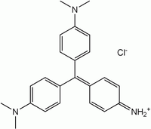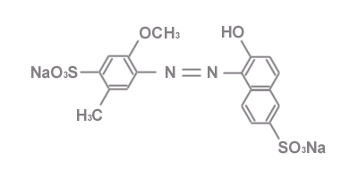

**Food Red No. 40 Methyl Violet 2B**

**1-1. Spectrophotometric Analysis of R and B in a Mixed Solution**

**a) Measure absorbance of both Solutions R (3.02 x 10-5 M) and B (1.25 x 10-5 M) (Fig. A & B). Fill in the Table in the Answer Sheet with your measurements. Draw absorption spectra for the red dye in red ink and for the blue dye in blue ink (Fig. 1-1).**

**b) Repeat absorbance measurements for Solution MD. Solution MD is a mixture of Solution R and B in a certain ratio. Add the spectrum in black ink to Fig. 1-1.**

**c) Based on the Beer-Lambert law, determine the molar concentration of both dyes in Solution MD using the data in the Table. Do not determine the fraction of one dye by subtracting the fraction of another dye from 1.**

**1-2. Chromatographic Separation Followed by Spectrophotometric Analysis**

**a) Elute the cartridge with about 10 mL of Solution E using 10 mL syringe (Fig. C).**

**b) Load 1.00 mL of solution MD onto the cartridge (Fig. D).**

**c) Using 1 mL syringe, elute with Solution E (Fig. E). Collect the solution eluting through the outlet in a 10 mL volumetric flask. Repeat until the red compound is completely eluted and collected.**

**d) Fill the flask to the 10 mL mark with Solution E and mix. Call this Solution F.**

**e) Obtain the absorption spectrum of solution F as in Experiment 1-1. Dilution takes place during elution. Therefore, multiply the measured absorbance by 10 when drawing the spectrum for Solution F. Draw spectrum with broken line in Fig. 1-1 in red ink.**

**f) Dilute Solution R as necessary and construct a calibration curve, at a wavelength of your choice, for analysis of the red dye (R) in Solution F. Draw a calibration curve in the answer sheet (X-axis, concentration; Y-axis, absorbance, Fig. 1-2). Indicate the wavelength used. The calibration curve must have three points in addition to the origin. Mark the position of Solution F on the calibration curve.**

**g) Report the concentration of R in the original Solution MD.**

**h) Compare this concentration with the value you obtained in Experiment 1-1 and report the recovery (amount eluted/amount loaded) associated with chromatography.**

**Practical Test 2**

Reverse-phase Chromatography:

**Acid-Base Titration of Acetic Acid and Salicylic Acid**

**Acetic acid (AA) and salicylic acid (SA) are slightly different in polarity and thus can be separated on a reverse-phase cartridge using distilled water as eluent. AA is eluted first. The total amount of AA and SA in a mixed solution will be determined by titration. Then, AA and SA will be separately determined following chromatographic separation.**

**2-1. Determination of the Total Amount of AA and SA in a Mixed Acid (MA) Solution**

**a) Titrate 10 mL of distilled water with the NaOH (< 5 mM) solution provided. Report blank acidity in 1 mL of distilled water in terms of the volume of the NaOH solution. Take this blank acidity into account for all solutions in subsequent data analyses. Show corrections in the calculation part in the answer sheet.**

**b) Standardize NaOH solution with 2.00 mL of the standard KHP (potassium hydrogen phthalate) solution (1.00 x 10-2 M) provided. Repeat and report the concentration of the NaOH solution. Show how you accounted for the blank acidity.**

**c) Withdraw 1.00 mL of Solution MA and determine the total acidity. Repeat and report the total number of moles of AA and SA combined in 1.00 mL of Solution MA.**

**2-2. Reverse-phase Separation and Titration**

a) Elute a new C-18 cartridge with about 10 mL of distilled water using 10 mL syringe.

**b) Load 1.00 mL of Solution MA onto the cartridge. Collect the liquid eluting at the outlet in tube 1 (Fraction 1).**

c) Elute with 1 mL of distilled water. Collect the eluent in a test tube (Fraction 2). Repeat until Fraction 20 is collected. You will have 20 test tubes with about 1 mL liquid in each tube.

**d) Titrate acidity in each test tube. Report volume of the NaOH solution consumed and the amount of acid(s) in each test tube. Make a graph in the answer sheet (Fig. 2-2) showing the amount of acid(s) in each test tube.**

**e) Blank acidity and the background (due to leaching out of residual materials from the column) must be subtracted. In determining the amount of eluted AA, disregard tubes containing only trace amounts of acids. Tube 2 and 3 contain most AA. Calculate the total amount of AA eluted by adding the amount of AA in tubes. Similarly calculate the total amount of SA eluted. Indicate, in Fig. 2-2, which fractions you used to get the amount of each acid.**

**f) Calculate the mole percent of AA in solution MA.**

**Practical Test 3**

### Qualitative Analysis of Organic Compounds

**In this experiment your task is to identify seven solid unknowns from the list of compounds on page 7 that are common drugs in everyday life and valuable agents in organic chemistry. To achieve this, perform chemical tests on unknowns according to the following procedures and analyze your results.**

**- Unknowns Labeled**

**Set U-1, Set U-2, Set U-3, Set U-4, Set U-5, Set U-6, Set U-7**

**Procedure**

**Helpful Comments**

**a) The weight of a spatula tip-full of a solid is about 15~20 mg.**

**b) Wipe spatula cleanly with Kimwipe between uses.**

**c) After adding any reagent described below to a solution of an unknown sample, mix the contents thoroughly and observe the resulting mixture carefully.**

1. **To get full marks, you should perform all the tests and fill out the table.**

**Test 1: Solubility test**

**To a test tube, add a spatula tip-full (15~20 mg) of an unknown sample and 1 mL of CH3CN. Shake the test tube and report the solubility. Repeat the test with 1M HCl, water, and 1M NaOH.**

**Test 2: 2,4-DNPH test**

**Place about 15~20 mg of an unknown sample in a test tube and dissolve with 2 mL of 95% EtOH (For the water soluble unknowns, dissolve about 15~20 mg of an unknown in 1 mL of water). Add five drops of the 2,4-dinitrophenylhydrazine solution in concentrated sulfuric acid and 95% ethanol (labeled as 2,4-DNPH).**

**Test 3: CAN test**

**Mix 3 mL of the cerium(IV) ammonium nitrate solution in dilute HNO3 (labeled as CAN) with 3 mL of CH3CN in a test tube. In another test tube add about 15~20 mg of an unknown sample in 1 mL of the mixed solution. (For the water soluble unknown samples, dissolve about 15~20 mg of an unknown sample in 1 mL of water first, and then add 1 mL of CAN.) If there is a color change in the solution, the solution may contain alcohol, phenol or aldehyde.**

**Test 4: Baeyer test**

**In a test tube, dissolve about 15~20 mg of an unknown sample in 2 mL of CH3CN (For the water soluble unknown samples, dissolve about 15~20 mg of an unknown in 1 mL of water). To the solution, slowly add five drops of the 0.5% KMnO4 solution, drop by drop while shaking.**

**Test 5: pH test**

**In a test tube, dissolve about 15~20 mg of an unknown sample in 2 mL of 95% EtOH (For the water soluble unknown samples, dissolve about 15~20 mg of an unknown sample in 1 mL of water). Measure the pH of the solution with pH paper.**

**Test 6: Iron(III) chloride test**

**Take the solution from Test 5 and add five drops of a 2.5% FeCl3 solution.**

**Results**

**1. Record your test results in the answer sheet. Write *O* if soluble and *X* if insoluble for the solubility tests. Write (+) for the positive reactions and (–) for the negative reactions for tests 2 ~ 4 and 6. Write *a*, *b* and *n* for acidic, basic or neutral, respectively, for pH test 5.**

**2. Based on your test results, identify the most plausible structures for the unknown compounds from the provided list of compounds. Write the compound initial in appropriate box.**

**Possible Unknown Compounds**



|  |  |  |  |  |  |  |  |  |  |  |  |  |  |  |  |  |  |  |  |  |  |  |  |  |  |  |  |  |  |  |  |  |  |  |  |  |  |  |  |  |  |  |  |  |  |  |  |  |  |  |  |  |  |  |  |  |  |  |  |
| --- | --- | --- | --- | --- | --- | --- | --- | --- | --- | --- | --- | --- | --- | --- | --- | --- | --- | --- | --- | --- | --- | --- | --- | --- | --- | --- | --- | --- | --- | --- | --- | --- | --- | --- | --- | --- | --- | --- | --- | --- | --- | --- | --- | --- | --- | --- | --- | --- | --- | --- | --- | --- | --- | --- | --- | --- | --- | --- | --- |
| Circle the Set Number of Solution  **1 2 3 4 5 6 7 8**  MD & MA you received.   * 1. **Spectrophotometric Analysis of R and B in a Mixed Solution**   **a), b) Absorbance measurements (3 marks)**   |  |  |  |  |  | | --- | --- | --- | --- | --- | | **Wavelength (nm)** | **Absorbance** | | | | | **Solution R** | **Solution B** | **Solution MD** | | | **470** |  |  |  | | | **490** |  |  |  | | | **510** |  |  |  | | | **530** |  |  |  | | | **550** |  |  |  | | | **570** |  |  |  | | | **590** |  |  |  | | | **610** |  |  |  | | | **630** |  |  |  | | | **650** |  |  |  |  |    Fig. 1-1 Absorption spectra of dyes (9 marks) |

|  |  |  |  |  |
| --- | --- | --- | --- | --- |
| **c) Concentration of R & B (Beer-Lambert law) (25 marks)**   |  |  | | --- | --- | | **Concentration of R in solution MD** | **M** | | **Concentration of B in solution MD** | **M** | |

|  |  |  |  |  |  |  |  |  |  |  |  |  |  |  |  |  |  |  |  |  |  |  |  |  |  |  |  |  |  |  |  |  |
| --- | --- | --- | --- | --- | --- | --- | --- | --- | --- | --- | --- | --- | --- | --- | --- | --- | --- | --- | --- | --- | --- | --- | --- | --- | --- | --- | --- | --- | --- | --- | --- | --- |
| * 1. **Chromatographic Separation Followed by Spectrophotometric Analysis**   **e) solution F (3 marks)**   |  |  |  |  |  |  |  |  |  |  |  | | --- | --- | --- | --- | --- | --- | --- | --- | --- | --- | --- | | **Wavelength (nm)** | **470** | **490** | **510** | **530** | **550** | **570** | **590** | **610** | **630** | **650** | | **absorbance** |  |  |  |  |  |  |  |  |  |  |   **f) Calibration curve (25 marks)**   |  |  |  |  | | --- | --- | --- | --- | | **Concentration (M)** |  |  |  | | **Absorbance at ( ) nm** |  |  |  |    Fig. 1-2 Calibration curve   **g) Concentration of R in solution MD (30 marks)**   |  | | --- | | **M** |   **h) Percent recovery of R (5 marks)**   |  | | --- | | **%** | |

|  |  |  |  |  |  |  |  |  |  |  |  |  |  |  |  |  |  |  |  |  |  |  |  |  |  |  |  |  |  |  |  |  |  |  |  |  |
| --- | --- | --- | --- | --- | --- | --- | --- | --- | --- | --- | --- | --- | --- | --- | --- | --- | --- | --- | --- | --- | --- | --- | --- | --- | --- | --- | --- | --- | --- | --- | --- | --- | --- | --- | --- | --- |
| **2-1. Determination of the Total Amount of AA and SA in a Mixed Solution**  **a) blank titration (5 marks)**   |  |  | | --- | --- | | **Volume of NaOH solution consumed for blank titration** | **mL** | | **NaOH solution equivalent to blank acidity of 1 mL water** | **mL** |   **b) standardization of the NaOH solution (10 marks)**   |  |  |  |  |  | | --- | --- | --- | --- | --- | | **KHP used (mL)** | **NaOH consumed (mL)** | | **concentration of NaOH (M)** | | |  |  | |  | | |  |  | |  | | | **Concentration measured** | |  |   **c) total amount of AA and SA in 1.00 mL of Solution MA (10 marks)**   |  |  |  |  | | --- | --- | --- | --- | | **Solution MA used (mL)** | **NaOH consumed (mL)** | **AA and SA in 1 mL MA (mol)** | | |  |  |  | | |  |  |  | | | **Total amount measured** |  | |

|  |  |  |  |  |  |  |  |  |  |  |  |  |  |  |  |  |  |  |  |  |  |  |  |  |  |  |  |  |  |  |  |  |  |  |  |  |  |  |  |  |  |  |  |  |  |  |  |  |  |  |  |  |  |  |  |  |  |  |  |  |  |  |  |  |  |  |  |  |  |  |  |  |
| --- | --- | --- | --- | --- | --- | --- | --- | --- | --- | --- | --- | --- | --- | --- | --- | --- | --- | --- | --- | --- | --- | --- | --- | --- | --- | --- | --- | --- | --- | --- | --- | --- | --- | --- | --- | --- | --- | --- | --- | --- | --- | --- | --- | --- | --- | --- | --- | --- | --- | --- | --- | --- | --- | --- | --- | --- | --- | --- | --- | --- | --- | --- | --- | --- | --- | --- | --- | --- | --- | --- | --- | --- |
| **2-2. Reverse-phase Separation and Titration**  **d) Amount of acid(s) in each test tube (25 marks)**     |  |  |  |  |  |  |  |  | | --- | --- | --- | --- | --- | --- | --- | --- | | **tube** | **1** | **2** | **3** | **4** | **5** | **6** | **7** | | **NaOH (mL)** |  |  |  |  |  |  |  | | **Acid (mmol)** |  |  |  |  |  |  |  | | **tube** | **8** | **9** | **10** | **11** | **12** | **13** | **14** | | **NaOH (mL)** |  |  |  |  |  |  |  | | **Acid (mmol)** |  |  |  |  |  |  |  | | **tube** | **15** | **16** | **17** | **18** | **19** | **20** |  | | **NaOH (mL)** |  |  |  |  |  |  |  | | **Acid (mmol)** |  |  |  |  |  |  |  |  Fig. 2-2 Amount of acid(s) in each test tube |

|  |  |  |  |  |  |  |  |  |  |  |  |
| --- | --- | --- | --- | --- | --- | --- | --- | --- | --- | --- | --- |
| **e) amount of AA and SA eluted (30 marks)**   |  |  | | --- | --- | | **Fraction numbers used** |  | | **Total amount of AA eluted (1st peak)** | **mmol** | | **Total amount of SA eluted (2nd peak)** | **mmol** |   **f) mole percent of AA in Solution MA** **(20 marks)**   |  |  | | --- | --- | | **AA from e)** | **mmol** | | **AA + SA from c)** | **mmol** |  |  | | --- | | **%** | |

|  |  |  |  |  |  |  |  |  |  |  |  |  |  |  |  |  |  |  |  |  |  |  |  |  |  |  |  |  |  |  |  |  |  |  |  |  |  |  |  |  |  |  |  |  |  |  |  |  |  |  |  |  |  |  |  |  |  |  |  |  |  |  |  |  |  |  |  |  |  |  |  |  |  |  |  |  |  |  |  |  |  |  |  |  |  |  |  |  |  |  |  |  |  |  |  |  |  |  |  |  |  |
| --- | --- | --- | --- | --- | --- | --- | --- | --- | --- | --- | --- | --- | --- | --- | --- | --- | --- | --- | --- | --- | --- | --- | --- | --- | --- | --- | --- | --- | --- | --- | --- | --- | --- | --- | --- | --- | --- | --- | --- | --- | --- | --- | --- | --- | --- | --- | --- | --- | --- | --- | --- | --- | --- | --- | --- | --- | --- | --- | --- | --- | --- | --- | --- | --- | --- | --- | --- | --- | --- | --- | --- | --- | --- | --- | --- | --- | --- | --- | --- | --- | --- | --- | --- | --- | --- | --- | --- | --- | --- | --- | --- | --- | --- | --- | --- | --- | --- | --- | --- | --- | --- |
| Circle your Set.  **A B C D E F G H**  3-1 Test Result (31.5 marks)   |  |  |  |  |  |  |  |  |  | | --- | --- | --- | --- | --- | --- | --- | --- | --- | | **unknown**  **test** | | **U-1** | **U-2** | **U-3** | **U-4** | **U-5** | **U-6** | **U-7** | | **Solubility** | **CH3CN** |  |  |  |  |  |  |  | | **1M HCl** |  |  |  |  |  |  |  | | **water** |  |  |  |  |  |  |  | | **1M NaOH** |  |  |  |  |  |  |  | | **Test 2 (DNPH)** | |  |  |  |  |  |  |  | | **Test 3 (CAN)** | |  |  |  |  |  |  |  | | **Test 4 (KMnO4)** | |  |  |  |  |  |  |  | | **Test 5 (pH)** | |  |  |  |  |  |  |  | | **Test 6 (FeCl3)** | |  |  |  |  |  |  |  |   3-2 Identity of unknown compounds (70 marks)   |  |  |  |  |  |  |  | | --- | --- | --- | --- | --- | --- | --- | | U-1 | U-2 | U-3 | U-4 | U-5 | U-6 | U-7 | |  |  |  |  |  |  |  | |