

48th International Chemistry Olympiad

Theoretical Problems

28 July 2016

Tbilisi, Georgia

# Instructions

* Begin only when the START command is given. You have 5 hours to work on the problems.
* Use only the pen and calculator provided.
* The problem booklet has 25 pages, the answer sheet is 29 pages.
* Make sure that your code is on every page of the answer sheet.
* Questions are identical in the problem text and on the answer sheets.
* All results must be written in the appropriate boxes on the answer sheets. Anything written elsewhere will not be graded. Use the reverse of the problem pages if you need scratch paper.
* Write relevant calculations in the appropriate boxes when necessary. If you provide only correct end results for complicated questions, you will receive no score.
* Raise your hand if you need a restroom break.
* When you have finished the examination, put your answer sheets into the envelope provided. Do not seal the envelope.
* You can keep the problem booklet.
* You must stop your work immediately when the STOP command is given. A delay in doing this may lead to cancellation of your exam.
* Do not leave your seat until permitted by the supervisors.
* The official English version of this examination is available on request only for clarification.

# Constants and formulae

|  |  |  |  |
| --- | --- | --- | --- |
| Avogadro constant: | NA = 6.022·1023 mol–1 | Zero of the Celsius scale: | 273.15 K |
| Gas constant: | R = 8.314 J K–1 mol–1 | Faraday constant: | F = 96485 C mol–1 |
| Ideal gas equation: | pV = nRT | Gibbs energy: | G = H – TS |
| $$∆_{r}G^{o}=-RTlnK=-nFE_{cell}^{o}$$ | | Ionic product of water at 298.15K : | $$K_{w}= {10}^{-14}$$ |
| Nernst equation: | $$E=E^{o}+\frac{RT}{nF}\ln{\frac{c_{ox}}{c_{red}}}=E^{o}+\frac{0.059\text{ V}}{n}\log{\frac{c_{ox}}{c_{red}}}$$ $$\text{or }E=E^{o}-\frac{RT}{nF}\ln{Q}=E^{o}-\frac{0.059\text{ V}}{n}\log{Q}$$ | | |
| Beer-Lambert law: | $$A=\log{\frac{I_{0}}{I}}=εcl$$ | | |

Consider all gases ideal throughout the exam.

**Periodic table with relative atomic masses**

|  |  |  |  |  |  |  |  |  |  |  |  |  |  |  |  |  |  |
| --- | --- | --- | --- | --- | --- | --- | --- | --- | --- | --- | --- | --- | --- | --- | --- | --- | --- |
| 1 |  |  |  |  |  |  |  |  |  |  |  |  |  |  |  |  | 18 |
| 1 H 1.008 | 2 |  | | | | | | | | | | 13 | 14 | 15 | 16 | 17 | 2 He 4.003 |
| 3 Li 6.94 | 4 Be 9.01 | 5 B 10.81 | 6 C 12.01 | 7 N 14.01 | 8 O 16.00 | 9 F 19.00 | 10 Ne 20.18 |
| 11 Na 22.99 | 12 Mg 24.30 | 3 | 4 | 5 | 6 | 7 | 8 | 9 | 10 | 11 | 12 | 13 Al 26.98 | 14 Si 28.09 | 15 P 30.97 | 16 S 32.06 | 17 Cl 35.45 | 18 Ar 39.95 |
| 19 K 39.10 | 20 Ca 40.08 | 21 Sc 44.96 | 22 Ti 47.87 | 23 V 50.94 | 24 Cr 52.00 | 25 Mn 54.94 | 26 Fe 55.85 | 27 Co 58.93 | 28 Ni 58.69 | 29 Cu 63.55 | 30 Zn 65.38 | 31 Ga 69.72 | 32 Ge 72.63 | 33 As 74.92 | 34 Se 78.97 | 35 Br 79.90 | 36 Kr 83.80 |
| 37 Rb 85.47 | 38 Sr 87.62 | 39 Y 88.91 | 40 Zr 91.22 | 41 Nb 92.91 | 42 Mo 95.95 | 43 Tc - | 44 Ru 101.1 | 45 Rh 102.9 | 46 Pd 106.4 | 47 Ag 107.9 | 48 Cd 112.4 | 49 In 114.8 | 50 Sn 118.7 | 51 Sb 121.8 | 52 Te 127.6 | 53 I 126.9 | 54 Xe 131.3 |
| 55 Cs 132.9 | 56 Ba 137.3 | 57-71 | 72 Hf 178.5 | 73 Ta 180.9 | 74 W 183.8 | 75 Re 186.2 | 76 Os 190.2 | 77 Ir 192.2 | 78 Pt 195.1 | 79 Au 197.0 | 80 Hg 200.6 | 81 Tl 204.4 | 82 Pb 207.2 | 83 Bi 209.0 | 84 Po - | 85 At - | 86 Rn - |
| 87 Fr - | 88 Ra - | 89-103 | 104 Rf - | 105 Db - | 106 Sg - | 107 Bh - | 108 Hs - | 109 Mt - | 110 Ds - | 111 Rg - | 112 Cn - | 113 Nh - | 114 Fl - | 115 Mc - | 116 Lv - | 117 Ts - | 118 Og - |
|  |  |  |  |  |  |  |  |  |  |  |  |  |  |  |  |  |  |
|  |  |  | 57 La 138.9 | 58 Ce 140.1 | 59 Pr 140.9 | 60 Nd 144.2 | 61 Pm - | 62 Sm 150.4 | 63 Eu 152.0 | 64 Gd 157.3 | 65 Tb 158.9 | 66 Dy 162.5 | 67 Ho 164.9 | 68 Er 167.3 | 69 Tm 168.9 | 70 Yb 173.0 | 71 Lu 175.0 |
|  |  |  | 89 Ac - | 90 Th 232.0 | 91 Pa 231.0 | 92 U 238.0 | 93 Np - | 94 Pu - | 95 Am - | 96 Cm - | 97 Bk - | 98 Cf - | 99 Es - | 100 Fm - | 101 Md - | 102 No - | 103 Lr - |

# Problem 1 5% of the total

Nitrogen trifluoride is a surprisingly stable compound that was first prepared in the melt electrolysis of a mixture of ammonium fluoride and hydrogen fluoride.

1.1. On which electrode does nitrogen trifluoride form? Write a balanced chemical equation for the electrode half reaction for the formation of NF3.

Interestingly the related fluoroamine (NH2F) and difluoroamine (NHF2) are very unstable materials; decomposition of either pure substance can even be explosive. This is dangerous as they are formed in the electrolysis as side products.

1.2. Which of NF3, NHF2 or NH2F compound is expected to condense at the lowest temperature?

The N-F bond lengths in these molecules were determined to be 136, 140 and 142 pm. The change in the bond lengths can be explained with a simple electrostatic model taking into account the partial charges on the atoms.

1.3. Assign the N-F bond lengths (136, 140, 142 pm) to the molecules.

When NHF2 is bubbled through a solution of KF in HF, a binary nitrogen – fluorine compound can be obtained as a mixture of two geometric isomers.

1.4. Write a balanced chemical equation for the formation of the binary nitrogen-fluorine compound.

Tetrafluoroammonium ion (NF4+) and its corresponding salt can form from NF3 with elementary fluorine in the presence of an appropriate reagent.

1.5. Propose a suitable reagent and write a balanced chemical equation for the reaction.

NF4+ ions form stable salts with a number of anions. These are very sensitive to humidity, because NF4+ ion hydrolyzes forming NF3 and O2. Interestingly nitrogen trifluoride always forms quantitatively, while the quantity of oxygen is often less than expected due to side reactions.

1.6. Write a balanced chemical equation for the hydrolysis of NF4+ Write a balanced chemical equation for a possible side reaction that can decrease the theoretically expected O2:NF3 mole ratio.

Tetrafluoroammonium salts were investigated for use as solid rocket fuels, because NF3 and F2 are released from them on heating. One of them has a fluorine content of 65.6 m/m%, all of which is converted into NF3 and F2 upon decomposition. During the decomposition 2.5 times as many moles of F2 are formed as of NF3.

1.7. Determine the formula of the salt in question.

# Problem 2 8% of the total

One of the first materials used in solid state electronics was red copper(I) oxide. Interest is renewed nowadays because it could be a non-toxic and cheap component of solar cells.

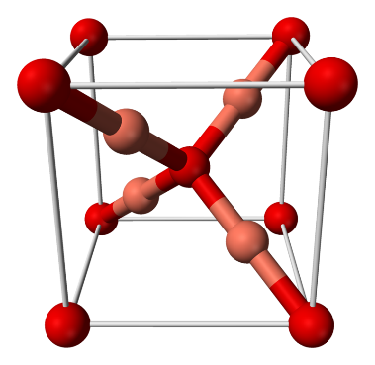

A

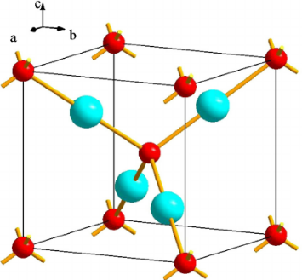

B

The two figures above depict the cubic unit cell of the Cu2O crystal. The lattice constant of the structure is 427.0 pm.

2.1.1. Which of the atoms (A or B) is copper?  
Which basic structure (primitive cubic, face centered cubic, body centered cubic, diamond) is formed by the A atoms and which structure is formed by the B atoms?  
What are the coordination numbers of the atoms?

2.1.2. Calculate the smallest O-O, Cu-O and Cu-Cu distances in the structure?

2.1.3. What is the density of pure copper(I) oxide?

A common defect in this crystal is some copper atoms missing with the oxygen lattice unchanged. The composition of one such crystal sample was studied, and 0.2% of all copper atoms were found to be in oxidation state +2.

2.2. What percentage of normal copper sites are empty in the crystal sample? What is x in the empirical formula Cu2-xO of the crystal?

Copper(I) oxide is insoluble in water. It is stable in dry air, but humidity in the air catalyzes a transformation (Reaction 1)

When copper(I) oxide is dissolved in dilute sulfuric acid, a blue solution containing a precipitate is formed without evolution of a gas (Reaction 2). When hot, concentrated sulfuric acid is used, no precipitate remains, but an odorous gas forms (Reaction 3). The same gas forms when the precipitate from reaction 2 is dissolved in hot concentrated sulfuric acid.

2.3. Write balanced chemical equations for reactions (1-3).

Copper (I) oxide can be produced in a number of ways. Heating copper in air is a common method in the synthesis of semiconductor Cu2O. In a pure oxygen atmosphere, the three species containing copper (Cu(s), Cu2O(s) or CuO(s)) can potentially interconvert.

Suppose that the ΔfHo and So data given for 105 Pa are independent of temperature:

|  |  |  |
| --- | --- | --- |
|  | ΔfHo / kJ mol−1 | So/ J mol−1 K−1 |
| Cu(s) | 0 | 65 |
| O2(g) | 0 | 244 |
| CuO(s) | −156 | 103 |
| Cu2O(s) | −170 | 180 |

2.4. Determine the temperature ranges, if any, of thermodynamic stability of copper and its oxides between 500 and 1500 K in a 105 Pa oxygen atmosphere.

Important data are given for 298 K. Use this temperature in the following calculations:

Ksp(Cu(OH)2)=2∙10−19  
Cu2O(s) + H2O(l) + 2 e− ⟶ 2 Cu(s) + 2 OH−(aq) Eo= −0.360 V  
Cu2+(aq) +  e− ⟶  Cu+(aq) Eo= +0.159 V  
Cu2+(aq) + 2 e− ⟶  Cu(s) Eo= +0.337 V

One possibility for producing Cu2O is the anodic oxidation of copper. Electrolysis of an aqueous basic solution (e.g. NaOH) with a copper anode and platinum cathode can lead to formation of copper(I) oxide on the anode.

2.5. Write the half reaction equations for the electrode processes during the anodic production of Cu2O in NaOH solution with a platinum cathode and copper anode.

Electrolytic reduction of copper(II) ions in solution is another possibility.

2.6.1. Write the half reaction equation of the cathode process giving Cu2O in acidic medium.

Let us use 0.100 mol dm−3 Cu2+ solution and carry out electrolysis with platinum electrodes.

2.6.2. What is the maximum pH of this solution at which the concentration of copper(II) can be maintained at 0.100 mol dm−3?

If the pH is too low, reduction to metallic copper is preferred to the formation of copper(I) oxide.

2.6.3. What is the minimum pH at which the cathodic production of Cu2O in a 0.100 mol dm−3 Cu2+ solution is still possible?

# Problem 3 9% of the total

Iodine deficiency is of special concern in Georgia because it occupies a region where iodine is scarce in soil and water. Iodine deficiency can be effectively and inexpensively prevented if salt for human consumption is fortified with small amounts of iodine. Methods for analyzing salt for iodine content are thus important. Current regulations in Georgia are that iodized salt must contain between 25-55 ppm iodine (1 ppm = 1 mg iodine/kg salt).

Most salt is iodized by fortification with potassium iodate (KIO3). Iodate content can be determined in salt samples using iodometric titration. In a typical procedure, 10.000 g of an iodized salt sample is dissolved in 100 cm3 of 1.0 mol/dm3 aqueous HCl to which 1.0 g KI has been added. The solution is then titrated with 0.00235 mol/dm3 aqueous sodium thiosulfate solution to a starch endpoint; this requires 7.50 cm3 of titrant.

3.1.1. Write a balanced net ionic equation for the reaction when iodate reacts with excess iodide in acidic solution.

3.1.2. Write a balanced net ionic equation for the reaction taking place during the titration with thiosulfate.

3.1.3. Calculate the iodization level, in ppm, of this salt sample.

A less common agent for iodizing salt is potassium iodide, which cannot be easily measured by iodometric titration.

One possible method for analyzing iodide in the presence of chloride is potentiometric titration. However, this method is not very precise in the presence of large amounts of chloride.

In this method, a silver wire is immersed in the solution (containing iodide and chloride) to be analyzed and silver ion is gradually added to the solution. The potential of the silver wire is measured relative to a reference electrode consisting of a silver wire in a 1.000  mol/dm3 solution of AgNO3. The measured potentials are negative and the absolute values of these potentials are reported. The solution to be analyzed has a volume of 1.000 dm3 (which you may assume does not change as silver ion is added), and T = 25.0°C.

The results of this experiment are governed by three equilibria: the solubility of AgI(s) [KspI] and AgCl(s) [KspCl] and the formation of AgCl2−(aq) [Kf]. (Iodide also forms complex ions with silver but this may be neglected at the very low concentrations of iodide present in this experiment).

AgI(s) ⇌ Ag+(aq) + I−(aq) KspI

AgCl(s) ⇌ Ag+(aq) + Cl−(aq) KspCl

Ag+(aq) + 2 Cl−(aq) ⇌ AgCl2−(aq) Kf

Below are shown the results of two experiments measuring the observed potential as a function of added number of moles of silver ion. Experiment A (solid circles) was carried out with 1.000 dm3 of solution containing 1.00∙10−5 mol/dm3 iodide and no chloride ion. Experiment B (open circles) was done using 1.000 dm3 of solution containing 1.00∙10−5 mol/dm3 iodide and 1.00∙10−1 mol/dm3 chloride.

|  |  |  |
| --- | --- | --- |
| μmol Ag+  added | |E|, V  exp. A | |E|, V  exp. B |
| 1.00 | 0.637 | 0.637 |
| 3.00 | 0.631 | 0.631 |
| 5.00 | 0.622 | 0.622 |
| 7.00 | 0.609 | 0.610 |
| 9.00 | 0.581 | 0.584 |
| 10.0 | 0.468 | 0.558 |
| 11.0 | 0.355 | 0.531 |
| 12.0 | 0.337 | 0.517 |
| 13.0 | 0.327 | 0.517 |
| 15.0 | 0.313 | 0.517 |



μmol Ag+ added

3.2.1. Select an appropriate data point from the experiments and use it to calculate the solubility product of AgI (KspI).

3.2.2. Select an appropriate data point from the experiments and use it to calculate the solubility product of AgCl (KspCl).

3.2.3. Select an appropriate data point from the experiments and use it to calculate Kf.   
You may need to use values of KspI or KspCl to do this calculation. If you were unable to carry out the calculations in 3.2.1. or 3.2.2., you may use the arbitrary values of KspI = 1.00∙10−15 and KspCl = 1.00∙10−9 without penalty.

An analytical method that is more practical, because it is not sensitive to the presence of chloride, uses the Sandell-Kolthoff reaction. This is the reaction of H3AsO3 with Ce(IV) to give Ce(III) in acidic solution, which is strongly catalyzed by iodide ion.

3.3.1. Write balanced net ionic equations for the reaction of cerium(IV) with H3AsO3 in acidic solution, as well as reactions of cerium(IV) with a species containing the element iodine and H3AsO3 with a species containing the element iodine, that could reasonably account for the catalysis of the net reaction by iodide.

The reaction of Ce(IV) with H3AsO3 can be monitored by measuring the absorbance at 405 nm, as Ce(IV) is orange and absorbs significantly at 405 nm, while the other reactants and products are colorless and do not absorb appreciably. Three runs were carried out, all in 0.50 mol/dm3 H2SO4 at 25.0°C using the following initial concentrations:

|  |  |  |  |
| --- | --- | --- | --- |
| Run | [H3AsO3]0,  mol dm−3 | [Ce(IV)]0,  mol dm−3 | [I–]0,  mol dm−3 |
| 1 | 0.01250 | 0.00120 | 1.43∙10−6 |
| 2 | 0.00625 | 0.00060 | 1.43∙10−6 |
| 3 | 0.01250 | 0.00120 | 7.16∙10−7 |

An analyst initiated the reactions by mixing the reagents in a cuvette. After a short variable delay absorbance measurements were started, with the first measurement recorded at t=0 s. The data obtained are shown below:

|  |  |  |  |
| --- | --- | --- | --- |
| t, s | A405  Run 1 | A405  Run 2 | A405  Run 3 |
| 0 | 0.621 | 0.287 | 0.818 |
| 20 | 0.348 | 0.149 | 0.608 |
| 40 | 0.198 | 0.083 | 0.455 |
| 60 | 0.113 | 0.046 | 0.340 |
| 80 | 0.064 | 0.025 | 0.254 |
| 100 | 0.037 | 0.014 | 0.191 |

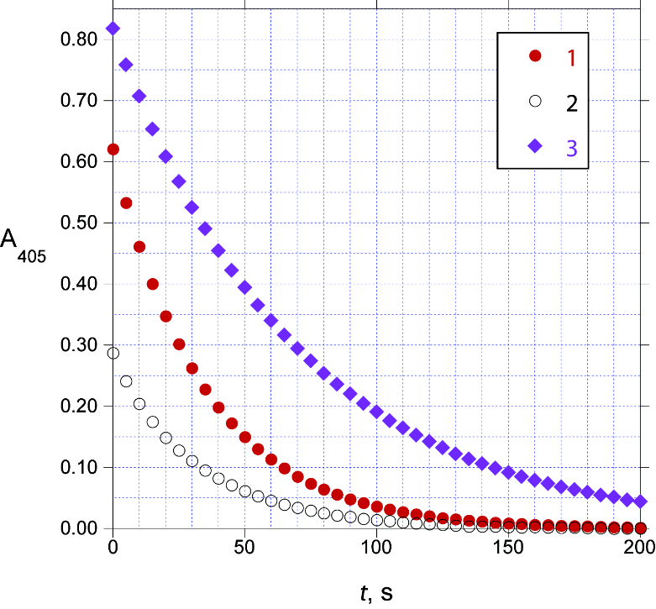

Under these conditions (0.5 mol/dm3 H2SO4, 25.0°C), the rate law for the reaction can be written as

Rate = k[H3AsO3]m[Ce(IV)]n[I−]p where m, n, and p are integers.

3.3.2. Determine the values of m, n, and p and calculate the value of k (be sure to specify its units).

|  |  |
| --- | --- |
| t, s | A405 |
| 0 | 0.756 |
| 20 | 0.531 |
| 40 | 0.373 |
| 60 | 0.262 |
| 80 | 0.185 |
| 100 | 0.129 |

A 1.000 g sample of iodized salt is dissolved in water to give 10.00 cm3 of solution. A 0.0500 cm3 aliquot of this solution is added to a mixture of 1.000 cm3 0.025 mol/dm3 H3AsO3 in 0.5 mol/dm3 H2SO4 and 0.800 cm3 0.5 mol/dm3 H2SO4. To this mixture is added 0.200 cm3 0.0120 mol/dm3 Ce(NH4)2(NO3)6 in 0.5 mol/dm3 H2SO4 and the absorbance at 405 nm is measured as a function of time at 25.0°C:

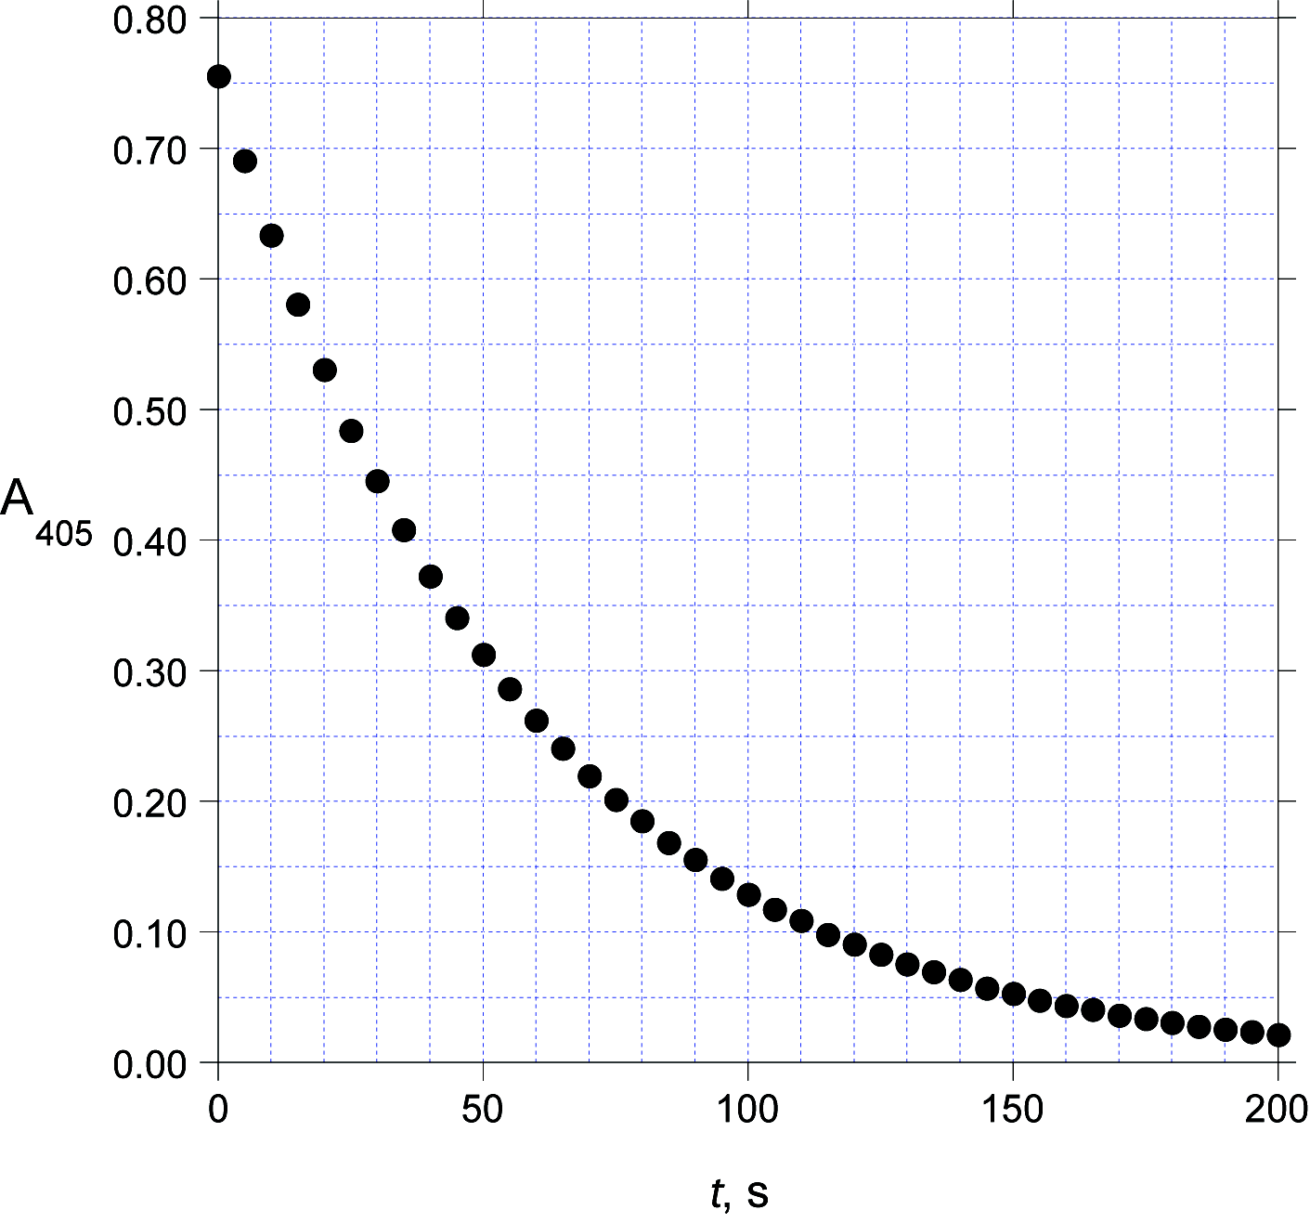

3.3.3. Calculate the iodization level, in ppm, of this salt sample.

# Problem 4 8% of the total

Application of kinetic studies in water treatment

Industrial waste is a major cause of water pollution and kinetic studies are carried out in a laboratory to design effluent treatment. 1,4-dioxane, more commonly known as dioxane (C4H8O2), an industrial solvent and by-product, is a significant water contaminant. It can be oxidised to hazard free chemicals using oxidants such as peroxodisulfate, ozone or hydrogen peroxide.

The data obtained in the kinetic study of oxidation of dioxane with potassium peroxodisulfate (K2S2O8) as oxidant and AgNO3 as catalyst at T = 303.15 K are given below. The reaction was monitored by the estimation of unreacted peroxodisulfate. The concentration of AgNO3 used in this study was 1.00∙10−3 mmol∙dm−3.

|  |  |  |  |
| --- | --- | --- | --- |
| Trial | Dioxane  mmol∙dm−3 | K2S2O8  mmol∙dm−3 | Initial rate  mmol∙dm−3∙min−1 |
| 1 | 0.0100 | 2.50 | 1.661∙10−2 |
| 2 | 0.0100 | 5.10 | 3.380∙10−2 |
| 3 | 0.00500 | 13.8 | 9.200∙10−2 |
| 4 | 0.0110 | 13.8 | 9.201∙10−2 |

In many countries the accepted maximum level of dioxane in drinking water is specified as 0.35 μg dm−3.

A water sample contains an initial dioxane concentration of 40.00 μg dm−3. Assume that 1 mol dioxane requires 1 mol of peroxodisulfate for oxidation. The concentration of AgNO3 used in this study was 1.00∙10−3 mmol∙dm−3.

4.1.1. Calculate the time in minutes the oxidation process has to continue in order to reach the accepted level of dioxane at 303.15 K if the initial concentration of K2S2O8 is 5.0∙10−6 mol dm−3. Assume that the rate law obtained from the data above is valid under these conditions.

Various mechanisms have been proposed for the peroxodisulfate oxidation of dioxane. Misra and Ghosh (1963) proposed the following mechanism:

|  |  |  |
| --- | --- | --- |
|  | k1 |  |
| S2O82− + Ag+ | ⇄ | Ag3+ + 2SO42− |
|  | k2 |  |
|  |  |  |
|  | k3 |  |
| Ag3+ + D (dioxane) | ⟶ | D’ (dioxane oxidised) + 2H+ + Ag+ |

4.1.2. Assuming Ag(III) to be in steady state, deduce the rate equation for the oxidation of dioxane.

4.1.3. Which of the following is/are correct?

A) The rate equation based on the mechanism given in 4.1.2, at very high concentrations of dioxane, is consistent with the experimental data in 4.1.1.   
B) The rate equation based on the mechanism given in 4.1.2, at very low concentrations of dioxane, is consistent with the experimental data in 4.1.1.  
C) The units of the observed rate constant are dm3∙mol−1∙s−1 at very high concentrations of dioxane.   
D) The units of the observed rate constant are dm3∙mol−1∙s−1 at very low concentrations of dioxane.

Degradation of pharmaceutical products – a kinetic overview

Kinetic studies are important in deciding the shelf life of a pharmaceutical product. Several chemical reactions can affect the shelf life of pharmaceutical products and the rates of these reactions depend on conditions such as pH, temperature, humidity.

Lysine acetylsalicylate (LAS) is prescribed as a pain killer and anti-inflammatory drug under the brand name Aspegic. LAS on hydrolysis forms lysine salicylate and acetic acid.

|  |  |  |
| --- | --- | --- |
|  |  |  |

Hydrolysis of LAS can proceed via three different pathways (a) acid catalysed,   
(b) uncatalysed and (c) base catalysed.

If [LAS] denotes the concentration of LAS at time ‘t’, the overall rate of the hydrolysis reaction can be written as

$$-\frac{d\left[\text{LAS}\right]}{dt}= k_{H}[LAS][H^{+}]+k_{0}[LAS]+k_{OH}[LAS][OH^{-}]$$

where kH, k0 and kOH  are the rate constants of the acid catalysed, uncatalysed and base catalysed pathways of hydrolysis, respectively. The overall rate constant is defined as:

$$-\frac{d\left[\text{LAS}\right]}{dt}= k_{obs}[LAS]$$

4.2.1. Write an expression for kobs in terms of kH, k0, kOH and [H+].

Hydrolysis of LAS was carried out at 298.15 K at various pH values (0.50 to 13.0). A very low initial concentration of LAS ensured that the pH did not change during the course of the reaction.

The following graph shows the pH dependence of the hydrolysis of LAS.



4.2.2. Which of the following is/are correct?  
A) kobs ≌ k0 at pH = 12  
B) kobs ≌ k0 at pH = 5.0  
C) The rate of the reaction increases when the pH is changed from 0.50 to 1.0.  
D) The rate of the reaction increases when the pH is changed from 10 to 12.

4.2.3. Using the diagram and the data given below, calculate kH, k0 and kOH. Make sure to specify the units.

|  |  |  |  |
| --- | --- | --- | --- |
| pH | 1.300 | 5.300 | 12.180 |
| log (kobs/min‒1) | −3.886 | −4.000 | −1.726 |

Acetylsalicylic acid, more commonly known as aspirin is a medicine often used for reducing fever, pain and inflammation. Like LAS, the hydrolysis of aspirin can also take different pathways depending on the pH. The pH rate profile of aspirin hydrolysis at **333.15 K** is given below:



The following are possible reactions for the hydrolysis of aspirin. Depending on the pH, one or more of these reactions will predominate.

I. CH3COOC6H4COOH + H3O+ ⟶ HOC6H4COOH + CH3COOH + H+ II. CH3COOC6H4COOH + H2O ⟶ HOC6H4COOH + CH3COOH  
 III. CH3COOC6H4COOH + OH− ⟶ HOC6H4COOH + CH3COO− IV. CH3COOC6H4COO− + H3O+ ⟶ HOC6H4COOH + CH3COOH V. CH3COOC6H4COO− + H2O ⟶ HOC6H4COOH + CH3COO− VI. CH3COOC6H4COO− + OH− ⟶ HOC6H4COO− + CH3COO−4.3.1. Using the pH-rate profile diagram and the reactions given above, state which of the following statements is/are correct. (pKa of aspirin = 3.57 at 333.15 K)

a) In the region C-D, reaction IV is predominant   
b) In the region C-D, reaction V is predominant  
c) In the region D-E reaction VI is predominant  
d) In the region A-B, reaction II is predominant

The plot of kobs vs pH for the hydrolysis of aspirin has been confirmed to show a minimum at a particular pH. At **290.15 K** the following rate constants for reactions I, II and III were determined:

|  |  |  |
| --- | --- | --- |
| kH (reaction I) | k0 (reaction II) | kOH (reaction III) |
| 1.99 dm3∙mol−1∙day−1 | 2.29∙10−4 day−1 | 3.18∙109 dm3∙mol−1∙day−1 |

The ionic product of water at 290.15 K can be taken as 1.0∙10−14.

4.3.2. Assuming that only reactions I, II and III occur, calculate the value of the pH at the minimum.

# Problem 5 8% of the total

5500 years ago in ancient Egypt people learned for the first time how to synthesize a blue pigment. Now we know this pigment as Egyptian blue. About 2000 years later in ancient China another pigment was widely used, which is now referred to as Chinese blue. The two pigments are similar in structure, but have different elemental compositions.

The ancient method of preparation for these pigments can be easily reproduced in a modern laboratory.

When considering the amounts, assume that all of the compounds in this task are pure, and the yields are quantitative.

To make **Egyptian blue**, one should heat 10.0 g of mineral **A** with 21.7 g of SiO2 and 9.05 g of mineral **B** at 800–900°C for a prolonged time. 16.7 dm3 of a mixture of two gaseous products are released (the volume is measured at 850°C and 1.013∙105 Pa (1.013 bar) pressure. In result, 34.0 g of the pigment was obtained. No other products are formed. As the gas mixture is cooled, one component of the mixture condenses. As the remaining gas is further cooled to 0°C, the gaseous volume reduces to 3.04 dm3.

**5.1.1.** Find the mass of the gaseous mixture formed upon heating of **A** with **B** and SiO2.

**5.1.2.** Determine the quantitative composition of this gas mixture.

When 10.0 g of mineral **A** is heated with 21.7 g of SiO2 in the absence of **B**, it forms 8.34 dm3 of gaseous products (measured at 850°C and 1.013∙105 Pa = 1.013 bar pressure). Mineral **A** contains only one metal.

**5.1.3.** Calculate the molar mass and determine the formula of mineral **B**. Hint: it is an ionic solid insoluble in water and containing no water of crystallization.

In order to obtain **Chinese blue**, one should take 17.8 g of mineral **C** instead of mineral **B** (keeping the amounts of mineral **A** and SiO2 same as for Egyptian blue), and run the reaction at higher temperatures. Besides the pigment, the same gaseous products in the same quantities are formed as in the preparation of Egyptian blue.

**5.1.4.** Determine the formula of mineral **C**.

**5.1.5.** Determine the formulae of Egyptian blue and Chinese blue.

**5.1.6.** Determine the formula of mineral **A**.

Elemental analysis of some samples of Chinese blue shows traces of sulfur. This led to a conclusion that those were synthesized using another common mineral instead of **C**.

**5.2.1.** Suggest a formula for the mineral used in place of **C**.

**5.2.2.** Could the temperature of synthesis of Chinese blue be decreased if this mineral is used instead of **C**?

If during the synthesis of Chinese blue we take a smaller amount of silica than in the process above, we will obtain a purple pigment: Chinese violet. It was used, in particular, for coloring the famous Terracotta army soldiers.

**5.3.** Write down the formula of a binary compound that forms under the conditions required for Chinese violet and is responsible for the change of the color.

# Problem 6 7% of the total

Although there is currently no known cure for Alzheimer’s disease, there are medications available to manage the neurodegenerative disorder. Among these are acetylcholinesterase inhibitors, of which galantamine **1** is an example. This molecule can be isolated from the Caucasian snowdrop, a plant native to Georgia; however, the large amounts needed for therapy require a synthetic route. Shown below is the route used to prepare galantamine industrially.

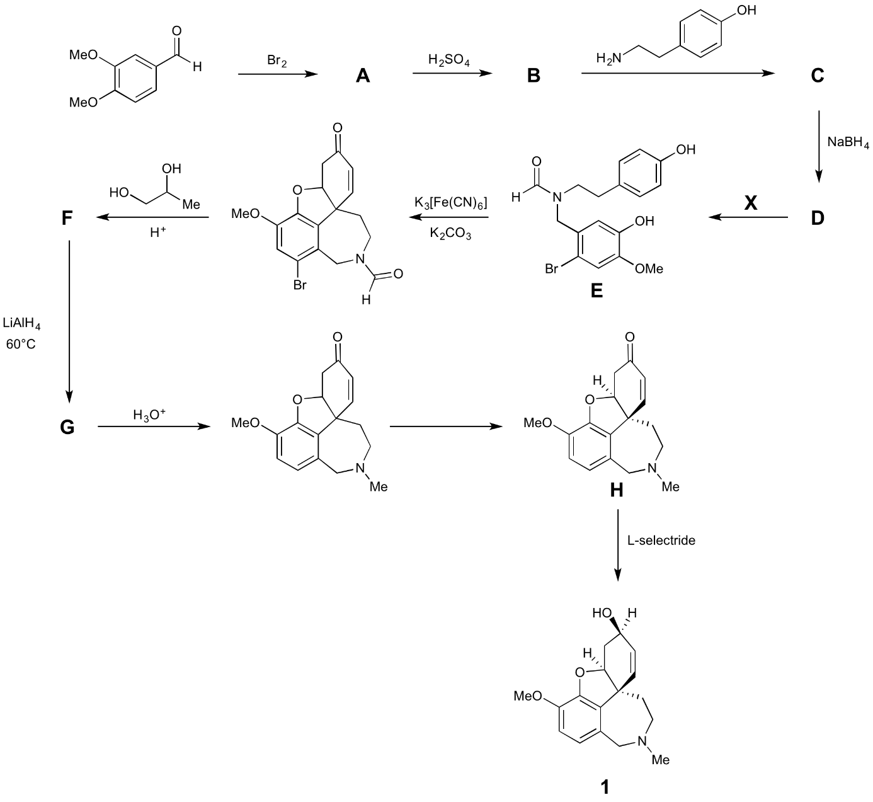

excess

resolution

Notes about the synthesis:

* 1H NMR of **A** indicates 2 aromatic protons in a *para* arrangement.
* **C** is labile in aqueous conditions, so it is not isolated, but rather reacted immediately with NaBH4 to convert it to **D**.

**6.1.1.** Suggest structures for **A**, **B**, **C**, **D**, **F**, and **G**. None of the reactions except for the final transformation with L-selectride are stereoselective. Therefore, stereochemistry does not need to be indicated in your answers.

**6.1.2.** Give the formula for a possible reagent, **X**, to convert compound **D** to **E**.

The optical rotation of the material obtained by resolution was –400° cm2 g-1, while that of the enantiomerically pure compound is –415° cm2 g-1 when measured under the same conditions. You may assume that the only optical impurity is the other enantiomer.

One way of describing optical purity is enantiomeric excess (*ee*). It is defined as the difference in the percentages of the enantiomers in a mixture. For example in a mixture of 70% *R* and 30% *S*, the *ee* is 40%.

**6.2.1.** What is the enantiomeric excess of the resolved compound as prepared by the industrial route?

**L-selectride is a commercial reagent that performs the final reaction stereoselectively.

**6.2.2.** Assign the labelled stereocentres (  ) in (–)-**1** as *R* or *S*.

**6.2.3.** Give the formula for a reagent that carries out the same reaction as L-selectride, converting **H** to **1**. You need not worry about stereoselectivity.

An alternative route to galantamine occurs with the seven-membered ring being the last ring to form.



pH = 5

(4 equivalents)

**6.3.1.** Give the formula for compound **Y** to carry out the first step of the route.

**6.3.2.** Suggest structures for **J** and **K**.

# Problem 7 8% of the total



This question looks at the synthesis of *dolasetron mesylate*, **Z** (shown right), a drug sold under the tradename *Anzemet* and used to treat post-operative nausea and vomiting.

The synthesis begins as shown below.



First cyclic compound **A** is made, which contains C, H, and O only. Compound **G** is achiral and can be prepared directly from **D** using ozone under reductive conditions, or via stereoisomers **E1** and **E2** using OsO4, or via stereoisomers **F1** and **F2** using the peracid shown.

**7.1.** Determine the empirical formula of **G** from the percentage masses given.

**7.2.** Give the structures of **A**, **B**, **C**, **D**, **E1**, **E2**, **F1**, **F2** and **G**.

Compound **G** is used in the next stage of the synthesis, under buffered conditions, to form **H** (as a mixture of two achiral diastereoisomers). Reduction of **H** with NaBH4 gives alcohol **I** (as a mixture of four achiral diastereoisomers). **I** reacts with acidified dihydropyran to form **J** (as a mixture of even more diastereoisomers). **J** is then treated first with *t*-butoxide base, then refluxed with acid before finally extracting under weakly basic conditions to form **K** as a mix of two diastereomers, **K1** (major product) and **K2** (minor product). These could be separated, and **K1** was used in the final stages of the synthesis.



**7.3.1.** Give the structures of **H**, **I**, and **J**. There is no need to show the different diastereoisomers formed.

**7.3.2.** Give the structures of diastereoisomers **K1**, and **K2**.

In the final stage of the synthesis, **L** and **M** react to form intermediate **N**. **N** then reacts with **K1** to form, after extraction, the neutral amine which gives the target compound upon protonation with CH3SO3H.



**7.4.** Give the structure of **N**.

# Problem 8 7% of the total

An exotic, but biologically relevant sugar analogue can be prepared from d-glucose in the following manner. Heating a mixture of d-glucose and acetone with a few drops of concentrated acid results in the formation of a diacetonide **A**. Then **A** can be hydrolyzed selectively to **B**.

|  |  |  |  |  |
| --- | --- | --- | --- | --- |
| https://upload.wikimedia.org/wikipedia/commons/7/71/Glucose_Fischerprojektionen.png | Acetone/H+ |  | **X** |  |
|  |  |
| d-glucose |  | **A** |  | **B** |

**8.1.** Give your chosen answers to the questions on the answer sheet.

**B** is treated with sodium metaperiodate to get **C**. **C** is then reacted with an aqueous solution of NaCN, then heated with 10% NaOH solution to get a mixture of two diastereomeric compounds **D**1 and **D**2. These compounds can be separated by column chromatography.

|  |  |  |  |  |
| --- | --- | --- | --- | --- |
|  | IO4− |  | 1. NaCN  2. NaOH/H2O |  |
| **B** |  | **C**  188.2 g/mol |  | **D**1 + **D**2 |

Reaction of **D**1 with LiAlH4 followed by heating with 1M HCl solution gives sugar **F** that is the hydrolysis product of the most abundant natural polysaccharide.

|  |  |  |  |  |
| --- | --- | --- | --- | --- |
|  | LiAlH4 |  | 1M HCl/H2O |  |
| **D**1 |  | **E** |  | **F** |

**8.2.1.** Draw the structures of **C**, **D**1, **D**2, **E** and **F** including stereochemical information. Show **F** as the more stable 6-membered ring containing isomer using the ring skeleton. Indicate with a wavy line if absolute chirality around a carbon is not known.

**8.2.2.** Give your chosen answer to the question on the answer sheet.

Neutralization of **D2** with HCl followed by heating in toluene results in dehydration and formation of **G**, which has a tricyclic structure in water-free solvents. Boiling **G** in 1M HCl solution gives **H** (C6H10O7), which is a natural sugar derivative containing a 6 membered ring. **H** is a building block of heparin, an anticoagulant polysaccharide produced by our bodies.

|  |  |  |  |  |
| --- | --- | --- | --- | --- |
|  | 1. Equimolar HCl  2. Heat, toluene |  | 1M HCl/H2O |  |
| **D**2 |  | **G** |  | **H** |
|  | −H2O |  |  |  |

**8.3.1.** Draw the structure of **G** including the stereochemistry.   
Draw **H** as the more stable 6-membered ring containing isomer using the ring skeleton. Indicate with a wavy line if absolute chirality around a carbon is not known.

**8.3.2.** Give your chosen answer to the question on the answer sheet.

**8.3.3.** Give your answer to the question on the answer sheet.



48th International Chemistry Olympiad

Theoretical Problems

Answer sheets

28 July 2016

Tbilisi, Georgia

# Problem 1 5% of the total

|  |  |  |  |  |  |  |  |
| --- | --- | --- | --- | --- | --- | --- | --- |
| 1.1. | 1.2. | 1.3. | 1.4. | 1.5. | 1.6. | 1.7. | Sum |
| 3 | 1 | 2 | 2 | 2 | 4 | 3 | 17 |
|  |  |  |  |  |  |  |  |

1.1. On which electrode does nitrogen trifluoride form?

Cathode  Anode

Write a balanced chemical equation for the electrode half reaction for the formation of NF3.

1.2. Which of NF3, NHF2 or NH2F compound is expected to condense at the lowest temperature?

NF3  NHF2  NH2F

1.3. Assign the N-F bond lengths (136, 140, 142 pm) to the molecules.

|  |  |  |  |
| --- | --- | --- | --- |
| Molecule | NH2F | NHF2 | NF3 |
| N-F bond length, pm |  |  |  |

1.4. Write a balanced chemical equation for the formation of the binary nitrogen – fluorine compound.

1.5. Propose a suitable reagent for the formation of NF4+ and write a balanced chemical equation for the reaction.

1.6. Write a balanced chemical equation for the hydrolysis of NF4+

Write a balanced chemical equation for a possible side reaction that can decrease the theoretically expected O2:NF3 mole ratio.

1.7. Determine the formula of the salt in question.

Your work:

Formula:

# Problem 2 8% of the total

|  |  |  |  |  |  |  |  |  |  |  |
| --- | --- | --- | --- | --- | --- | --- | --- | --- | --- | --- |
| 2.1.1 | 2.1.2 | 2.1.3 | 2.2 | 2.3 | 2.4 | 2.5 | 2.6.1 | 2.6.2 | 2.6.3 | Sum |
| 5 | 3 | 2 | 2 | 3 | 6 | 2 | 1 | 3 | 6 | 33 |
|  |  |  |  |  |  |  |  |  |  |  |

2.1.1. Which of the atoms (A or B) is copper?

Cu:

Which basic structure (primitive cubic, face centered cubic, body centered cubic, diamond) is formed by the A atoms and which structure is formed by the B atoms?

|  |  |  |  |  |
| --- | --- | --- | --- | --- |
|  | pr. cubic | fcc | bcc | diamond |
| A |  |  |  |  |
| B |  |  |  |  |

Calculate the coordination numbers of the atoms?

A: B:

2.1.2. What are the smallest O-O, Cu-O and Cu-Cu distances in the structure?

Your work:

O-O:

Cu-O:

Cu-Cu:

2.1.3. What is the density of pure copper(I) oxide?

Your work:

density:

2.2. What percentage of normal copper sites are empty in the crystal sample?

Your work:

percentage:

What is x in the empirical formula Cu2-xO of the crystal?

Your work:

x:

2.3. Write balanced chemical equations for reactions (1-3).

Reaction 1:

Reaction 2:

Reaction 3:

2.4. Determine the temperature ranges, if any, of thermodynamic stability of copper and its oxides between 500 and 1500 K in a 105 Pa oxygen atmosphere.

Your work:

|  |  |
| --- | --- |
| Temperature range between 500-1500K | The most stable form (Cu, Cu2O or CuO) |
|  |  |
|  |  |
|  |  |

2.5. Write the half reaction equations for the electrode processes during the anodic production of Cu2O in NaOH solution with a platinum cathode and copper anode.

Cathode:

Anode:

2.6.1. Write the half reaction equation of the cathode process giving Cu2O in acidic medium.

2.6.2. What is the maximum pH at which the concentration of copper(II) can be maintained at 0.100 mol dm−3?

Your work:

maximum pH:

2.6.3. What is the minimum pH at which the cathodic production of Cu2O in a 0.100  mol dm−3 Cu2+ solution is still possible?

Your work:

minimum pH:

# Problem 3 9% of the total

|  |  |  |  |  |  |  |  |  |  |
| --- | --- | --- | --- | --- | --- | --- | --- | --- | --- |
| 3.1.1. | 3.1.2. | 3.1.3. | 3.2.1. | 3.2.2. | 3.2.3. | 3.3.1. | 3.3.2. | 3.3.3. | Sum |
| 2 | 2 | 6 | 5 | 4 | 7 | 6 | 11 | 5 | 48 |
|  |  |  |  |  |  |  |  |  |  |

3.1.1. Write a balanced net ionic equation for the reaction when iodate reacts with excess iodide in acidic solution.

3.1.2. Write a balanced net ionic equation for the reaction taking place during the titration with thiosulfate.

3.1.3. Calculate the iodization level, in ppm, of the salt sample.

Your work:

ppm iodine =

3.2.1. Select an appropriate data point from the experiments and use it to calculate the solubility product of AgI (KspI).

Your work:

KspI:

3.2.2. Select an appropriate data point from the experiments and use it to calculate the solubility product of AgCl (KspCl).

Your work:

KspCl:

3.2.3. Select an appropriate data point from the experiments and use it to calculate Kf.   
You may need to use values of KspI or KspCl to do this calculation. If you were unable to carry out the calculations in 3.2.1. or 3.2.2., you may use the arbitrary values of KspI = 1.00∙10−15 and KspCl = 1.00∙10−9 without penalty.

Your work:

Kf:

3.3.1. Write balanced net ionic equations for the reaction of cerium(IV) with H3AsO3 in acidic solution, as well as reactions of cerium(IV) with a species containing the element iodine and H3AsO3 with a species containing the element iodine, that could reasonably account for the catalysis of the net reaction by iodide.

Net reaction of cerium(IV) with H3AsO3 in acidic solution:

Reaction of cerium(IV) with an iodine-containing species:

Reaction of H3AsO3 with an iodine-containing species:

3.3.2. Determine the integer values of m, n, and p and calculate the value of k (be sure to specify its units).

Your work:

m = n = p = k =

3.3.3. Calculate the iodization level, in ppm, of the salt sample.

Your work:

ppm I =

# Problem 4 8% of the total

|  |  |  |  |  |  |  |  |  |
| --- | --- | --- | --- | --- | --- | --- | --- | --- |
| 4.1.1 | 4.1.2 | 4.1.3 | 4.2.1 | 4.2.2 | 4.2.3 | 4.3.1 | 4.3.2 | Sum |
| 5 | 3 | 2 | 1 | 2 | 6 | 2 | 4 | 25 |
|  |  |  |  |  |  |  |  |  |

4.1.1. Calculate the time in minutes the oxidation process has to continue in order to reach the accepted level of dioxane at 303.15 K if the initial concentration of K2S2O8 is 5.0∙10−6 mol/dm3. Assume that the rate law obtained from the data above is valid under these conditions.

Your work:

Oxidation time:

4.1.2. Assuming Ag(III) to be in steady state, deduce the rate equation for the oxidation of dioxane.

Your work:

|  |  |
| --- | --- |
| 4.1.3. |  |

4.2.1. Write an expression for kobs in terms of kH, k0, kOH and [H+].

Your work:

|  |  |
| --- | --- |
| 4.2.2. |  |

4.2.3. Using the diagram and the data in the table, calculate kH, k0 and kOH. Make sure to specify the units.

Your work:

k0: kOH: kH:

|  |  |
| --- | --- |
| 4.3.1. |  |

4.3.2. Assuming that only reactions I, II and III occur, calculate the value of the pH at the minimum of *k*obs.

Your work:

pH at minimum:

# Problem 5 8% of the total

|  |  |  |  |  |  |  |  |  |  |
| --- | --- | --- | --- | --- | --- | --- | --- | --- | --- |
| 5.1.1. | 5.1.2. | 5.1.3. | 5.1.4. | 5.1.5. | 5.1.6. | 5.2.1. | 5.2.2. | 5.3. | Sum |
| 1 | 3 | 2 | 2 | 5 | 2 | 1 | 1 | 2 | 19 |
|  |  |  |  |  |  |  |  |  |  |

5.1.1. Find the mass of the gaseous mixture formed upon heating of A with B and SiO2.

Your work:

5.1.2. Determine the quantitative composition of this gas mixture.

Your work:

The gaseous mixture formed at 850°C contains ……… mol of ………. and ……… mol of ………

5.1.3. Calculate the molar mass and determine the formula of mineral B. Hint: it is an ionic solid insoluble in water and containing no water of crystallization.

Your work:

B is:

5.1.4. Determine the formula of mineral C.

Your work:

C is:

5.1.5. Determine the formulae of Egyptian blue and Chinese blue.

Your work:

Egyptian blue is: Chinese blue is:

5.1.6. Determine the formula of mineral A.

Your work:

A is:

5.2.1. Suggest the formula of the mineral used in place of C.

5.2.2. Could the temperature of synthesis of Chinese blue be decreased if this mineral is used instead of C?

Yes  No

5.3. Write down a formula of a binary compound that forms under the conditions required for Chinese violet and is responsible for the change of the color.

# Problem 6 7% of the total

|  |  |  |  |  |  |  |  |
| --- | --- | --- | --- | --- | --- | --- | --- |
| 6.1.1. | 6.1.2 | 6.2.1. | 6.2.2. | 6.2.3. | 6.3.1 | 6.3.2. | Sum |
| 24 | 4 | 3 | 6 | 2 | 2 | 8 | 49 |
|  |  |  |  |  |  |  |  |

6.1.1. Suggest structures for A, B, C, D, F, and G. None of the reactions except for the final transformation with L-selectride are stereoselective. Therefore, stereochemistry does not need to be indicated in your answers.

|  |  |
| --- | --- |
| A | B |
| C | D |
| F | G |

6.1.2. Give the formula for a possible reagent, X, to convert compound D to E.

X

6.2.1. What is the enantiomeric excess of the resolved compound prepared by the industrial route?

Your work:

*ee*:

6.2.2. Assign the labelled stereocentres (α, β, γ) in (–)-1 as *R* or *S*.

|  |  |  |
| --- | --- | --- |
| α | β | γ |

6.2.3. Give the formula for a reagent that carries out the same reaction as L-selectride, the conversion of H to 1. You need not worry about stereoselectivity.

6.3.1. Give the formula for compound Y to carry out the first step of the route.

Y

6.3.2. Suggest structures for J and K.

|  |  |
| --- | --- |
| J | K |

# Problem 7 8% of the total

|  |  |  |  |  |  |
| --- | --- | --- | --- | --- | --- |
| 7.1. | 7.2. | 7.3.1. | 7.3.2. | 7.4. | Sum |
| 2 | 36 | 16 | 8 | 4 | 66 |
|  |  |  |  |  |  |

7.1. Determine the empirical formula of G.

Your work:

7.2. Give the structures of A, B, C, D, E1, E2, F1, F2 and G.

|  |  |
| --- | --- |
| A | B |
| C | D |
| E1 and E2 | |
| F1 and F2 | |

|  |
| --- |
| G |

7.3.1. Give the structures of H, I, and J. There is no need to show the different diastereoisomers formed.

|  |
| --- |
| H |
| I |

|  |
| --- |
| J |

**7.3.2** Give the structures of diastereoisomers K1, and K2.

|  |
| --- |
| K1 |
| K2 |

7.4. Give the structure of N.

|  |
| --- |
| N |

# Problem 8 7% of the total

|  |  |  |  |  |  |  |
| --- | --- | --- | --- | --- | --- | --- |
| 8.1. | 8.2.1. | 8.2.2. | 8.3.1. | 8.3.2. | 8.3.3. | Sum |
| 4 | 10 | 1 | 4 | 1 | 2 | 22 |
|  |  |  |  |  |  |  |

8.1.1. Which of the following sentences is true?

🞎 A is an α isomer. 🞎 A is neither α nor β.  
🞎 A is a β isomer. 🞎 A is a mixture of α and β isomers.

8.1.2. Which of the following sentences is true?

🞎 We can get product A only if we use α-d glucose as starting material.  
🞎 We can get product A only if we use β-d glucose as starting material.  
🞎 We can get product A either from α- or from β-d glucose as starting material.

8.1.3. Which one of these reagents can be utilized as **X** for the selective hydrolysis of A?

🞎 50% acetic acid 🞎 concentrated H2SO4  
🞎 6M HCl in water 🞎 1M NaOH in water  
🞎 6M HCl in acetic acid

8.1.4. Which is the stereochemically correct structure for compound B?

|  |  |  |
| --- | --- | --- |
|  |  | Neither of these |
| 🞎 | 🞎 | 🞎 |

8.2.1. Draw the structures of C, D1, D2, E and F including stereochemical information. Show F as the more stable 6-membered ring containing isomer using the ring skeleton. Indicate with a wavy line if absolute chirality around a carbon is not known.

|  |  |
| --- | --- |
| C | D1 |
| D2 | E |
| F |  |

8.2.2. The reaction sequence from glucose to F does not seem to be useful. In some cases, however, this is the most economical way to produce F. In which case?

🞎 13C labelling at carbon 6 of F  
🞎 13C labelling at carbon 5 of F  
🞎 13C labelling at carbon 1 of F  
🞎 15O labelling at glycosidic OH of F  
🞎 synthesis of an uncommon isomer of F

8.3.1. Draw the structure of G including stereochemistry.   
Draw H as the more stable 6-membered ring containing isomer using the ring skeleton. Indicate with a wavy line if absolute chirality around a carbon is not known.

|  |  |
| --- | --- |
| G | H |

8.3.2. How are the rings of G fused together?

🞎 both junctions cis  
🞎 one cis and one trans junction  
🞎 both junctions trans

8.3.3. Which of the following is true for H? (You can choose more than one option.)

🞎 H is a reducing sugar (reacts with Fehling’s reagent)  
🞎 H is an aldaric acid (dicarboxylic derivative of an aldose)  
🞎 H is an aldonic acid (α-carboxyl derivative of an aldose)  
🞎 H is a uronic acid (ω-carboxyl derivative of an aldose)  
🞎 H is a ketose  
🞎 H is a lactone  
🞎 H is a d sugar   
🞎 H is achiral  
🞎 H is a meso compound