NATIONAL CHEMISTRY OLYMPIAD

PROBLEMS ROUND 1

to be held from Wednesday, January 25, 2012 until Wednesday, February 1, 2012

- This preliminary round consists of 24 multiple choice questions divided into five topics and 2 open assignments with a total of 12 sub-questions and an answer sheet for multiple choice questions.
- Use for each problem (open questions), a separate answer sheet, with your name.
- The maximum score is 72 points for this work.
- The preliminary round takes up to 2 clock hours.
- Required tools: graphic calculator and Binas 5th edition.
- For each question, the maximum mark is given

Exercise 1 Multiple choice (36 points total)

Marks: 1 ½ points for each correct answer (fill for each question your answer (letter) on the answer sheet

Note: wrong answer: - ¼ pt; no answer: 0 pt.

Calculations:

- An oxide of vanadium consists of vanadium ions and oxide ions. This oxide has
56.0 mass% V and 44.0 mass% O. What is the charge of the vanadium ions in this
compound?
A 0
B + 1
C + 2
D + 3
E + 4
F + 5

- Magnetite, Fe₃O₄, contains iron (II) ions, iron (III) ions and oxide ions. What is the ratio between the number of iron (II) ions and iron (III) ions in magnetite?
A iron (II) iron (III) = 1: 2
B iron (II) iron (III) = 2: 3
C iron (II) iron (III) = 1: 1
D iron (II) iron (III) = 3: 2
E iron (II) iron (III) = 2: 1

- Given the reaction 2 X + 3 Y → 3 Z
2.00 moles Y and 1.50 moles X are mixed and left to react. There is 1.25 mole Z formed. What is the percentage yield of this conversion?
A 41.7%
B 55.6%
C 62.5%
D 83.3%

- A saturated solution of sucrose, C₁₂H₂₂O₁₁, contains 525 g of sucrose per 100 g of water. How large is the molar ratio sucrose : water (number of moles of sucrose/moles of water) in this solution?:
A 0.276
B 1.00
C 1.53
D 3.62
E 5.25

- How many mL of concentrated sulfuric acid is needed to make 2.50 L 2.00 M sulfuric acid solution? Concentrated sulfuric acid is 18.0 M.
A 7.20
B 9.00
C 22.5
D 55.6
E 139
F 278
pH / acidity

- A 0.015 M solution of weak acid has a pH = 2.30. What is the value of Ka of this acid?
A 2.5 · 10⁻⁵
B 1.7 · 10⁻³
C 5.0 · 10⁻³
D 2.5 · 10⁻³
E 3.3 . 10⁻¹
F 5.0 . 10⁻¹

- Someone wants to make a buffer solution from a solution with x mole of a monoprotic weak acid HA with pH = pK_{a} . What should he add to that solution?
A ½ x mole NaA
B ½ x mole of NaOH
C 2x mole NaA
D 2x moles of NaOH

- One beaker contains 20 mL of 0.5 M NH₃ solution and another beaker has 20 mL 0.5 M HCl solution. The contents of both beakers are mixed. What is approximately the pH of the resulting solution?
A 1
B 5
C 7
D 10

- To 250 mL hydrochloric acid with pH = 1.0 250 mL hydrochloric acid with pH 3.0 was added. What is the pH of the resulting solution?
A 1.0
B 1.3
C 1.7
D 2.0
E 2.3
F 4.0

- An aqueous solution is diluted with water. The pH of the solution decreases.
Which of the following substances could have been dissolved?
A CH₃COONa
B HCl
C NaCl
D NH₄Cl

- Three beakers, I, II and III contain the following solutions:
I: 0.10 M HCl, with pH_{I};
II: 0.10 M H₂SO₄, with pH_{II};
III: 0.10 M H₃PO₄, with pH_{III}.

What can you say about the pH of these solutions?
A pH_{I}> pH_{II}> pH_{III}
B pH_{I}> pH_{III}> pH_{II}
C pH_{II}> pH_{I}> pH_{III}
D pH_{II}> pH_{III}> pH_{I}
E pH_{III}> pH_{I}> pH_{II}
F pH_{III}> pH_{II}> pH_{I}

Reaction

- To a not too dilute solution of sodium hydrogen sulphate, a fixed amount
barium chloride was added.
What happens to the pH of the solution?
A the pH decreases
B the pH remains the same
C the pH increases

- Which of the following statements is correct?
A | in reaction: 2 KCl + F₂ → 2 KF + Cl₂ is KCl the oxidising agent
B | in reaction: MnO₄– + 5 Fe²⁺ → Mn²⁺ + 5 Fe³⁺ + 4 H₂O Fe²⁺ takes on an electron
C | in reaction: SO₄^{2–} + Sn²⁺ + 4 H⁺ → SO₂ + Sn⁴⁺ + 2 H₂O Sn²⁺ is the reducing agent
D | NaOH + HCl → NaCl + H₂O is a redox reaction.

- To a saturated solution of CuCO₃, with some undissolved CuCO₃ on the bottom,
NH₄Cl was added. What happens to the amount of undissolved CuCO₃?
A becomes smaller
B will not change
C becomes larger

- It is possible to express the reaction rate for the complete combustion of propane as the rate at
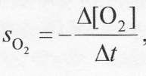
which oxygen disappears: as well as the rate at which carbon dioxide

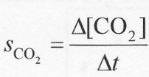
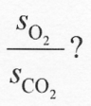
appears: What is the reaction rate ratio of:

A 0.2
B 0.6
C 1.0
D 1.7

- Acetone (propanone) reacts in acid conditions with iodine as shown in the following
equation:

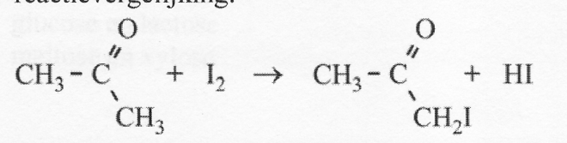

The speed of the reaction was studied by determining how long it takes until the
solution turns colorless. The following results were obtained: (ontkleuringstijd = time it took solution to lose color completely)
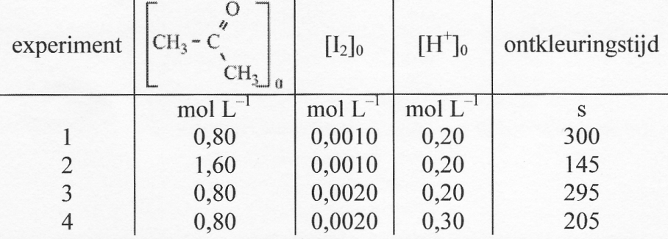

What is the rate equation for this reaction?
A s = k [CH₃COCH₃] [I₂] [H⁺]
B s = k [CH₃COCH₃] [I₂]
C s = k [CH₃COCH₃] [H⁺]
D s = k [I₂] [H⁺]

Structure and properties

- Which of the following atoms have the same amount of neutrons in the nucleus as an atom I-127?
A I-126 C Te-127
B Te-126 D Xe-129

- Which compound is liquid at room temperature and dissolves easily in water?
A CH₃CH₂OH
B CH₄
C C₆H₆
D CO₂
E HCl
F NH₃

- Which substance is NOT an isomer of 2-methyl-pentan-3-one?
A cyclohexanol
B 2.3-dimethylbutanal
C 4-methylcyclopentene-3-ol
D 2-methylpent-3-ene-2-ol

- In which of the following cases does stereo-isomerism occur?
A FHC = CHF
B F₂C = CCl₂
C FH₂C - CHF₂
D F₃C - CCl₃

- How many asymmetric carbon atoms has the molecule below?
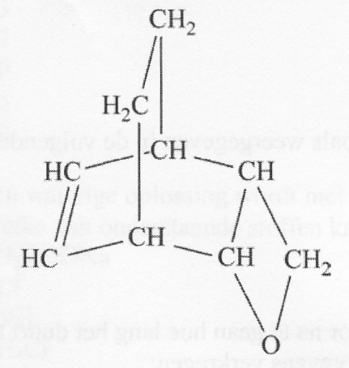
A 2
B 3
C 4
D 5
E 6

Daily practice

- Which of the following substances dissolves poorly in water but well in dilute nitric acid?
A barium sulfate
B barium carbonate
C Magnesium sulfate
D sodium carbonate

- A chromatogram of a mixture of gases was taken twice. Both times, the same amount of mixture was taken. The second time the column was used twice as long as the column that was used the first time. All other conditions were kept the same.
What can you say about the peaks in the second chromatogram compared to the peaks in the first chromatogram?
A The peaks in the second chromatogram are broader and higher than in the first chromatogram
B The peaks in the second chromatogram are broader and lower than in the first chromatogram
C The peaks in the second chromatogram are sharper and higher than in the first chromatogram
D The peaks in the second chromatogram are sharper and lower than in the first chromatogram
E The peaks in the second chromatogram are half as broad and equally high as in the first chromatogram

- Thin layer chromatography is used to examine which sugars are present in milk.
Five samples are placed on a plate of silica:
1) glucose, 2) maltose, 3) xylose, 4) lactose, 5) milk.

Below a picture of the initial situation and the final situation.

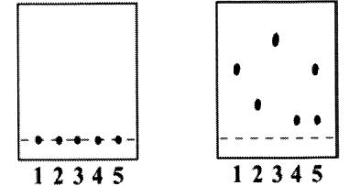
Initial final

Which sugar (s) are present in the milk?
A only glucose
B only lactose
C glucose and lactose
D maltose and xylose

Open assignments (36 points total)

Exercise 2: amines (18 points)
Amines are organic nitrogen compounds that show similarity both in terms of molecular structure and properties with ammonia. An amine molecule can be made by substituting  one, two or three hydrogen atoms in an ammonia molecule by hydrocarbon groups such as alkyl groups. When respectively one, two or three hydrogen atoms are replaced, they are called primary, secondary and tertiary amines:  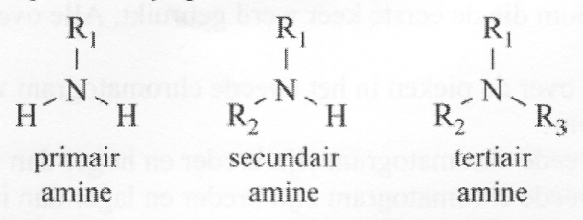  In these structural formulas R₁, R₂ and R₃ represent hydrocarbon groups such as alkyl groups.  - Give the structural formulas of all the amines with the molecular formula C₃H₉N.  The shape of a molecule of an amine has a great resemblance to that of an  ammonia molecule. In both cases a pyramidal structure, with the nitrogen atom  at the top of the pyramid. The shape a molecule of a tertiary amine could be drawn in the following way:  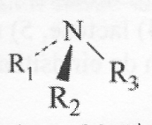  In these pictures a line ( ) represents a bond in the plane of drawing;  - - - - and represent bonds respectively backwards and forwards directed.  Given the shape of an amine molecule you might expect that in each tertiary  amine where R₁, R₂ and R₃ are different groups, stereo-isomerism occurs. There are two  stereo-isomers whose molecules mirror each other. These two stereo-isomers should also show optical activity. However scientist have never observed any optical activity in these type of amines, where one assumes that two stereo-isomers exist. Also scientists never succeeded in separating both stereo-isomers.  To explain this, one can assume that the two enantiomers are in equilibrium with each other, where the groups R₁, R₂ and R₃ rapidly 'flip':  To this equilibrium an equilibrium constant K was assigned.  - Explain whether the above data give enough information to predict the value of K.  Amines are weak bases, like ammonia. They form positive ions by binding H⁺.  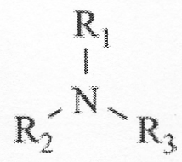  In the reaction of the tertiary amine with hydrogen chloride the  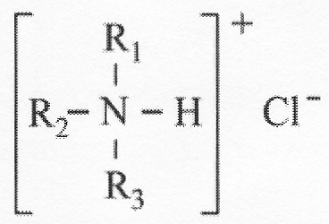  following salt is produced:  Each kind of salt in which R₁, R₂ and R₃ are different, appears to show stereo-isomerism. When one of the two optically active stereo-isomers of these kinds of salts is dissolved in water, a reaction occurs where the positive ion donates a proton. An equilibrium is installed. After a while the resulting solution shows no more optical activity.  - Give the equation for the reaction of 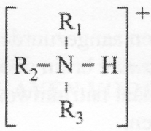in water.  - Explain why it is that the resulting solution over time shows no longer optical activity.  Primary amines can be prepared when chloroalkanes react with ammonia. In this reaction of chloroethane with ammonia in a polar solvent ethylamine is formed. This  conversion proceeds in two steps:  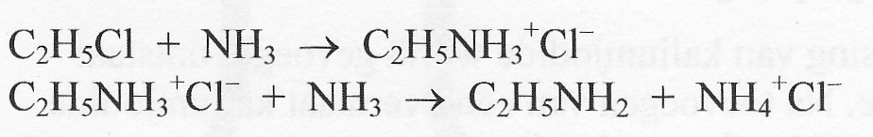  In the resulting reaction mixture, except for ethylamine, diethylamine, (C₂H₅)₂NH, is also formed. Scientists believe that this secondary amine is formed out of the produced primary amine.  - Give the reaction equations of the two steps where diethylamine is formed from the  primary amine.  Studies on the reaction of ammonia with one of the stereo-isomers of 2-chlorobutane in a polar solvent have shown that both stereo-isomers formed from the primary amine are present in the reaction mixture. The fact that the two stereo-isomers are formed is explained through the assumption that from the 2-chlorobutane first carbocations (positively charged alkyl groups) with a flat structure are formed:  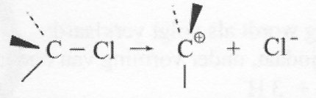  The now formed carbocations react on with ammonia molecules where, after donation of H⁺, both the stereo-isomers arise.  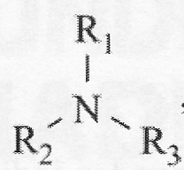  If a tertiary amine, where R₁, R₂ and R₃ are different, would react with one  of the stere-oisomers of 2-chlorobutane, one can expect that the following salt will be  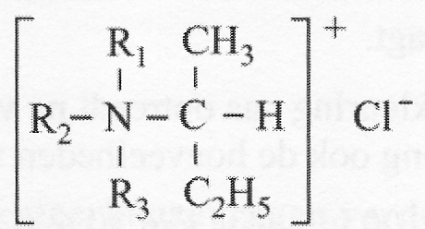3  formed:  If this reaction occurs, one can expect that of this salt different stereo-isomers are created too.  - Explain how many stereo-isomers one would expect, if the reaction is performed with only one of the stereo-isomers of 2-chloro butane.  Exercise 3, Colorful (18 points)  In this whole exercise, the solvent is water.  If a solution of potassium iodate, KIO₃, is added to an acidified solution of potassium iodide, the colorless solution turns slowly brown because of the formation of brown iodine.  This color disappears immediately if an excess of sodium hydrogen sulfite solution is  added. In this reaction sulfate ions are formed.  The reaction schemes for the above reaction are:  IO₃⁻ + I⁻ + H⁺ → I₂ + H₂O  and  I₂ + H₂O + HSO₃⁻ → I⁻ + SO₄²⁻ + H⁺  - Turn these reaction schemes in to balanced reaction equations.  If to a solution of mercury (II) chloride a solution of potassium iodide is added, immediately an orange precipitate of mercury (II) iodide is formed. After addition of excess potassium iodide solution the precipitate disappears and an almost colorless solution is left over.  This phenomenon is caused by the formation of HgI₄²⁻ ions.  In a magazine the following experiment is described:  Dissolve in water 2.0 mmol of mercury (II) chloride and 30 mmol of sodium hydrogen sulfite. Also some starch water is added, a reagent that turns Iodine blue. The total volume of the mixture is brought to 840 mL by adding distilled water. The dissolved substances do not react with each other and the solution is colorless.  Now, while stirring, 160 mL of a 0.10 M solution of potassium iodate is added. The mixture remains colorless for 15 seconds, but suddenly an orange precipitate of mercury (II) iodide appears. After another 15 seconds the orange precipitate disappears and an intense blue staining enters.  The formation of the orange precipitate is explained as follows:  First hydrogen sulfite reacts with iodate and, among others, iodide is formed:  3 HSO₃⁻ + IO₃⁻ → 3 SO₄²⁻ + I⁻ + 3 H⁺  Then precipitating the iodide with Hg²⁺:  Hg²⁺ + 2 I⁻ → HgI₂  The reaction of hydrogen sulfite with iodate is a redox reaction.  - Give the two half equations of this redox reaction.  - Calculate the average rate of the formation of iodide during the first 15 seconds. State the unit in which you express this rate and assume that the solubility product of  mercury (II) iodide is 2.0 · 10⁻¹¹ mol³L⁻³ is.  - Explain why the blue coloration only occurs after the formation and disappearance of the orange precipitate. Include in your argument, the amounts of the substances used.  The test is repeated, but with 100 instead of 30 mmol of sodium hydrogen sulfite. There is again an orange precipitate, but the reaction mixture will not turn blue. The precipitate disappears after some time and an almost colorless solution is formed.  - Explain (with or without a calculation) why both the lack of blue coloration and the dissolving of mercury (II) iodide is due to the greater amount of sodium hydrogen sulfite.  - Calculate how many mmol mercury (II) chloride should be dissolved in this last test to ensure that the orange precipitate just completely dissolves. | 4  2  2  3  4  3  3  3  4  4  2  2

Name:

Answer sheet for multiple choice questions of the preliminary round of the 33rd National Chemistry Olympiad 2012

Nr. | Letter | score

